Preventing Sexual Violence in the Intellectual and Developmentally Disabled Community
Handout

Power and Control Wheels

Partner Relationships –

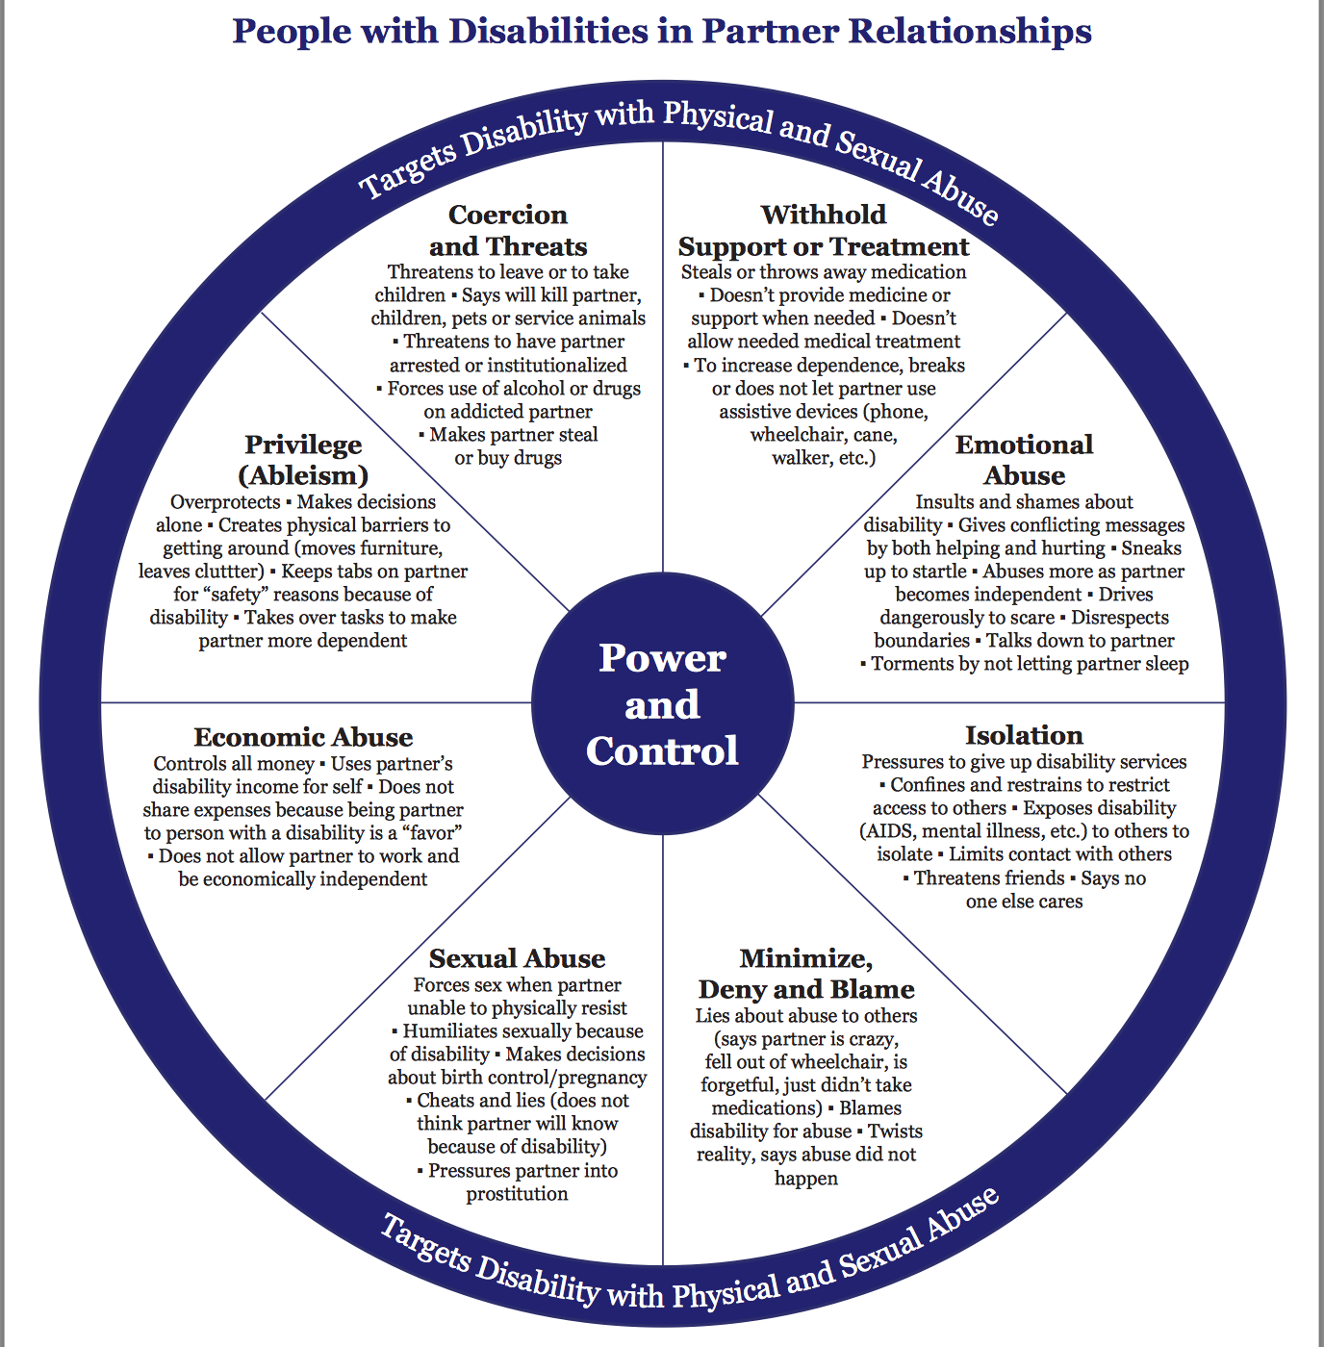
Caregiver Relationships -
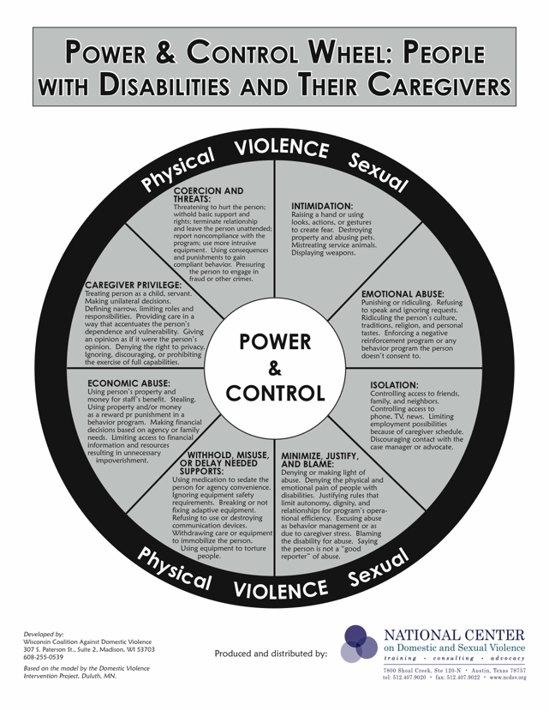
Scenarios Activity
- Read the scenarios and decide what type(s) of abuse are occurring.
- What could the disabled person do to get help?
- What could you do as a service provider to support the disabled person?
- What might have prevented the abuse from occurring?

1. Jenna is a 30 year old woman with Down Syndrome living in a group home. She recently meet a 27 year old man without a disability at bingo. She asked him on a date and he said yes, but the staff and her group home refuse to drive her to meet him. They are worried that he is going to hurt Jenna. When she video called him, they deleted his number from her phone and took away her computer. The staff said that if she tries to meet this man again, she won’t be allowed to go to bingo night or any other community outings until she proves she can be trusted.
2. Jose is 16 and lives with his family. Jose has cerebral palsy and needs help with changing clothes and bathing. He uses an electric wheelchair to get around. His older brother sometimes helps him bathe when his parents are busy. Recently, his brother has been taking a much longer time to wash his genitals. He’s also been making comments about Jose’s body and genitals. Jose has told him that it’s enough, but his brother ignores him and says he is helping. Jose asked his mom if she could help with his showers, instead of his brother, but she said that she’s too busy to help him every day and that he should be grateful that his brother is willing to help.
3. Chris is 20 years old and has Autism. He attends a recreation program in Issaquah. Chris has been complaining about a toothache. A staff member calls Chris' guardian, who agrees to take him to a dentist. Several weeks later Chris again comes to the recreation program, and this time the tooth is obviously abscessed. The staff member again calls his guardian who says she could not get a dental appointment. The staff member assists the parent in making an appointment for the next day with a dentist. The guardian cancels the appointment. Three days later Chris still has not received treatment, and now is presenting with a fever and severe swelling. (Note: Chris’ guardian is his parent)
4. Kayla is 28 years old with Cerebral Palsy. She has been dating her girlfriend Sam for the past two years and they currently live together. Lately Kayla has been feeling suffocated in her relationship. When she expresses to Sam that she needs space, Sam tells her that if she leaves, she will have no one to take care of her. Over the last two years Kayla has lost touch with most of her friends and even her family. She feels scared to leave Sam as Sam is the only one who is up to date on her disability and knows about her medical needs.

Resource Links

10 Principles of Disability – Sins Invalid:
https://www.sinsinvalid.org/blog/10-principles-of-disability-justice

Comprehensive sex health education implementation:
https://www.k12.wa.us/student-success/resources-subject-area/sexual-health-education/comprehensive-sexual-health-education-implementation

NPR Abused and Betrayed podcast:
https://www.npr.org/series/575502633/abused-and-betrayed

Mandatory Reporting is Not Neutral:
https://www.mandatoryreportingisnotneutral.com/

