A Training for Care Providers

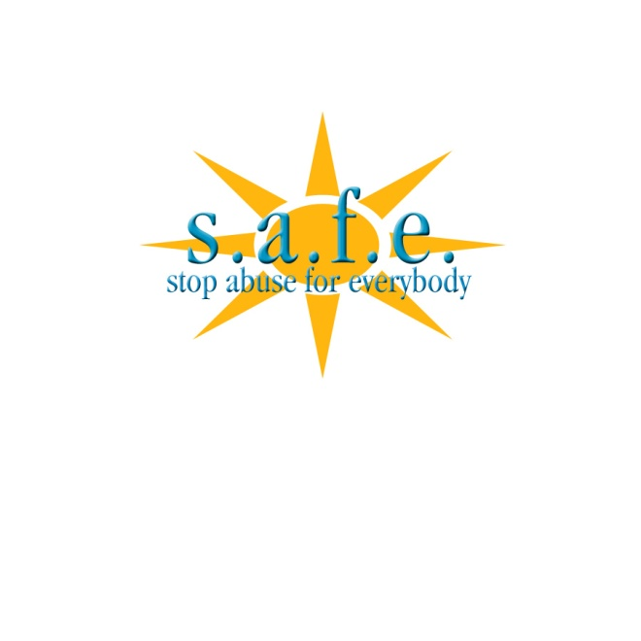

Understanding Safety and Your Responsibilities

When Caring for People with Disabilities

Participant Handout



”With great power comes great responsibility.”
Stan Lee, Author, Spiderman

Module Objectives:

- Participants will be able to identify different types of abuse.
- Participants will learn about the rights of the people they care for.
- Participants will learn about their responsibilities related to protecting the people they care for.

Your Goals:

- ___________________________________________________________________
- ___________________________________________________________________
- ___________________________________________________________________
- ___________________________________________________________________

What is Power?

- Power is a noun.
- Ability to make decision for yourself or someone else
- Ability to influence others
- Ability to do what you want
- Ability to act
- Possession of authority. Not necessarily using the authority
What is Control?

- Control is a verb.
- To exercise restraining or directing influence
- Control situation
- Control others behaviors

Every caregiver has power and control. Not all power is negative, and not all people who have control use it negatively. When a caregiver crosses the line and takes advantage of his/her power or control, it becomes abuse.


Think about the power you have in our life? How could you abuse that power?

- ___________________________________________________________________
- ___________________________________________________________________
- ___________________________________________________________________
- ___________________________________________________________________
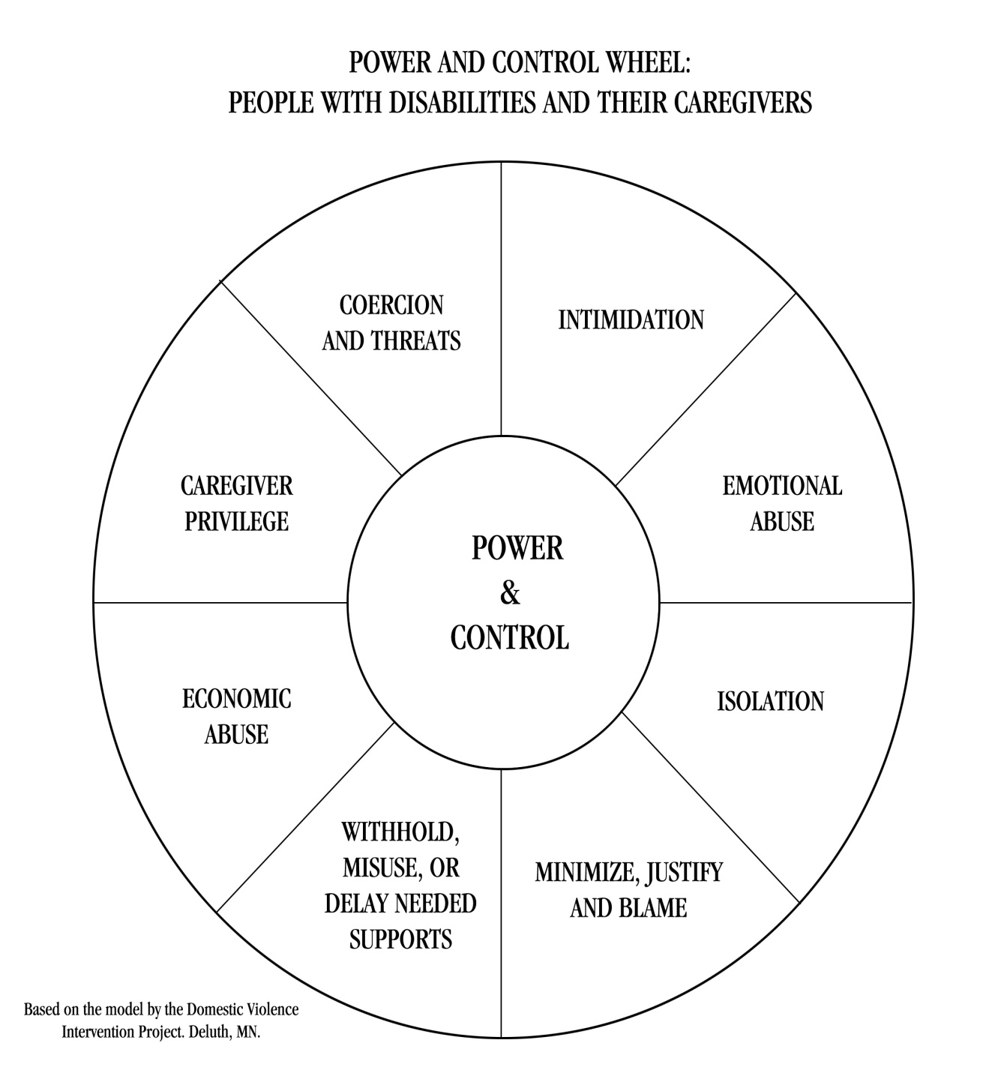

Examples of Abusive Incidents:

- ___________________________________________________________________
- ___________________________________________________________________
- ___________________________________________________________________
- ___________________________________________________________________
- _______________________________________________________

How many of these examples of abuse are intentional or unintentional? What is the difference?

- ___________________________________________________________________
- ___________________________________________________________________
- ___________________________________________________________________
- ___________________________________________________________________

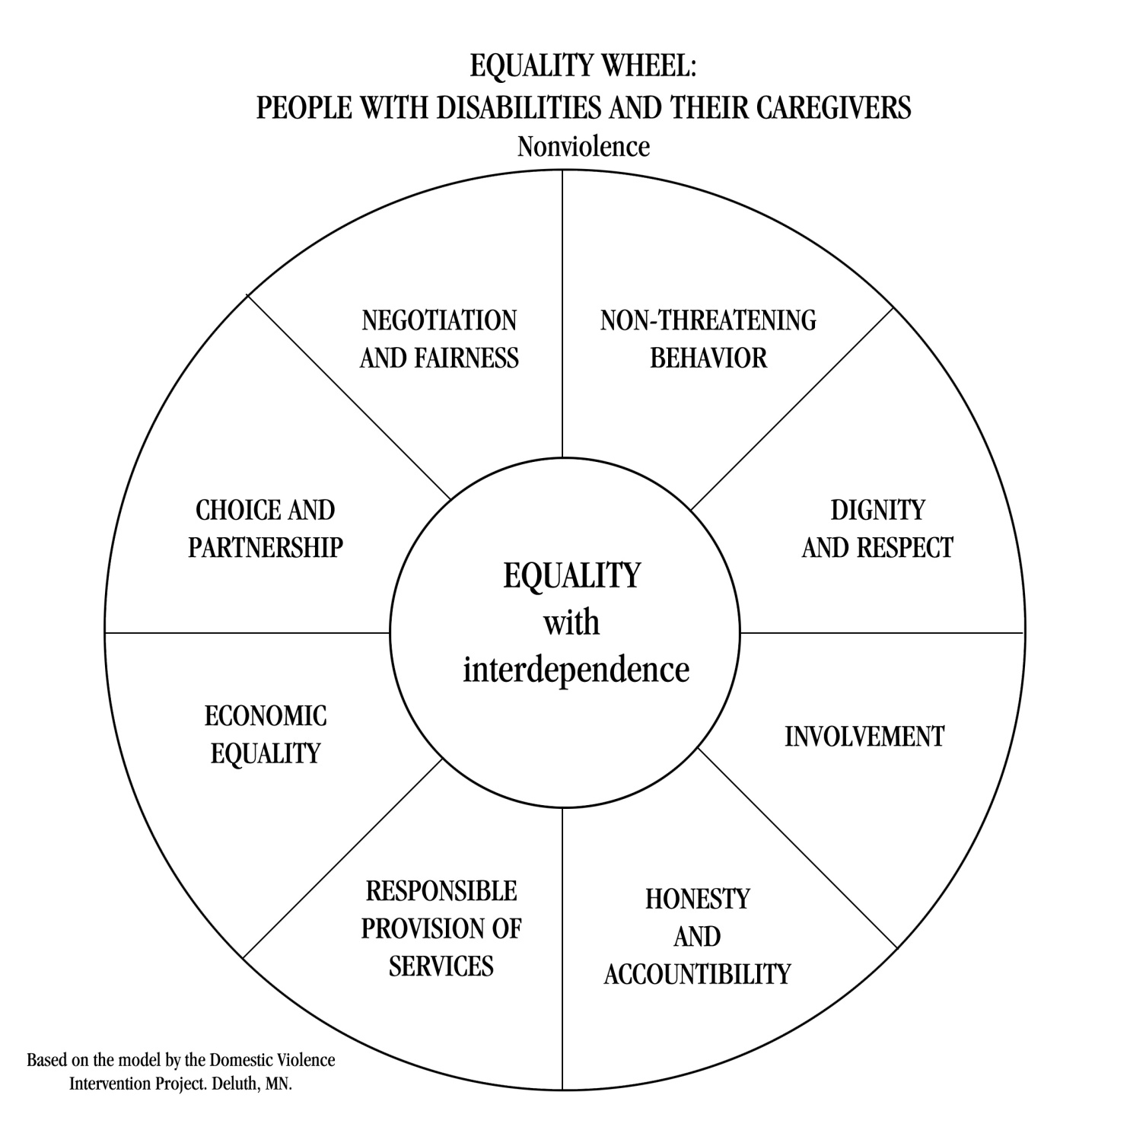

Examples of Ways to be Non-violent:

- ___________________________________________________________________
- ___________________________________________________________________
- ___________________________________________________________________
- ___________________________________________________________________
- ___________________________________________________________________

Name three things you could do differently as a caregiver after thinking about these issues?

- ________________________________________________
- ___________________________________________________________________
- ___________________________________________________________________

“With great power comes great responsibility!”
Stan Lee, Author, Spiderman

Safety Exercise

Question | Your Response

What does safety mean to you? List at least 3 words that describe safety?

What are things you do to stay safe?

If you weren’t safe, what would you do?

How is safety different for people with disabilities?

- _________________________________________________________
- ___________________________________________________________________
- ___________________________________________________________________

What is abuse?

- When someone is harmed or at risk of being harmed, they are often victims of abuse.
- There are many different forms of abuse.
- As we discussed previously, people with disabilities are at higher risk of being victims of abuse than people without disabilities.

Examples?

- ___________________________________________________________________
- ___________________________________________________________________
- ___________________________________________________________________
- ___________________________________________________________________

What does this have to do with you as a care provider?

- ___________________________________________________________________
- ___________________________________________________________________
- ___________________________________________________________________
- ___________________________________________________________________

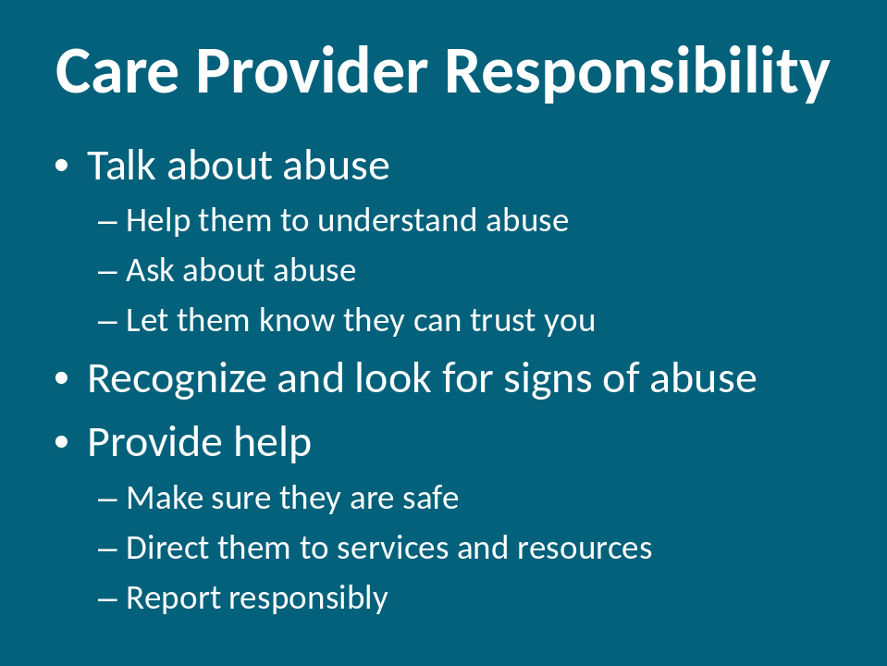

What does this mean to you in particular?

- ___________________________________________________________________
- ___________________________________________________________________
- ___________________________________________________________________
- ___________________________________________________________________

Quiz

- It was estimated that compared to the general population, individuals with developmental disabilities are 4 to ____ times more vulnerable to crime victimization.
a. 5
b. 7
c. 10

Sobsey, D., Wells, D., Lucardie, R., & Mansell, S. (1995). Violence and disability: An annotated bibliography. Baltimore, MD: Paul H. Brookes Publishing Company

- Adults with intellectual disabilities had greater rates of victimization when compared to adults without disabilities as follows: Three times greater for crimes of assault and ____ times greater for crimes of sexual assault.

  - 6
  - 8
  - 11

Wilson, C. & Brewer, N. (1992). The incidence of criminal victimization of individuals with an intellectual disability. Australian Psychologist, 27 (2), 114-117

- Males with disabilities are _____ as likely than males without disabilities to be sexually abused in their lifetime.
  - twice
  - three time
  - four times

Statistics Canada, Centre for Justice Statistics, 1994 in Roeher Institute (1995). Harm's Way. Ontario: Roeher Institute.

- ____% of women and ____% of men with intellectual disabilities have been sexually assaulted.
  - 30 and 10
  - 50 and 15
  - 80 and 30

- ____% of those women have been assaulted more than ten times.
  - 20
  - 35
  - 50

Sobsey, D. & Doe, T. (1991). Patterns of sexual abuse and assault. Journal of Sexuality and Disability, 9 (3), 243-259.

- Numerous nationwide studies consistently show prevalence rates of sexual abuse histories at among _____ percent women in inpatient psychiatric facilities.
  - 20-40
  - 50-70
  - 60-80

On Record: Facts about Mental Health & Physical and Sexual Abuse. 1994. U.S. Department of Health and Human Services, Center for Mental Health Services.

- Only ______% of sexual abuse cases involving people with developmental disabilities are ever reported.
  - 3
  - 10
  - 20

Valenti-Hein, D. & Schwartz, L. (1995). The sexual abuse intervention for those with developmental disabilities. Santa Barbara, CA: James Stanfield Company.

- _____ % of boys who are deaf have been sexually abused, compared to 10% of boys who are hearing. _____% of girls who are deaf have been sexually abused, compared to 25% of girls who are hearing.
  - 23 and 30
  - 30 and 44
  - 54 and 50

Sullivan, P. M., Vernon, M., & Scanlan, J. (1987). Sexual abuse of deaf youth. American Annals of the Deaf, 132 (4), 256-262.

Types of Abuse

Financial: The intentional misuse of a person’s money or assets for personal gain.

Examples:
_________________________________________________________________
_________________________________________________________________
_________________________________________________________________

Indicators:
_________________________________________________________________
_________________________________________________________________
_________________________________________________________________

Neglect: The failure of a caregiver to provide for a person’s basic needs.

Examples:
_________________________________________________________________
_________________________________________________________________
_________________________________________________________________

Indicators:
_________________________________________________________________
_________________________________________________________________
_________________________________________________________________

Emotional: The use of manipulation, deception or deprivation intended to violate the emotional or psychological integrity of a person.

Examples:
_________________________________________________________________
_________________________________________________________________
_________________________________________________________________

Indicators:
_________________________________________________________________
_________________________________________________________________
_________________________________________________________________

Verbal: The use of specific language that humiliates or insults another person. This can include profanity, name calling and yelling.

Examples:
_________________________________________________________________
_________________________________________________________________
_________________________________________________________________

Indicators:
_________________________________________________________________
_________________________________________________________________
_________________________________________________________________

Physical: The infliction of injury or unreasonable confinement resulting in bodily harm or injury.

Examples:
_________________________________________________________________
_________________________________________________________________
_________________________________________________________________

Indicators:
_________________________________________________________________
_________________________________________________________________
_________________________________________________________________

Sexual: Occurs any time a person is forced, coerced, and/or manipulated into any unwanted sexual activity. This can include anything from sexual harassment, to groping and rape.

Examples:
_________________________________________________________________
_________________________________________________________________
_________________________________________________________________

Indicators:
_________________________________________________________________
_________________________________________________________________
_________________________________________________________________

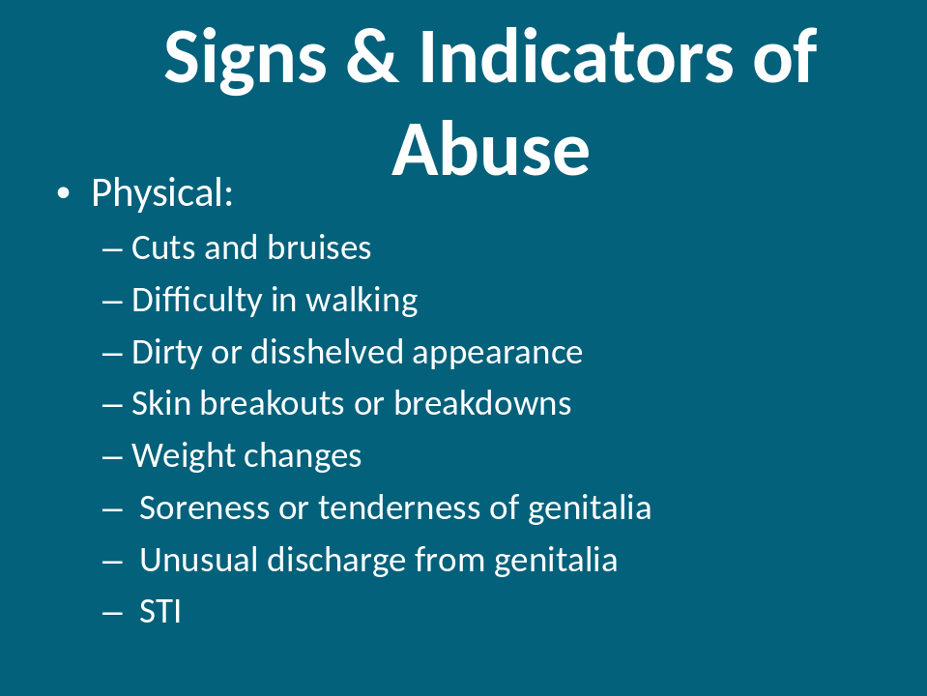

There are both physical and psychological signs of abuse. Physical signs are a lot easier to detect.

_________________________________________________________________
_________________________________________________________________
_________________________________________________________________
_________________________________________________________________
_________________________________________________________________
_________________________________________________________________

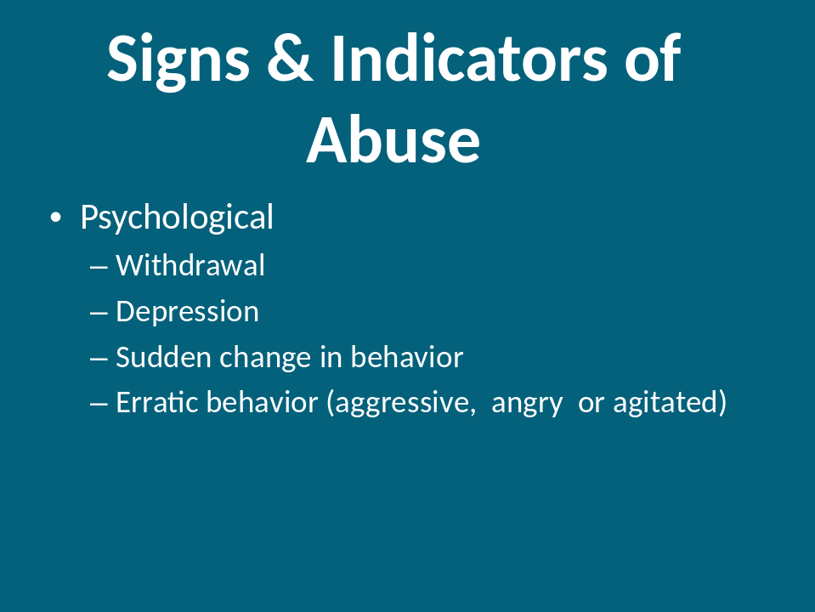
Psychological signs of abuse are harder to detect. As caregivers, you know the people you care for better than most people. Watch for changes in behavior like sudden anger, crying, yelling, and withdrawing from interaction.

_________________________________________________________________
_________________________________________________________________
_________________________________________________________________
_________________________________________________________________
_________________________________________________________________
_________________________________________________________________

Teaching the people you support “how to tell” can make a difference in the response to their abuse. These are some helpful hints.

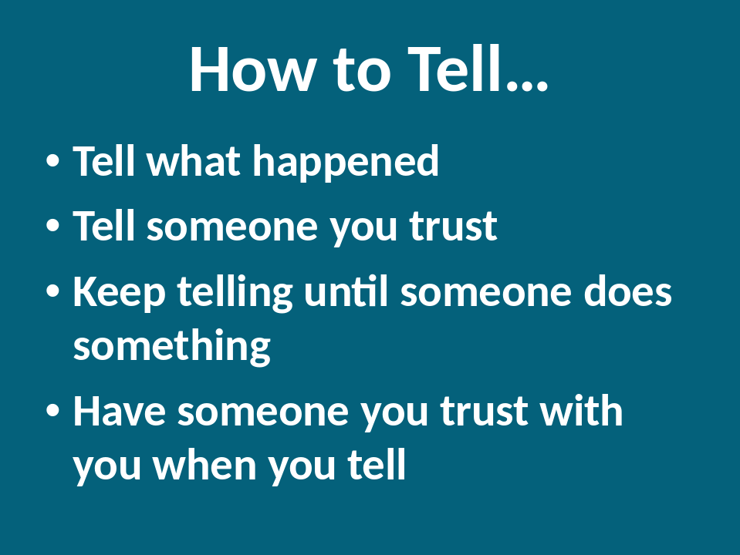

Think about a time when it had been difficult for you to tell something. What made it difficult?

- ___________________________________________________________________
- ___________________________________________________________________
- ___________________________________________________________________
- ___________________________________________________________________

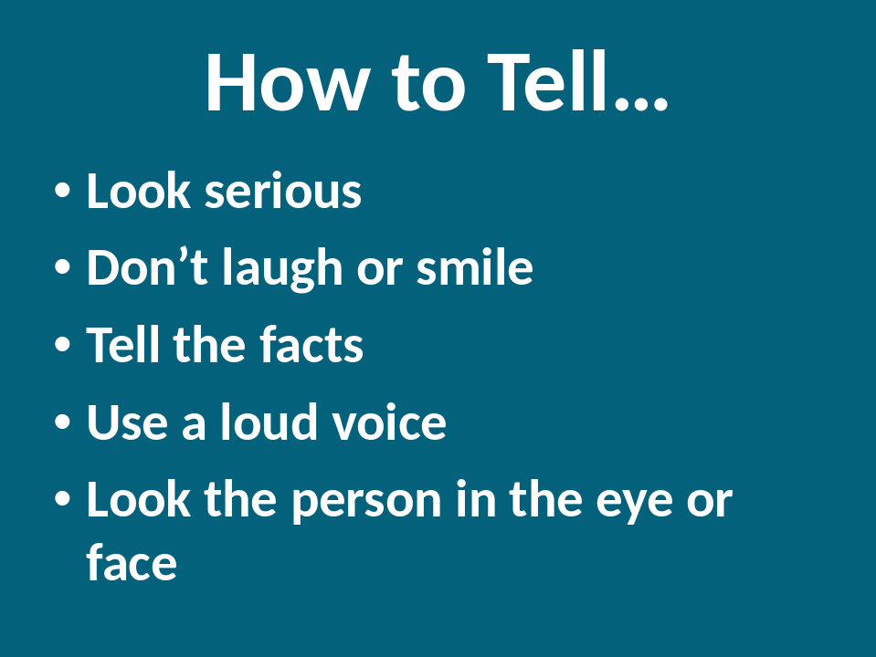

Can you think of others?

- ___________________________________________________________________
- ___________________________________________________________________
- ___________________________________________________________________
- ___________________________________________________________________

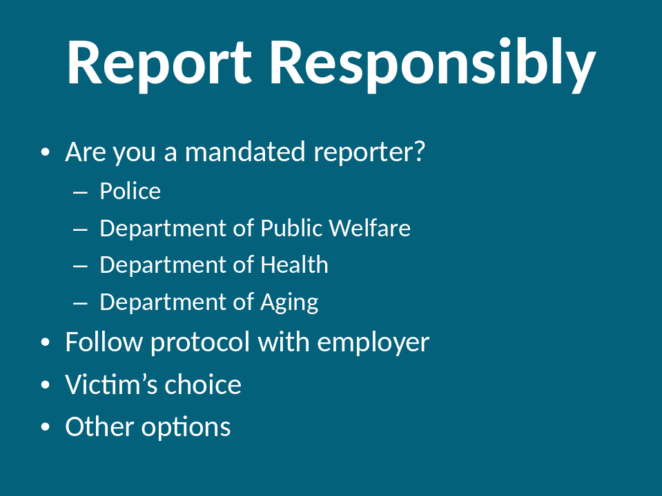

What are your mandated reporting requirements, if any?

- ___________________________________________________________________
- ___________________________________________________________________
- ___________________________________________________________________
- ___________________________________________________________________

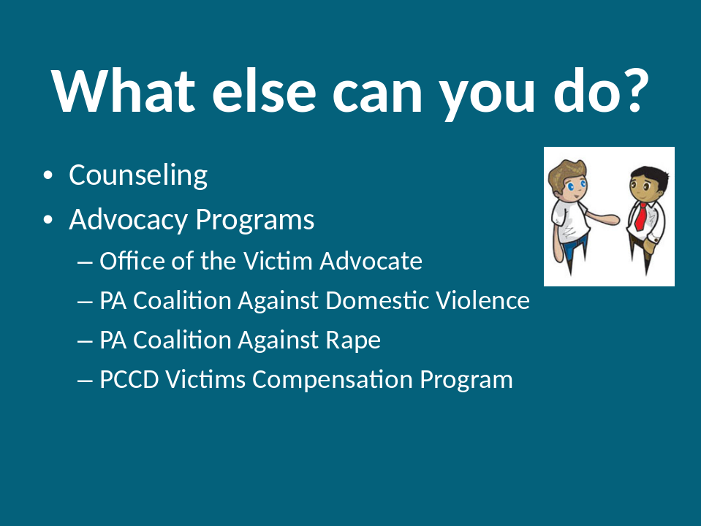

- Counseling:
  - Therapists: ____________________________________________
  - Psychologists:__________________________________________
  - Psychiatrists:___________________________________________
  - Advocates:_____________________________________________

- The Office of the Victim Advocate (OVA) was created by the Victim Advocate Law, Act 8 of the 1995 Special Legislative Session on Crime. The purpose of the Victim Advocate is to represent the rights and interests of crime victims before the Board of Probation and Parole and the Department of Corrections. In addition, the Office of the Victim Advocate also provides notification to crime victims of the potential for inmate release and opportunity to provide testimony, notification of the inmate’s movement within the correctional system, referrals for crime victims to local programs, basic crisis intervention and support, general information on the status and location of the inmate as allowed by law, and notification of the expiration of an inmate’s maximum sentence or date of execution, if applicable, as well as preparation of a victim who chooses to witness an execution. 800.563.6399
- The Pennsylvania Coalition Against Domestic Violence:

The Pennsylvania Coalition Against Domestic Violence (PCADV) is a private nonprofit organization working at the state and national levels to eliminate domestic violence, secure justice for victims, enhance safety for families and communities, and create lasting systems and social change.
PCADV coordinates these efforts with its statewide network of programs, which provides 24-hour emergency hotlines, shelter, counseling, legal advocacy and representation, healthcare-based advocacy, children’s programs, transitional housing and many other free and confidential services. http://www.pcadv.org/About-Contact/; 800-932-4632

- The mission of the Pennsylvania Coalition Against Rape is to work to eliminate all forms of sexual violence and to advocate for the rights and needs of victims of sexual assault. The Pennsylvania Coalition Against Rape (PCAR) is an organization working at the state and national levels to prevent sexual violence. Incepted in 1975, PCAR continues to use its voice to challenge public attitudes, raise public awareness, and effect critical changes in public policy, protocols, and responses to sexual violence. To provide quality services to victims/survivors of sexual violence and their significant others, PCAR works in concert with its statewide network of 51 rape crisis centers serving all 67 counties in the Commonwealth of Pennsylvania. The centers also work to create public awareness and prevention education within their communities. 1-888-772-7227

- The Pennsylvania Commission on Crime and Delinquency's Office of Victims’ Services (OVS) ensures that victims of crime get the help they need to transcend their trauma and move forward with their lives.
OVS does this in many ways, including providing financial help through the Victims Compensation Assistance Program (VCAP), administering funding to local and statewide victim service agencies that work directly with victims of crime and training victim service and allied professionals.

Examples
- Anthony wore his new jacket to work. At the end of the work day when he went to get it, it was gone. He looked all over, but couldn’t find it. The next day at work he saw one of his coworkers with a jacket on that looked just like his.

What type of abuse is this?

________________________________________________________________

What should he do?

________________________________________________________________
_______________________________________________________________

What could you do?
____________________________________________________________________________________________________________________________________________________________

- Mary is a young woman who lives in a group home with other young women and men. Mary likes talking to guys, and wants a boyfriend. Mary’s mother is her legal guardian. That means Mary’s mother went to court and asked a judge if she could make decisions for Mary, instead of Mary making her own decisions. Mary’s mother does not like Mary talking to guys or want her to have a boyfriend. Mary’s mother told staff that they were to keep Mary away from guys. Mary was not to talk to guys, or go to the movies or out to dinner if guys were also along. This makes Mary angry and sad.

What type of abuse is this?

________________________________________________________________

What should he do?

________________________________________________________________
________________________________________________________________

What could you do?
____________________________________________________________________________________________________________________________________________________________

- Bill is friends with Steve. More than five times, Steve has punched Bill in the arm or in the face and called him stupid. Steve apologizes to Bill after each time it happens. Bill is hurt and sad when this happens but wants to remain friends with Steve.

What type of abuse is this?

________________________________________________________________

What should he do?

________________________________________________________________
________________________________________________________________

What could you do?
____________________________________________________________________________________________________________________________________________________________

- Juan is Theresa’s boyfriend. Theresa has lots of friends and talks to lots of people at the training they both go to. Juan doesn’t like other people talking to his girlfriend. He tells Theresa she is not allowed to talk to her friends. Theresa tells Juan that she likes her friends and continues to talk to them anyway. Juan becomes angry and tells Theresa that he will punch her if she does not stop talking to her friends. Theresa wants to talk to her friends but is scared of losing Juan and getting punched.

What type of abuse is this?

______________________________________________________________

What should he do?

______________________________________________________________
______________________________________________________________

What could you do?
____________________________________________________________________________________________________________________________________________________________

- Tom is a van driver. One day, Tom asked Anna if she would like to sit in the front passenger seat for the ride home from work. Anna said yes. When the van got to Anna’s house Tom leaned over to open the door for her and when he did his arm rubbed against Anna’s breast. The next day when Tom reached over to open the van door he tried to put his hand down Anna’s slacks. She was scared and tried to get out of the van. Tom laughed and told Anna not to tell anyone because she would get in trouble for riding in the front of the van. What type of abuse is this?

________________________________________________________________

What should he do?

_____________________________________________________________________________________________________________________________________

What could you do?
____________________________________________________________________________________________________________________________________________________________

- Mary has a cell phone with prepaid minutes. A staff member in Mary’s group home asks her if he can use her cell phone. He tells Mary it will be a very short call. The next time Mary goes to use her phone, it won’t work. Mary asks another staff member to help her fix her phone. The staff member looks at the phone and tells Mary she used all her minutes.

What type of abuse is this?

________________________________________________________________

What should he do?

________________________________________________________________
________________________________________________________________

What could you do?
____________________________________________________________________________________________________________________________________________________________

- Malcolm uses an electric wheelchair and also requires support with his personal hygiene, such as bathing, toileting, and dressing. He also needs support transferring to and from his wheelchair. Malcolm wants to hire a new personal assistant. During each interview Malcolm explained that he needs support during the night to go to the bathroom, sometimes two or three times a night. After interviewing several people Malcolm makes his decision and hires a new personal assistant. But after several days the new personal assistant ignores Malcolm’s call during the night for help to go to the bathroom.

What type of abuse is this?

______________________________________________________________

What should he do?

______________________________________________________________
______________________________________________________________

What could you do?

__________________________________________________________________________________________________________________________________________________________________________

- Joe and his housemate both use wheelchairs and require assistance with daily living activities, such as bathing, toileting and dressing. They also need support transferring to and from their wheelchairs. A female staff always offers to help Joe with bathing and toileting, but not his roommate. She makes comments about Joe’s penis and asks him if he wants her to help him make his penis get bigger. She won’t use a wash cloth when washing Joe’s private parts. Joe doesn’t like this and has asked her to please use a wash cloth. She said no because she is a trained staff person and knows what is best for Joe.

What type of abuse is this?

________________________________________________________________

What should he do?

________________________________________________________________
________________________________________________________________

What could you do?
____________________________________________________________________________________________________________________________________________________________

What did you learn?

________________________________________________________________________
- ________________________________________________________________________

________________________________________________________________________
- ________________________________________________________________________

________________________________________________________________________


