Module Three: Physical and Verbal Abuse

Module Objectives:
- Participants will be able to define words
- Participants will be able to talk about experiences
- Participants will learn their rights and responsibilities

Physical and Verbal Abuse  (2 hours) | 1 | Getting Started and Introductions and Definitions | - Overview  - Ground Rules  - Icebreaker  - Empowerment  - Three Themes  - Defining Terms  - Self Discovery | 50 Minutes
Physical and Verbal Abuse  (2 hours) | 2 | Exploring Experiences and Know Your Rights | - Who can take advantage?  - Explore three Examples  - How to tell | 55 Minutes
Physical and Verbal Abuse  (2 hours) | 3 | Review & Wrap Up |  | 15 Minutes
Instructor Key:
- Italics – Prompts and instructions for trainers
- Non-italics – suggested talking points for trainers
- Bold Centered Text – Questions used for group exercises

Materials Needed:
- Flip Chart
- Markers
- Masking Tape
- Participant Name Tents
- Computer with PowerPoint®
- CD Projector and Screen
- Yes and No Cards for each Participant

Module 3: Part 1: Course Overview and Definitions |  |  | Estimated Time:  50 minutes
Cues |  | Content |  | Notes
  List the course’s three main themes and ground rules to be covered. |  | Before your participants arrive, post the three themes of the training and the proposed ground rules on flip charts so everyone can see them. Keep both posted for the entire training.  Three Themes:  - Right to be Safe  - Right to Speak Out  - Right to Get Help  Ground Rules:  - Only one person talks at a time  - Listen when others are talking  - Turn off/mute cell phones  Optional: Whatever is said here is confidential. Please do not share other’s personal stories outside of this room.  Please be aware that if I learn that someone is being hurt or is hurting someone else that I will need to find out more information and make sure the person is safe. It is important that everyone is safe.
  Welcome  Clarify the classroom ground rules and review housekeeping information. |  | Before we get started with the training, we need to create some training ground rules. I listed some on the flip chart.  Instructor reads:  - Only one person talks at a time  - Listen when others are talking  - Turn off/mute your cell phone  When acceptable to you, you can ask participants to put their cell phones on vibrate mode. Don’t answer phones during this training.  Are there other ground rules you’d like to add?  Here are some ground rules that were suggested at other trainings:  - Everyone should participate. Please participate freely.  - Be on time. I will start and end on time, so please be here on time so you don’t miss any information.  - Respect the opinions of others. Be respectful of others and what they think.  Once each participant has had an opportunity to add a ground rule, ask if there are any other comments and then by a show of hands ask the participants to accept ground rules by saying something like: “Can we all agree on these ground rules?”
Housekeeping:
- You will have:
  - Breaks. (Add the number and length of the breaks; e.g., there will be one 15- minute break.)
  - The restrooms, vending machines, coffee and water are… (provide directions)

 |  | Now that the breaking times and restroom information is out of the way, let’s begin training.
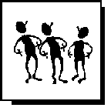  Conduct an ice breaker as an introductory exercise. |  | TIP: People are often hesitant to participate in training programs until they become comfortable with their fellow training participants and the instructor. To help initiate participant interaction, instructors often initiate exercises called “icebreakers” to get people talking and interacting. One of the most common methods to get participants talking is to have them talk about something they know—themselves or their own experiences.
  Slide: 2    Questions for participants |  | Icebreaker Exercise  Using a round robin format, ask each participant to answer one of the following questions. Be sure to let participants know they can pass if they want to, and be sure to take your turn.  The questions below are simple and fun, and serve as a way to have the group interact before getting into module material.  - What is your favorite food?  - What is your favorite TV show?  - What makes you laugh?  - What is your favorite thing?  - What is your favorite holiday?  - What are you most proud of?  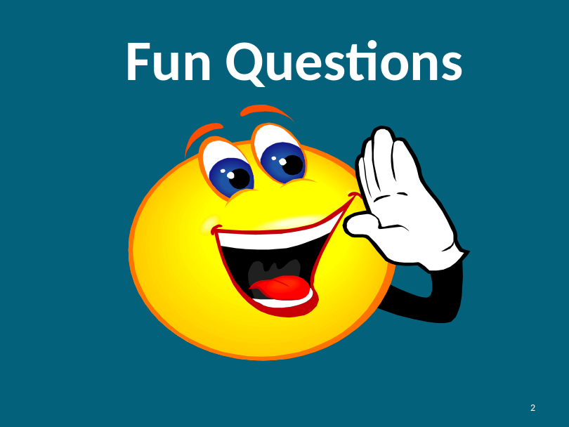  That was great. Thank you.
Slide: 3    Know Your Rights |  | 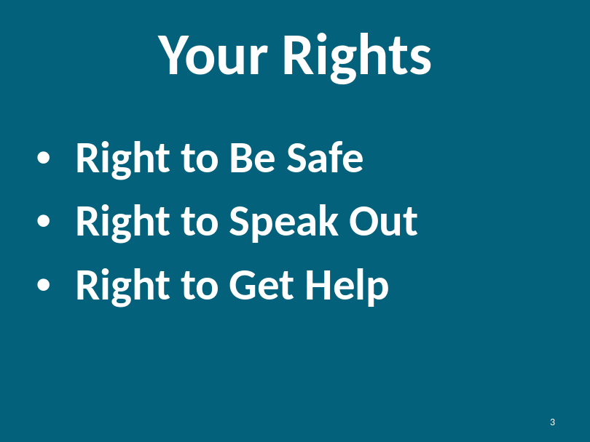  Today we will be talking about your rights. Everyone has the right to be safe, speak out and get help.  - You have the right to be safe at home, at work and in your community  - You have the right to speak out and tell someone if you feel unsafe  - You have the right to get help from others when you don’t feel safe.
Slide: 4  What is Empower-ment? |  | 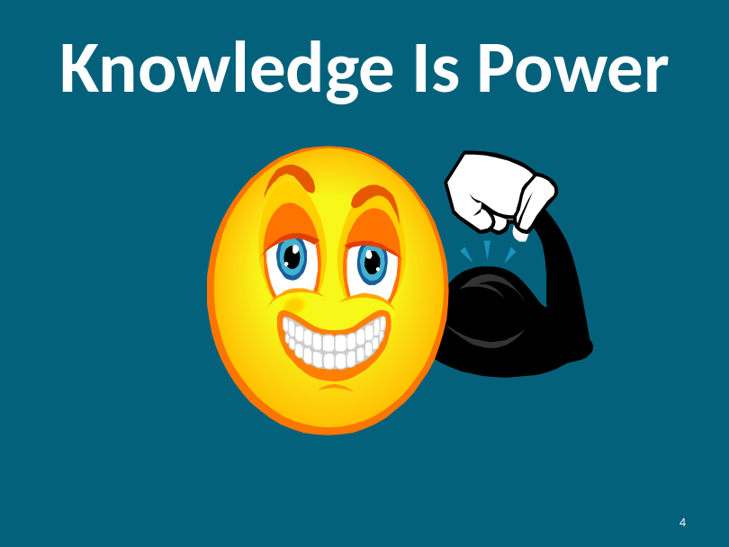  Knowledge is power. When you have knowledge, it helps you to:  - Make wise decisions  - Speak out  - Stay safe  - Know what is right  - Stick up for yourself  Instructor Note:  We have defined empowerment through the phrase “knowledge is power.” Please refer to the Introduction in the overview of the curriculum for more information.
Slide: 5  Defining Safety |  | 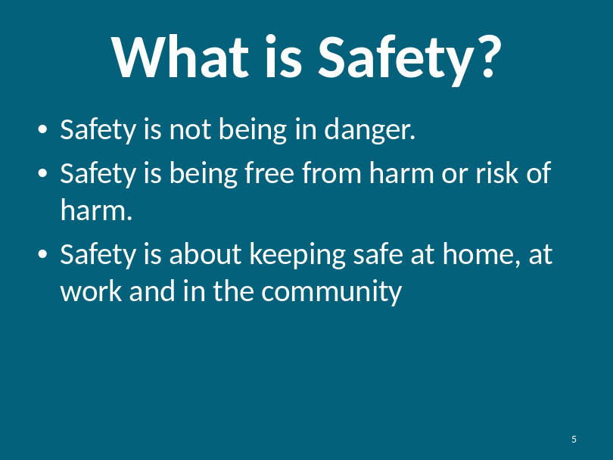  Safety is about not having someone hurt you, take things from you or doing things that scare you.  Safety is a feeling.  Instructor Note:  Remind participants of the Safety Exercise they did during Module #1 (Financial Safety) to help them define what safety means to them. If participants have not taken Module #1, you may optionally provide this exercise at this time.
Slide: 6  Defining Safety |  | 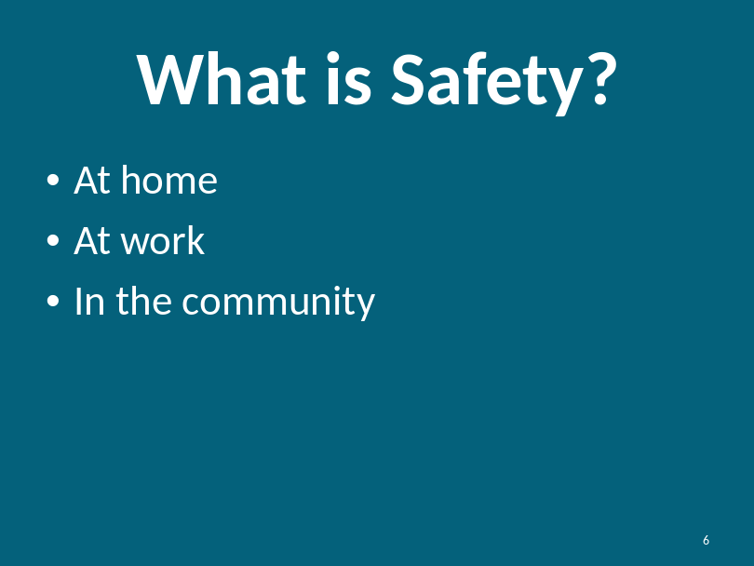Can you name some ways to stay safe?  How do you keep safe at home?  Examples: locking your window and doors, being careful when you cook, being careful when you take a bath or shower  Can you think of some other things?  What about safety at work?  Examples: protecting your purse, wallet, lunch, being careful with any tools you may use  Can you think of other examples?  What about community safety?  Examples: not talking to strangers, using seatbelts, crossing the street at a traffic light.  Can you think of other examples?
Slide: 7  Overview of Safety |  | 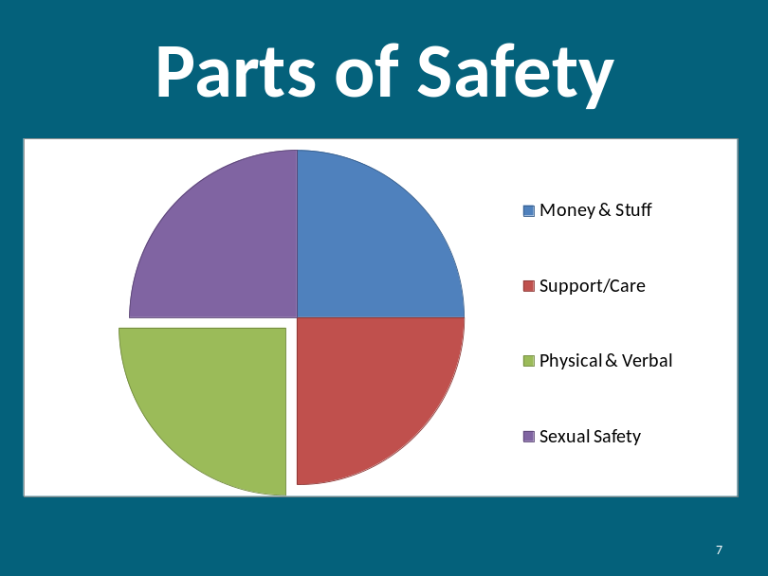  Part of safety is about keeping your body and heart, being safe at home and being safe around others.  Safety is a part of being happy. Everyone has the right to be safe. All parts of your life should be safe.
Slide: 8  Overview of Safety |  | 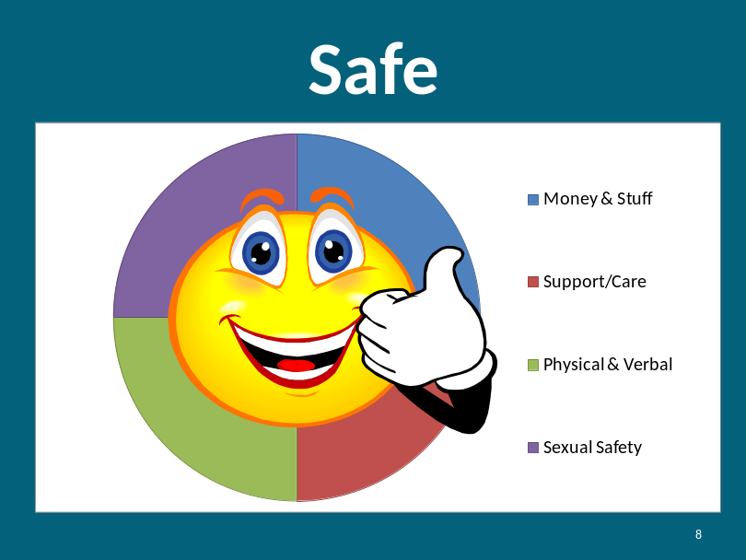
Slide: 9  Overview of Safety  Continued |  | 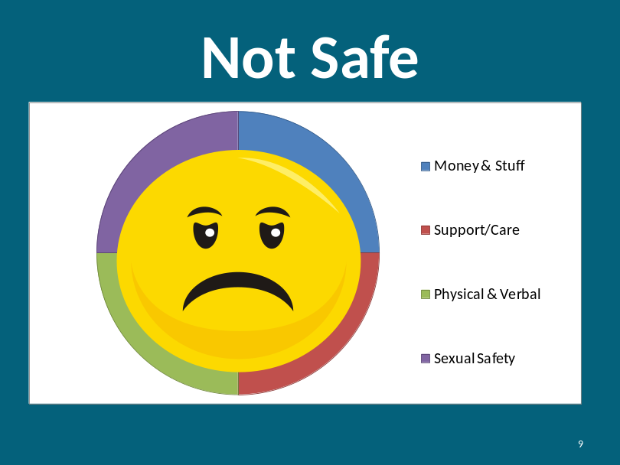  - Sometimes you may not feel safe  - Sometimes when you are not safe, it makes you feel sad and unhappy  - You have the right to be happy and safe  Instructor Note:  In the following section, we discuss a consumer’s right to speak out. It is important to note that “speaking out” may be conducted differently with persons with non-verbal communication techniques. There are a variety of ways to speak out, including, but not limited to, sign language, writing, and/or using a communication device.
Slide: 10  Know Your Rights:  3 Themes |  | 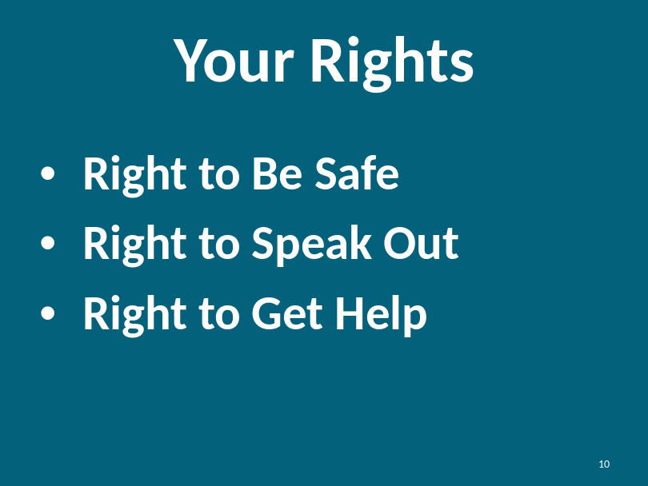  As a reminder, we are going to explore your rights to safety. Remember your drawings? Remember your feelings of safety?  - Right to Be Safe: at home, at work and in the community  What makes you feel not safe? How do you feel when you are not safe? Prompt: scared, worried, angry, sad, hurt or nervous to trust others.  - Right to Speak Out: You have the right to tell if you don’t feel safe.  What does speaking out mean to you? How would you tell a friend to speak out? Who would you speak out to if you didn’t feel safe?  - Right to Get Help: You have the right to have others help you when you are not safe.  We will talk more about how to get help later in the training.
Slide: 11 |  | For today, we are just going to talk about keeping your body safe. You will learn some safety tips that you can share with your friends and family.  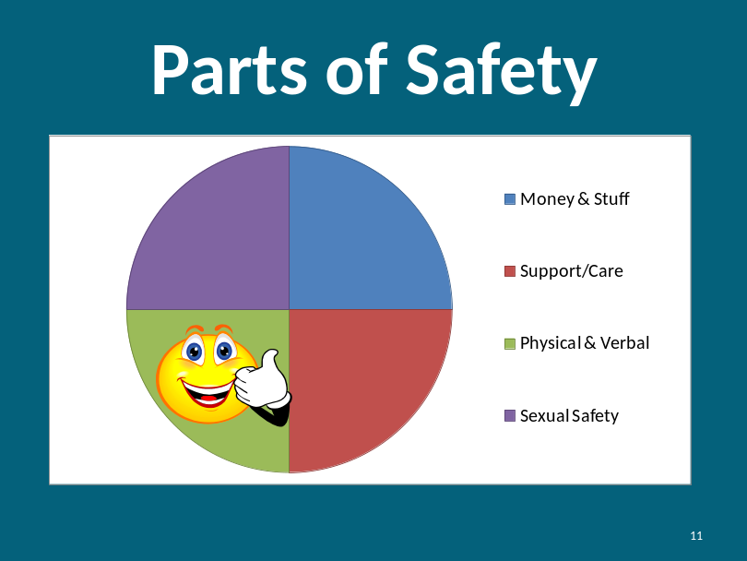
Identifying Abuse |  | For the next couple of minutes, I am going to show you some pictures, and ask what you think is happening.  Describe what you think is happening.  You may want to write the question on a flip chart.  After the participants share what they think is happening, describe a possible example.
Slide: 12  Choking |  | 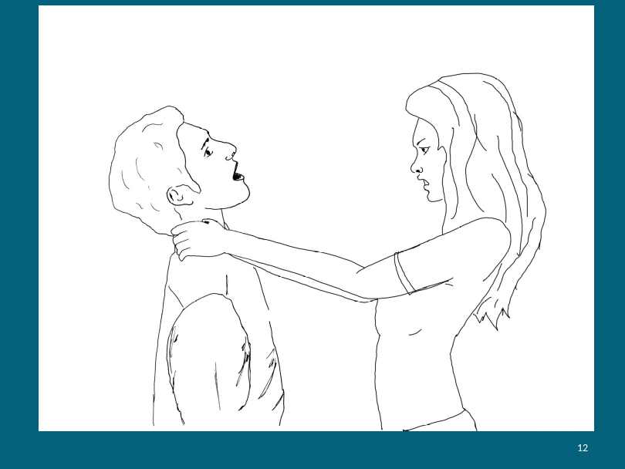  Lee lives at home with his family: his brother, sister and mother. Lee’s sister Lisa is not nice to Lee, and calls him names and makes fun of him almost daily. One day, Lee sees Lisa taking money from their mother’s purse. Lisa notices that Lee is watching her, and grabs Lee by the throat so he can’t breathe. She tells him he better not tell anyone what he saw.  Is it okay?  Instructor talking points: It is never okay to strangle someone even if you are angry. Lee has the right to keep his body safe.
Slide: 13  Yelling & Threatening |  | 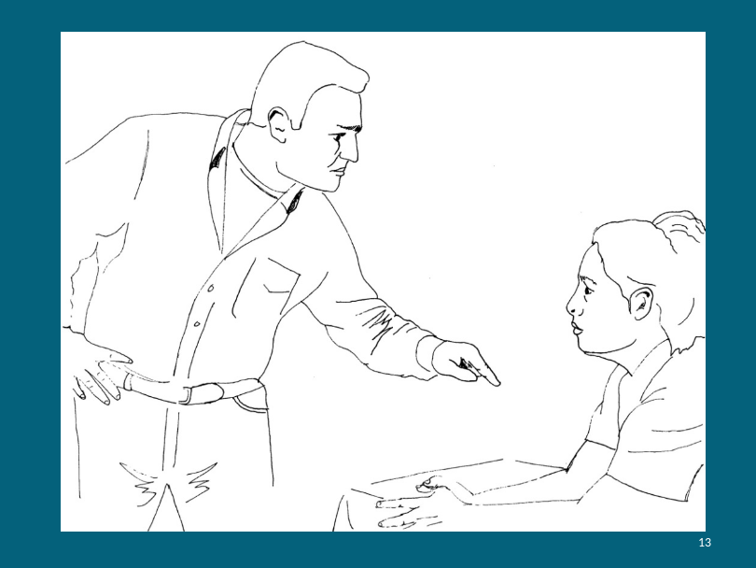  Maria was hired by a large drug store to help stock the shelves after the store is closed. Maria really likes the job and the store manager is happy with Maria’s work, but Maria doesn’t like the night supervisor. The night supervisor tells Maria she better quit because she works slower than the other workers. Maria and the night supervisor only work one night a week together, but that one night of working together makes Maria very sad and scared.  Is it okay?  Instructor talking points: Maria’s night supervisor is threatening Maria. He is intimidating her by raising his voice and pointing at her. He does not have the right to treat her this way.  Note: when dealing with abuse situations at work, there are laws to protect employees.
Slide: 14  Boxing |  | 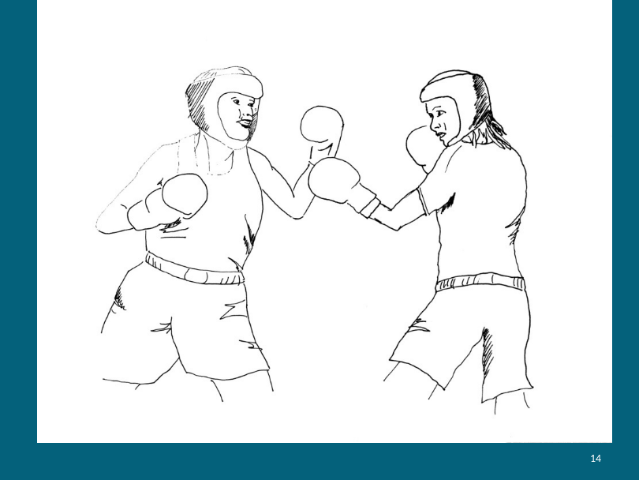  Pat and Terry enjoy the sport of boxing. They have both learned techniques on how to properly throw punches, and wear protective gear when boxing.  Is it okay?  Instructor talking points: Boxing is a sport. Because Pat and Terry are wearing protective gear and are trained on how to box properly, it is okay to box each other. They both consented to box together. No one is forcing them.
Slide: 15  Yelling |  | 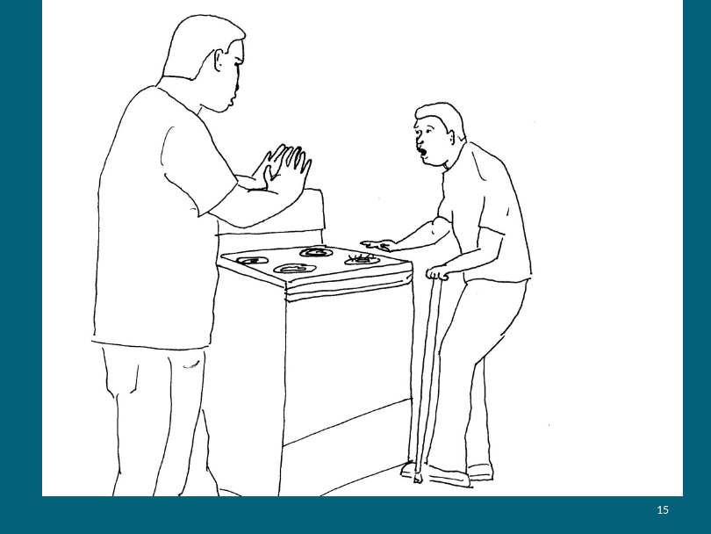  Bob was making oatmeal in a pot on the stove. When he was finished, he took the pot off the stovetop, put the oatmeal in a bowl and the pot in the sink to be washed. Jamie came into the kitchen and was walking towards the stove. Bob realized he had forgotten to turn the burner off, and that Jamie was going to touch the burner! Bob yelled loudly to Jamie, “Don’t touch that!”  Is it okay?  Instructor talking points:  Bob yelled at Jamie because Jamie was in danger. He yelled to protect him from getting hurt by the hot stove.
Slide: 16  Slapping |  | 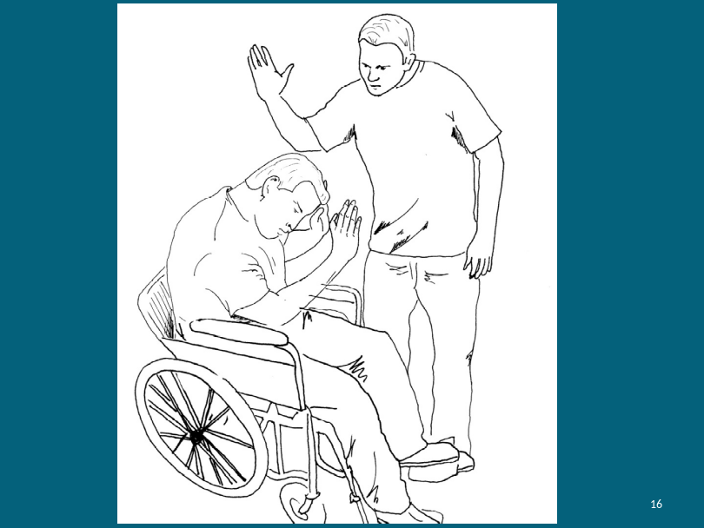  Bill is friends with Dwayne. Dwayne has slapped Bill in the arm and in the face, punched him in the arm, and called him stupid repeatedly. Dwayne apologizes to Bill after each time it happens. Bill is hurt and sad when this happens but wants to remain friends with Dwayne.  Is it okay?  Instructor talking points:  It is not okay for Dwayne to slap, punch or call Bill names. Just because Bill and Dwayne are friends, it doesn’t give Dwayne the right to hurt Bill. Friends don’t hurt one another repeatedly. Even if Dwayne says he is sorry, it doesn’t make the fear and the sadness go away for Bill.
Slide: 17  Defining Abuse |  | 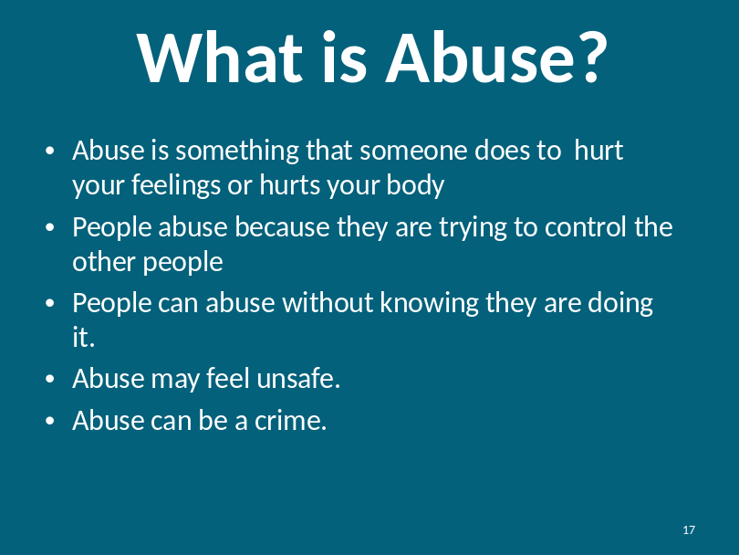  What is abuse?  Instructor Note:  Ask participants to define abuse in their own words. After they have shared their thoughts go through each bullet on the PowerPoint slide above and talk about them.  - Abuse is something that someone does to hurt your feelings or hurts your body  - People abuse because they are trying to control other people  - People can abuse without knowing they are doing it  - Abuse may feel unsafe  - Abuse can be a crime  Is there anything else you want to add?
Instructor Note: If someone discloses being abused during the discussion, thank them for sharing their story. Remind everyone in the room to keep everything said in the room private. Check-in with them after the presentation in case they want to talk further or need assistance. Reminder, if someone is currently being abused, you should take the proper steps outlined in the Introduction.

The Pennsylvania Crime Code can provide some insight as to what is considered criminal activity. You can view the code online via:

- 204 Pa. Code § 303.15. Offense Listing.
901, Criminal Attempt [INCHOATE], 18 Pa.C.S. § 905, See § 303.3(c) .... 2702(a)(6), Aggravated Assault (physical menace, fear of imminent SBI), F2, 6, 2 ...
http://www.pacode.com/secure/data/204/chapter303/s303.15.html
Slide: 18  Intent |  | 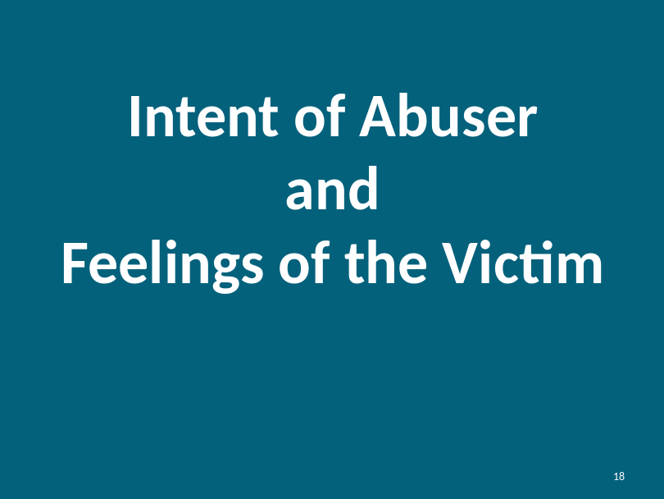  First, we need to understand what the abuser intended to do. Did they intend to hurt the victim? Second, we need to determine the impact on the victim. How does the victim feel? If the abuser did not intent to hurt the victim and the victim feels abused, what occurred is abuse regardless of intent.  Can you think of an example when someone was hurt by someone else but they did not mean to hurt them?  Instructor use the following examples:  - You are shoving someone playfully. The person falls back, hits their head and is hurt by the fall. You did not intend to hurt them but you did.  - You yell at someone to stop them from crossing the street when a car is coming. You hurt the person’s feelings because you yelled. You did not mean to hurt them.
Slide: 19  Physical Abuse |  | 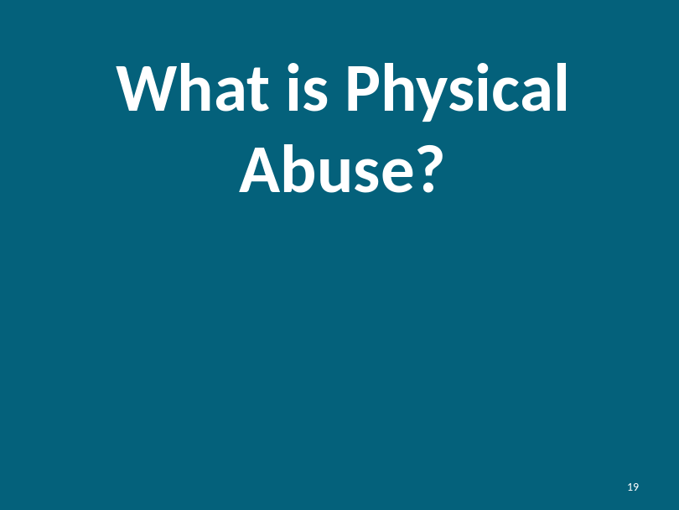  What is Physical abuse?  Prompt the participants to provide the following answers:  - Hitting  - Punching  - Strangling  - Slapping  - Pinching  - Poking  - Sexual Assault  - Biting  - Spitting  - Being too rough
Physical abuse is when someone else hurts your body. Sometimes, it may be accidental (they did not mean it) but most often it happens because someone wants to control you or make you do something.

We will not be talking about sexual abuse today. That is a whole other training program. It is important to recognize that sexual abuse is a form of physical abuse. Like with any form of abuse, you don’t deserve it and you should do what you can to be safe.
Slide: 20  Verbal Abuse |  | 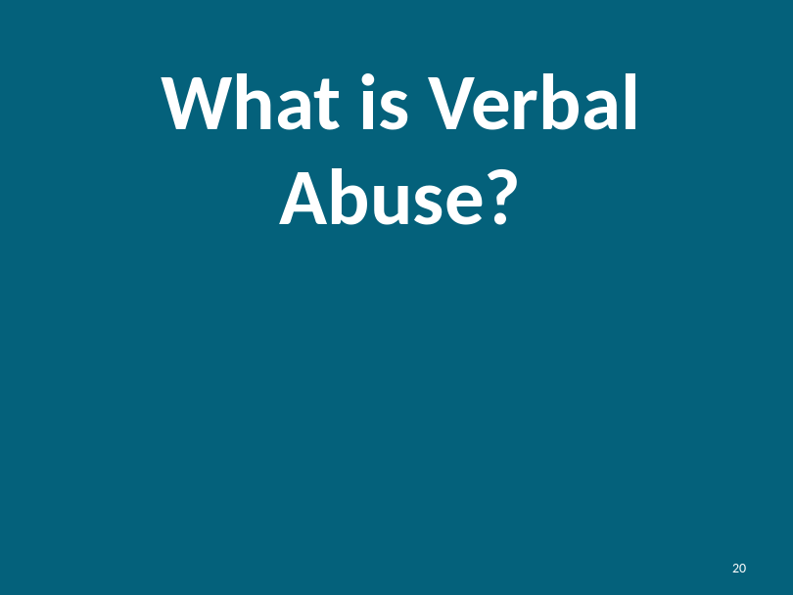  What is Verbal Abuse?  Prompt the participants to provide the following answers:  - Name-calling  - Yelling  - Ordering  - Teasing or making fun of  - Threatening  - Criticizing and Judging  - Discounting  - Swearing  - Using a harsh tone
Examples of Verbal Abuse |  | Let’s talk more about threats. Threats generally take on two forms. Here are some examples:  If you (don't).....I'll....  For instance:  - If you don't leave me alone, I'll leave.  - If you don't have these chores done by the time I get home, I'll be really angry.  - If you keep arguing with me, I'll hit you.  The second type takes this form:  Do this or I'll...  For instance:  - Do the dishes now or I'll make the dog sleep outside in the snow tonight.  - Hang up the phone or I'll hurt you.  - Do what I say or else!
Examples of Verbal Abuse |  | Some examples of critical and judgmental "you" statements include:  - You complain too much  - You can't take a joke  - Your problem is...  - You have issues  Discounting is a form of verbal abuse that leaves you feeling as if your feelings, thoughts, and experiences are worthless or don't matter.  Some statements that may be considered as discounting include:  - You don't know what you are talking about.  - You twist my words around.  - You are trying to start a fight.  - You are making a mountain out of a molehill.  - You cannot take a joke.  - You see everything in the worst possible way.  - You think you know it all.  - You think you're always right.  - No one asked you.  - Your feelings don't matter.
Slide: 21  Physical and Verbal Abuse |  | 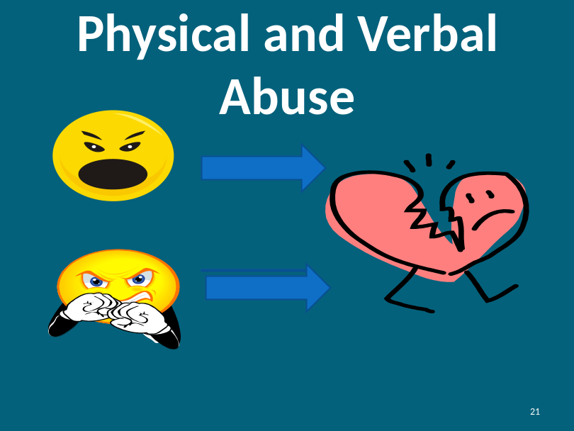  Verbal abuse hurts our feelings and physical abuse hurts both our bodies and our feelings.
Effects of Abuse |  | How does physical and verbal abuse hurt your heart and your feelings?  Instructor prompts some responses:  - Feel bad about yourself  - Hurts your feelings  - Makes you scared  - Worry about what is going to happen to you  - Angry at the person who hurts you  - Nervous about trusting people  - Feel sad  - Want to get away  - Feel alone  - Self esteem or self worth is affected  - You doubt yourself; you lose your confidence  - You might feel ashamed or guilty about what happened
Slide: 22  Who Might Abuse You? |  | 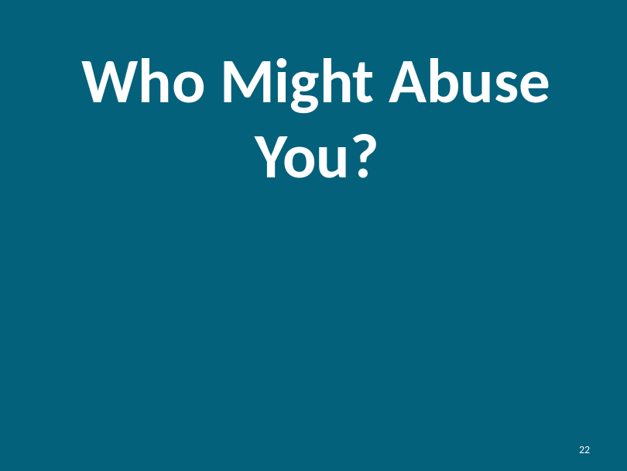
Slide: 23  Who Might Abuse You? |  | Instructor should use this slide to illustrate the point of who might hurt them.  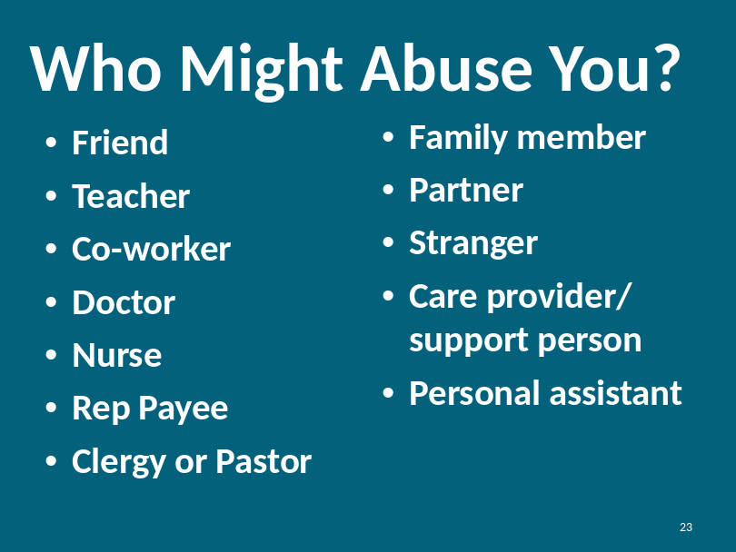
Who Might Abuse You?  continued |  | Prompt them to answer this question. They may say someone in power wouldn’t do anything wrong.  You have the right to be safe. Sometimes people can abuse other people. These can be the same people you trust.  Sometimes these people might not even know they are abusing you.  Anyone could be someone who hurts your feeling/heart and/or body—even if they are your friend, co-worker, or care provider. But that doesn’t mean all of these people will hurt you. If someone is hurting you, it is your right to speak out and get help!
Slide: 24  What can you do if someone hurts you? |  | 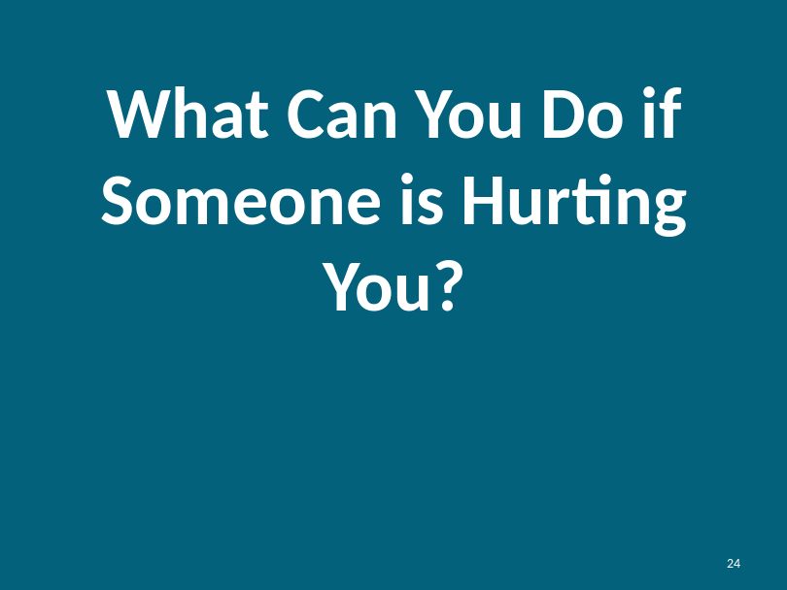  What can you do if someone is hurting you?  Instructor prompts potential responses:  - Tell the person to stop.  - Tell someone else that might be able to help.  Instructor Note: Remind participants that it may not be safe to tell an abuser to stop. In cases where they may not be safe, advise them to tell someone else who might be able to help.
Slide: 25  Yes or No Exercise |  | 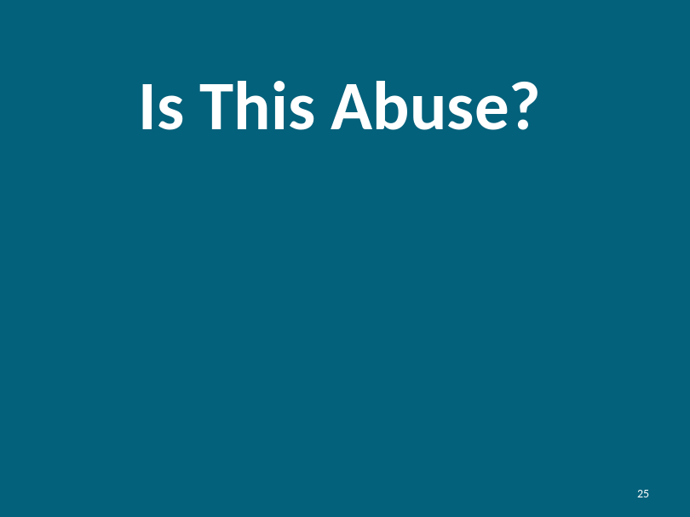  Using your Yes and No Cards in front of you… Raise your Red card for Yes if you agree with the statements and raise your Green card for No if you disagree with the statement.  Instructor use examples from participants before and facilitates an exercise where participants can show their Yes or No cards
- Jessica keeps getting poked and pinched by her friend. Even when she says stop it, her friend does not. Is this abuse?
Yes, this is abuse. If Jessica doesn’t want her friend to poke her then her friend should stop. Participants should raise their red card.

- Juan gets called names by some of the people he lives with. Is this abuse?
Yes, name-calling is mean and is abusive behavior. Juan should not be abused by the people he lives with. Participants should raise their red card.

- Sometimes Maura misbehaves; her mom spanks her very hard when she misbehaves. Is this abuse?
Yes, spanking is not considered an appropriate form of reprimanding children. Years ago this was acceptable but not anymore. Participants should raise their red card.

Module 3: Part 2: Exploring Experiences and Knowing Your Rights |  |  | Estimated Time:  55 minutes
Cues |  | Content |  | Notes
Explore three Examples |  | Instructor reads each Example. After each Example is read, the instructor will ask each of the outlined questions in order. The objective is for the instructor to garner participant’s specific answers.  At the appropriate time, the instructor should reinforce the key concepts of each of the Examples about participant rights and safety rules.  Instructor Note: The questions listed after each Examples are a starting point for a group discussion. The instructor can tailor questions to the audience and the discussion.  Additionally you may want to ask questions about the intent of the abuser and the feelings of the victim.
Slide: 26  Choking |  | 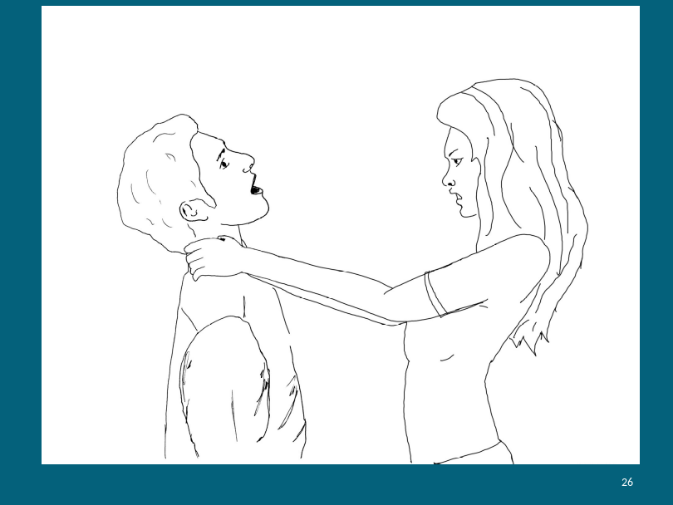  Lee lives at home with his family: his brother, sister and mother. Lee’s sister Lisa is not nice to Lee, and calls him names and makes fun of him almost daily. One day, Lee sees Lisa taking money from their mother’s purse. Lisa notices that Lee is watching her, and grabs Lee by the throat so he can’t breathe. She tells him he better not tell anyone what he saw.  Is this abuse?  Yes, stangling someone is abuse.  What kind of abuse?  This is a form of physical abuse.  What can Lee do to feel safe?  Talking Points: Lee can try to talk to his sister and ask her not to do those things in the future. Lee can tell his brother and/or mother about what Lisa did and get them to help him make this abuse stop.
Slide: 27  Threatening |  | 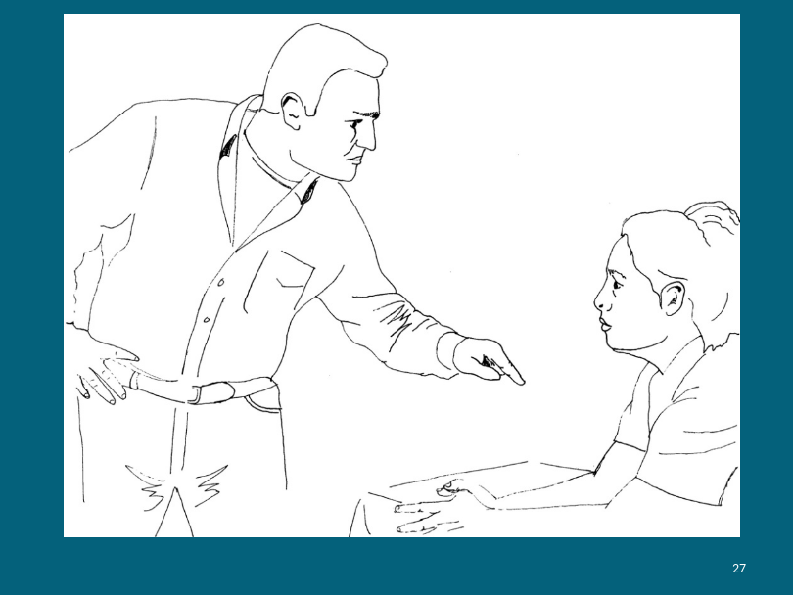  Maria was hired by a large drug store to help stock the shelves after the store is closed. Maria really likes the job and the store manager is happy with Maria’s work, but Maria doesn’t like the night supervisor. The night supervisor tells Maria she better quit because she works slower than the other workers. Maria and the night supervisor only work one night together, but that one night of working together makes Maria very sad and scared.  In this example, are the night supervisor’s threats verbal abuse?  Yes  What can Maria do?  Talking Points: Maria needs to tell someone that her supervisor is doing this to her. Her best option is to talk to another supervisor or the store manager. She needs to keep telling until someone does something.
Slide: 28  Punching |  | 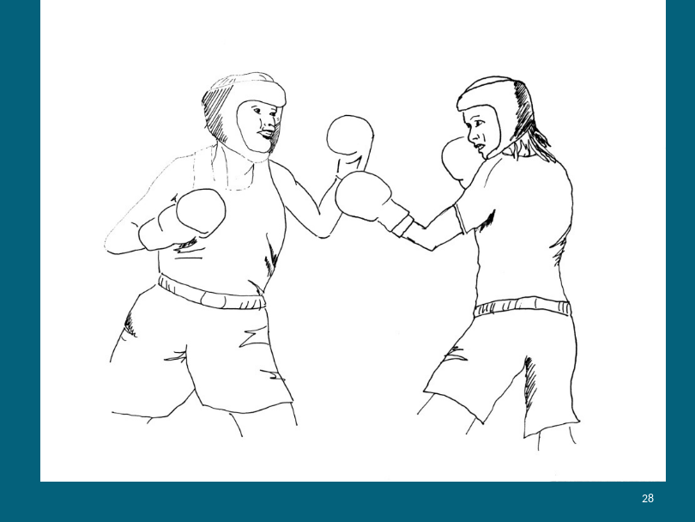  Pat and Terry enjoy the sport of boxing. They have both learned techniques on how to properly throw punches, and wear protective gear when boxing.  In this example, is punching physical abuse?  Not in this case. They both consented to play this sport and are wearing protective gear.  Why or Why not?  Talking Points: This picture shows people exercising. They are boxing. They are wearing protective gear and are playing a sport.
Slide: 29  Punching |  | 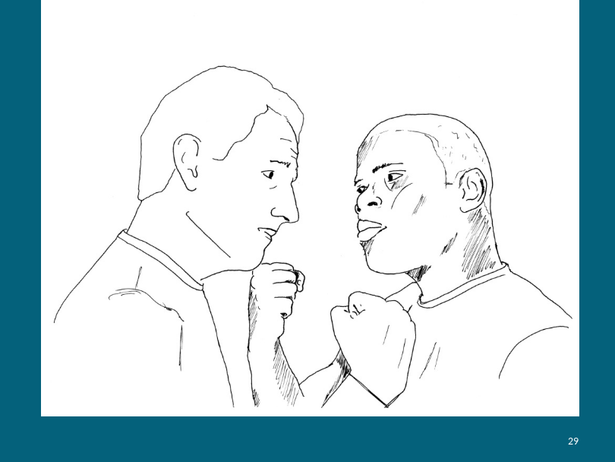  John and Ben are friends. Ben gets mad at John quite frequently. For example Ben gets mad when John wears a shirt that Ben doesn’t like. He doesn’t like when Ben talks too long to another friend in front of John. Once John burnt pancakes for breakfast and Ben got mad. One day, when Ben was mad at John, he got very angry and punched John in the face.  Is it okay in this example to punch?  No, we should not punch someone when we get mad. It is never okay to punch and hit someone else.  We should try to talk about it with the other person.  What should John do?  Talking Points: John should first ask Ben not to punch him. He should tell someone else what is happening. If it continues Ben can report the abuse to the police.
Slide: 30  Yelling |  | 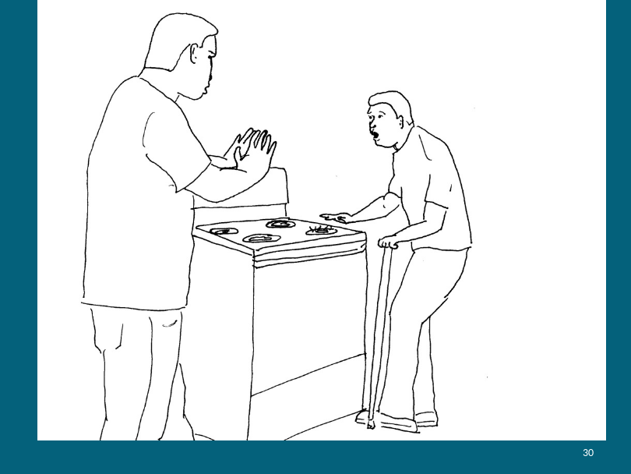  Bob was making oatmeal in a pot on the stove. When he was finished, he took the pot off the stovetop, put the oatmeal in a bowl and the pot in the sink to be washed. Jamie came into the kitchen and was walking towards the stove. Bob realized he had forgotten to turn the burner off, and that Jamie was going to touch the burner! Bob yelled loudly to Jamie, “Don’t touch that!”  Is it okay to yell?  Are there ever times when you should yell?  Talking Points: Sometimes we have to yell to get someone’s attention if they are in danger of getting hurt. In this picture, the man/father is yelling at the boy. Though the boy looks scared, the man’s hands are open and indicating that he is trying to prevent the boy from getting hurt.
Slide: 31  Yelling |  | 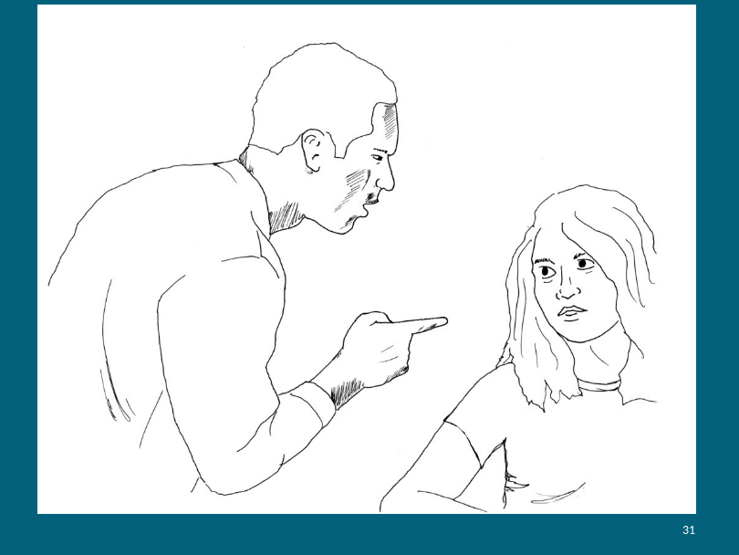  Aeesha lives with his father. The two have a good relationship, except that Aeesha’s father tends to yell at her a lot. He’ll yell at Aeesha for not washing his dishes, or cleaning his room, or taking out the trash. When he yells, he calls Aeesha names, like “stupid” and “idiot.”  Is this abuse? What kind of abuse is it?  Instructor Prompt: This is verbal abuse because calling people names is never okay.  Are there ever times when you should yell?  Only to prevent danger!  What can Bob do?  Talking Points: Aeesha needs to tell her father how it makes her feel when he yells at her and calls her names. If her father doesn’t stop, then Aeesha should find someone else she trusts to tell.
Slide: 32  Slapping |  | 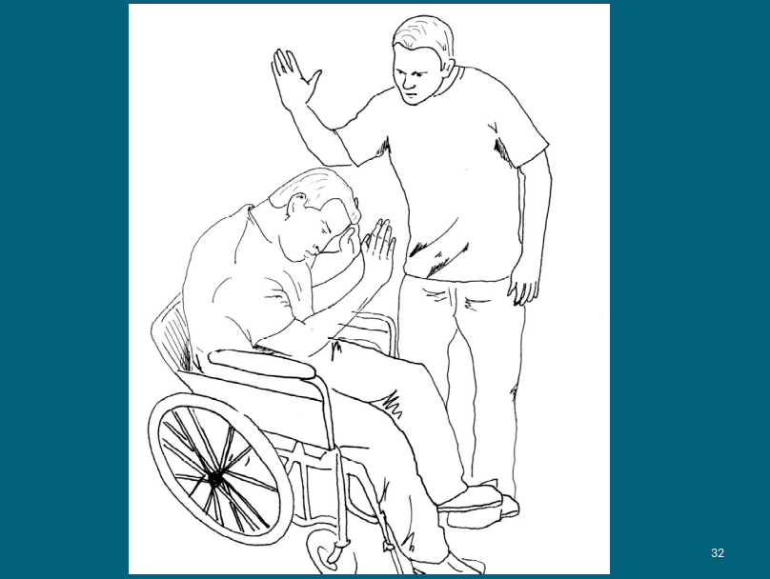  Bill is friends with Dwayne. Dwayne has slapped Bill in the arm and in the face, punched him in the arm, and called him stupid repeatedly. Dwayne apologizes to Bill after each time it happens. Bill is hurt and sad when this happens but wants to remain friends with Dwayne.  Is this abuse? If so, what kind of abuse?  Instructor Prompt: slapping, punching, name-calling  What should Bill do?  Talking Points: No one should slap another person. If telling Dwayne does not work, then Bill should tell someone else that can help stop Dwayne’s abuse.
Slide: 33  Why is it hard to tell? |  | 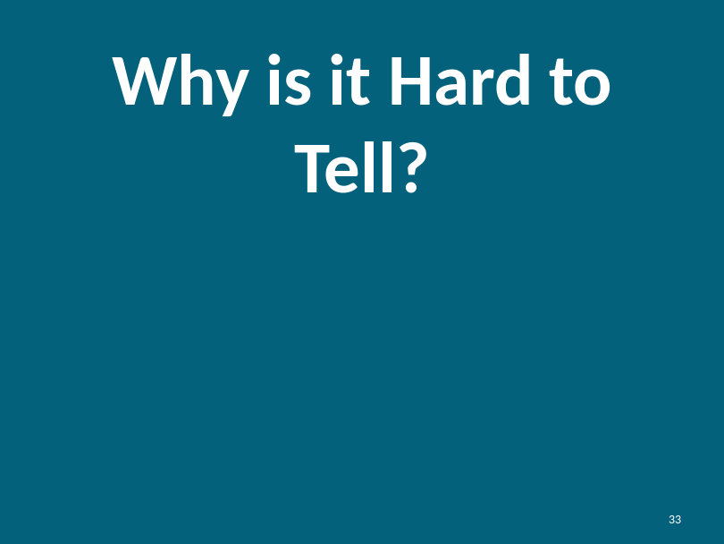  Instructor prompts:  - Scared of getting hurt or of getting in trouble  - Guilty for letting this happen to me  - I think it may be my fault somehow  - Embarrassed by what happened  - Don’t want to get someone in trouble  - Uncomfortable sharing the information  - Don’t like talking to people I don’t know  Regardless of the intent of the abuser if the victim feels unsafe, the best thing for the victim to do is tell and get help.
Optional |  | OPTIONAL EXERCISE  Has there been a time when it was difficult for you to tell? What happened?  Be aware that this question can lead to disclosure. It is important for the instructor to judge his/her participants and determine if this would be an effective exercise to use.  Instructor should provide one example from their own personal history.
Do you remember we practiced about saying “NO?” We talked about how important it is to be serious and say “NO” in a powerful way. When we tell someone that something wrong has happened or that someone has taken something from us, we need to use these same tips.

These are tools on how to tell if you think someone is abusing you or taking your things without your permission.

Slide: 34  How to Tell |  | 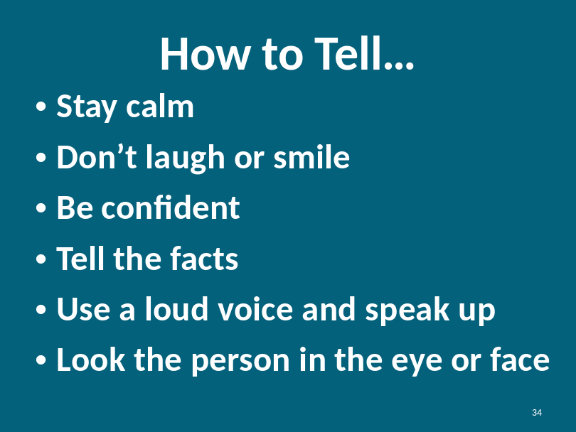
How to Tell |  | We discussed how hard it is to tell. Sometimes we feel uncomfortable or embarrassed to tell others when bad things happens.  When we are scared sometimes we raise our voice, cry or yell. It is important that we stay calm when telling so that they can understand what we are saying and help us to tell the whole story.  Sometimes when we are embarrassed we may smile, laugh or giggle. When we smile or laugh, it is hard for the person who we are telling to understand that we are not safe.
How to Tell |  | Even though you may think some of the story is not relevant, don’t hold back anything when telling what happened. The more information you provide, the more people can help you.  No matter what happens be confident in what you have to say. Even though it may be very difficult, try to look the person you are telling in the eye. This shows your confidence in yourself and the truth.  It is disappointing and frustrating when we tell someone something and we are not believed or helped. This is not your fault. If this happens to you, tell someone else until someone helps you. Keep telling until you are safe.  It can be hard to tell but it is important to tell. Sometimes how we tell can affect how people believe us.
Slide: 35  How to Tell Continued |  | 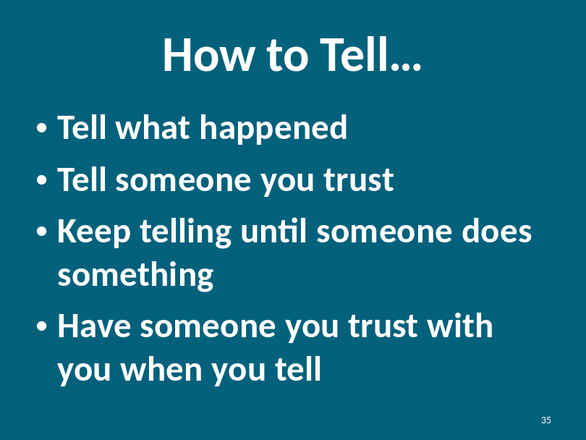  It is never too late to tell.
Slide: 36  Trust |  | We talked about how to tell. Now we are going to talk about who to tell. Of course, we want to tell people we trust.  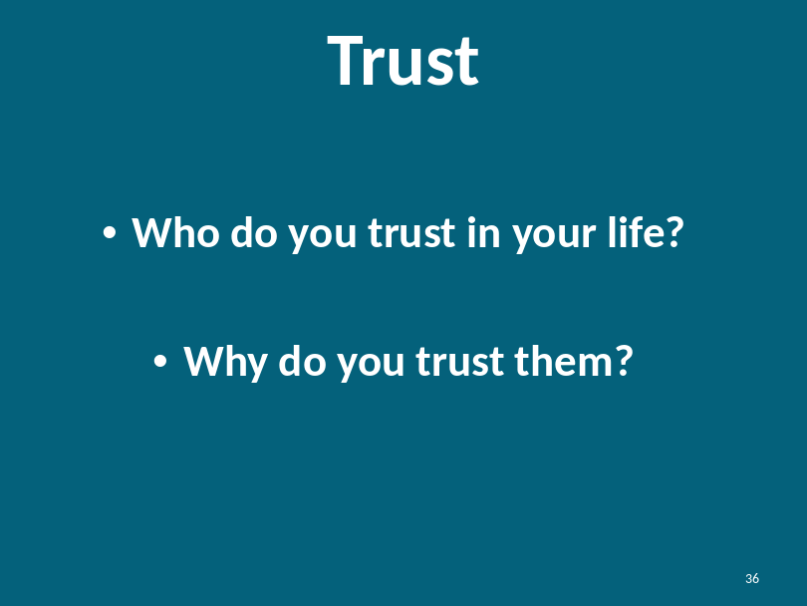
Defining Trust |  | Who do you trust in your life?  Instructor has each participant share with the class one person they trust. Instructor can be the first to share his/her person of trust.  Who is worthy of your trust?  Instructor prompt:  - Someone that makes you feel safe and comfortable  - You can rely on them  - They are honest with you  - They help you when you need help  - You can depend upon them  - Someone you go to when you need help  - Someone you know will help you when you need help  - Person that keeps their promises to you  - Someone you have gotten to know over time as being reliable  You have identified people you trust in your life. Do you see how this list matches up to why you trust them?
Slide: 37  Who Can You Tell? |  | 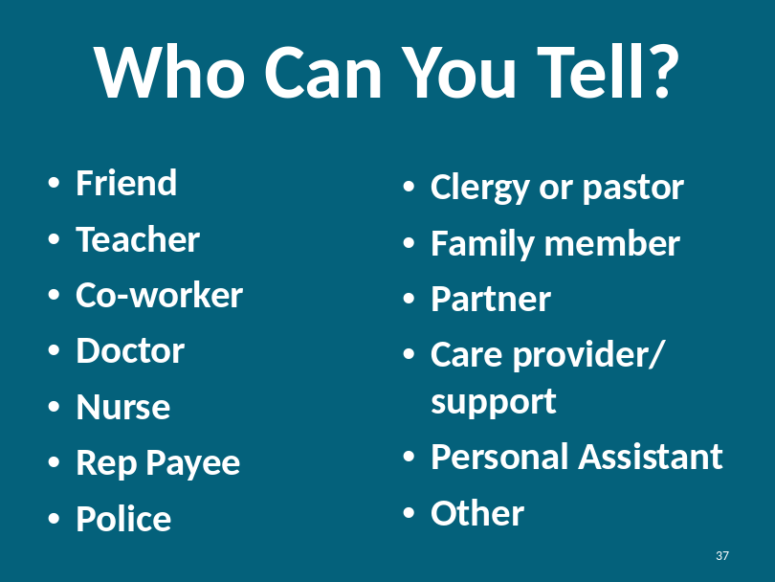  Instructor should explain that sometimes the same people we tell are the same people who may be people who can hurt us. Before you decide who to tell you must decide who you can trust.  Who else can you tell?  Instructor encourages participants to share other ideas.
Who Can You Tell?  Continued |  | Would you ever tell a stranger? When?  Participants share situations when it may be appropriate to tell a stranger:  - When there is no one else to help  - When a stranger sees what is happening and no one else does  - When it becomes a legal issue  - Prompt for other responses from participants
Review what to do if you tell someone and they don’t believe you or do anything about what you tell them?

What do you do if you tell someone and they don’t help you or believe you?
Reiterate the importance of telling others until someone believes you and helps you. You might have to tell multiple people.

Module 3: Part 3: Wrap Up and Resources |  |  |  |  | Estimated Time:  15 minutes
Cues |  |  |  | Content |  | Notes
Slide: 38  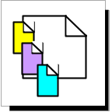  Resources |  |  | 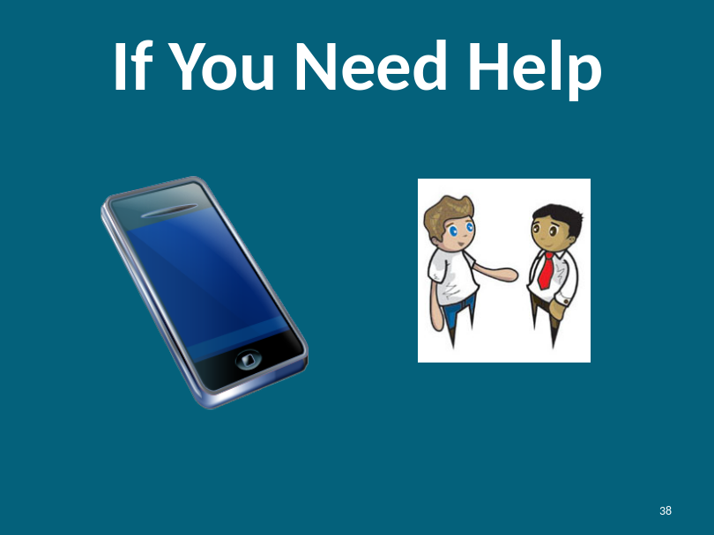  Remember, we talked about how to tell and keep telling until someone helps you. Everyone has the right to be safe. If you need help you can:  - Speak out to family members, care providers or people you trust  - Speak out to staff members at your facility  - Talk to the police if you feel someone is physically abusing you  Instructor should refer to the resource list.
Slide: 39  Wrap Up |  |  | 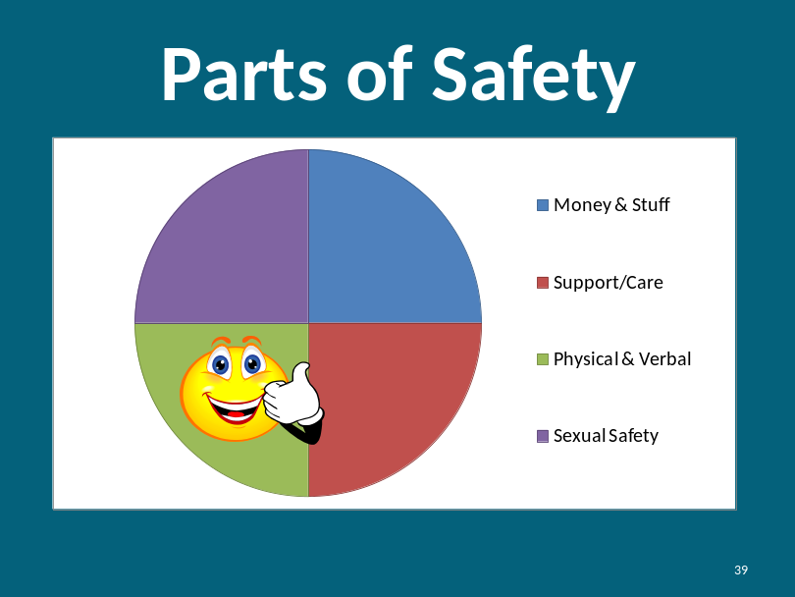  Now we understand how to help keep our bodies safe from abuse. No one deserves to be physically or verbally abused. You have the power to do something about it.  Do you have any questions?
Slide: 40  Rights  Reviewed |  |  | 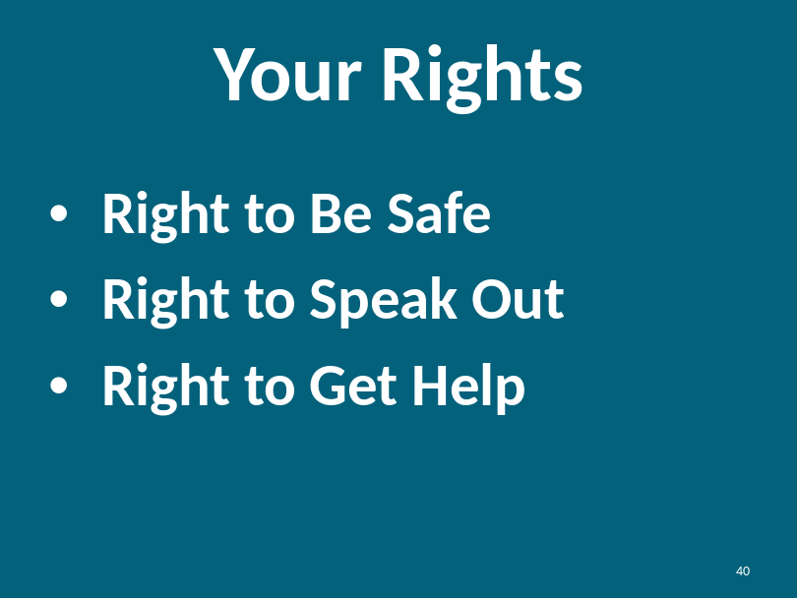  Instructor reviews the rights of every human being.  Next, review the concepts presented throughout the program.
Lesson Review |  |  | REVIEW EXERCISE  Instructor: You can review the concepts by either opening a discussion with the question or seeking answers from participants or you can recite the question and then you can provide a summary of the learning concept.  What is Safety?  Safety is a feeling. If you are safe you won’t get hurt and you are comfortable at home, at work and in your community
What is abuse?
- Abuse is something that someone does to hurt your feelings (heart) or hurts your body
- People abuse because they are trying to control other people
- People can abuse without knowing they are doing it
- Abuse may feel unsafe
- Abuse can be a crime

Intent
First, we need to understand what the abuser intended to do. Did they intend to hurt the victim? Second, we need to determine the impact on the victim. How does the victim feel? Did it hurt their feelings or hurt them physically? Even if the abuser did not intent to hurt the victim, it could still be considered abuse.
What is physical abuse?
- Hitting
- Punching
- Choking
- Slapping
- Pinching
- Poking
- Sexual Assault
- Biting
- Spitting
- Being too rough
What is verbal abuse?
- Name-calling
- Yelling
- Ordering
- Teasing or making fun of
- Threatening
- Criticizing and Judging
- Discounting
- Swearing
- Using a harsh tone

What can you do to protect yourself from abuse?
- Tell the person to stop.
- Tell someone else that might be able to help.

Who do you trust?
We trust people we can count on. People who are always there for us. People, who over time, have proven they are trustworthy.
If you told someone and they didn’t help you, what else would you do?
Continue to tell people until someone helps you and you feel safe.

What else could you do to get help?
Aside from finding someone to help you who is close to you, you can try to reach out to others like clergy or the police.
Refer to the resource list for other potential resources.
What are your rights?
- Right to Be Safe
- Right to Speak Out
- Right to Get Help
Slide: 41  Wrap Up |  |  | 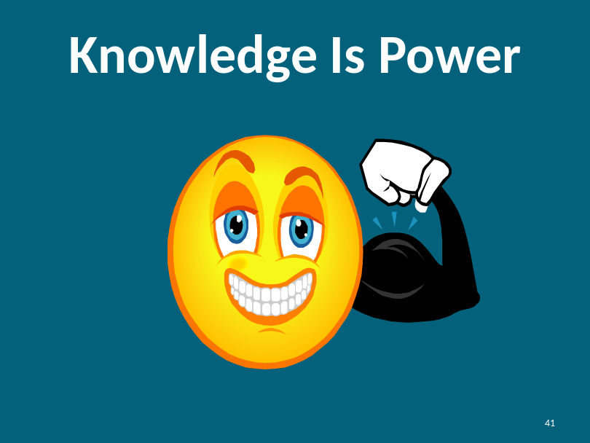  You have increased your power by attending this class. You now have more skills to stay safe. Sometimes bad things can still happen. Remember, it is never your fault if you are abused. Tell someone you trust if this happens. Keep telling someone you trust until you get help.  You now have the power to keep yourself safe.
Share with the group one thing you learned today.

What knowledge did you get here today?

Slide: 42  Thank You! |  |  |   Instructor thanks participants for coming and for sharing their ideas.

