Module Two: Neglect and Withholding Support

Module Objectives:
- Participants will be able to define words
- Participants will be able to talk about experiences
- Participants will learn their rights and responsibilities

Neglect and Withholding Support  (2 hours) | 1 | Getting Started and Introductions and Definitions | - Overview  - Ground Rules  - Icebreaker  - Empowerment  - Three Themes  - Defining Safety  - Defining Terms  - Self Discovery | 50 Minutes
Neglect and Withholding Support  (2 hours) | 2 | Exploring Experiences and Know Your Rights | - Who can take advantage?  - Explore Three Examples  - How to tell | 55 Minutes
Neglect and Withholding Support  (2 hours) | 3 | Review & Wrap Up |  | 15 Minutes
Instructor Key:
- Italics – Prompts and instructions for trainers
- Non-italics – suggested talking points for trainers
- Bold Centered Text – Questions used for group exercises

Materials Needed:
- Flip Chart
- Markers
- Masking Tape
- Participant Name Tents
- Computer with PowerPoint®
- CD Projector and Screen
- Yes and No Cards for each Participant
- Paper and Crayons for Safety Exercise

Module 2: Part 1: Course Overview and Definitions |  |  | Estimated Time:  50 minutes
Cues |  | Content |  | Notes
  List the course’s three main themes and ground rules to be covered. |  | Before your participants arrive, post the three themes of the training and the proposed ground rules on flip charts so everyone can see them. Keep both posted for the entire training.  Three Themes:  - Right to Be Safe  - Right to Speak Out  - Right to Get Help  Ground Rules:  - Only one person talks at a time  - Listen when others are talking  - Turn off/mute cell phones  Optional: Whatever is said here is confidential. Please do not share other’s personal stories outside of this room.  Please be aware that if I learn that someone is being hurt or is hurting someone else, that I will need to find out more information and make sure the person is safe. It is important that everyone is safe.
  Welcome  Clarify the classroom ground rules and review housekeeping information. |  | Before we get started with the training, we need to create some training ground rules. I listed some on the flip chart.  Instructor reads:  - Only one person talks at a time  - Listen when others are talking  - Turn off/mute your cell phone  When acceptable to you, you can ask participants to put their cell phones on vibrate mode. Don’t answer phones during this training.  Are there other ground rules you’d like to add?  Here are some ground rules that were suggested at other trainings:  - Everyone should participate. Please participate freely.  - Be on time. I will start and end on time, so please be here on time so you don’t miss any information.  - Respect the opinions of others. Be respectful of others and what they think  Once each participant has had an opportunity to add a ground rule, ask if there are any other comments and then by a show of hands ask the participants to accept ground rules by saying something like: “Can we all agree on these ground rules?”
Housekeeping:
- You will have:
  - Breaks. (Add the number and length of the breaks; e.g., there will be one 15- minute break.)
  - The restrooms, vending machines, coffee and water are… (provide directions)

 |  | Now that the breaking times and restroom information is out of the way, let’s begin training.
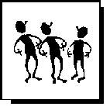  Conduct an ice breaker as an introductory exercise. |  | TIP: People are often hesitant to participate in training programs until they become comfortable with their fellow training participants and the instructor. To help initiate participant interaction, instructors often initiate exercises called “icebreakers” to get people talking and interacting. One of the most common methods to get participants talking is to have them talk about something they know—themselves or their own experiences.
  Slide: 2    Questions for participants |  | Icebreaker Exercise  Using a round robin format, ask each participant to answer one of the following questions. Be sure to let participants know they can pass if they want to, and be sure to take your turn.  The questions below are simple and fun, and serve as a way to have the group interact before getting into module material.  - What is your favorite food?  - What is your favorite TV show?  - What makes you laugh?  - What is your favorite thing?  - What is your favorite holiday?  - What are you most proud of?  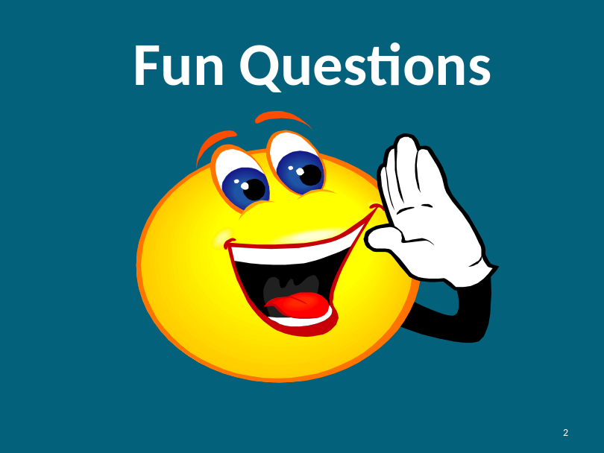  That was great. Thank you.
Slide: 3    Know Your Rights |  | 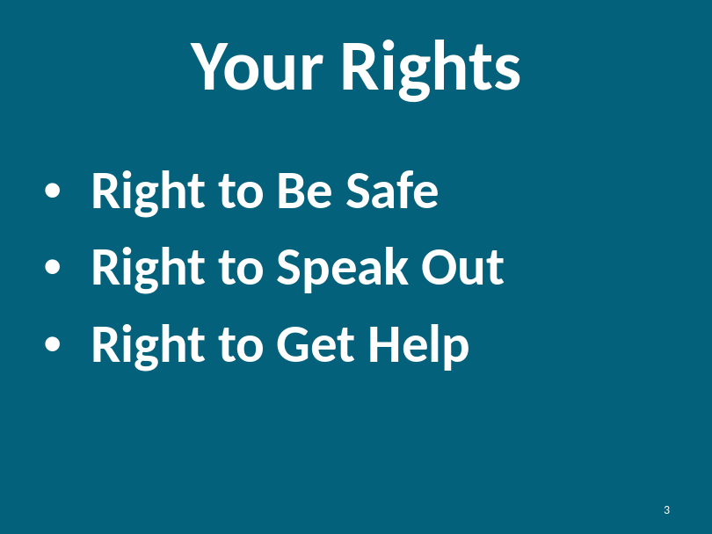  Today we will be talking about your rights. Everyone has the right to be safe, speak out and get help.  - You have the right to be safe at home, at work and in your community  - You have the right to speak out and tell someone if you feel unsafe  - You have the right to get help from others when you don’t feel safe.
Slide: 4  What is Empower-ment? |  | 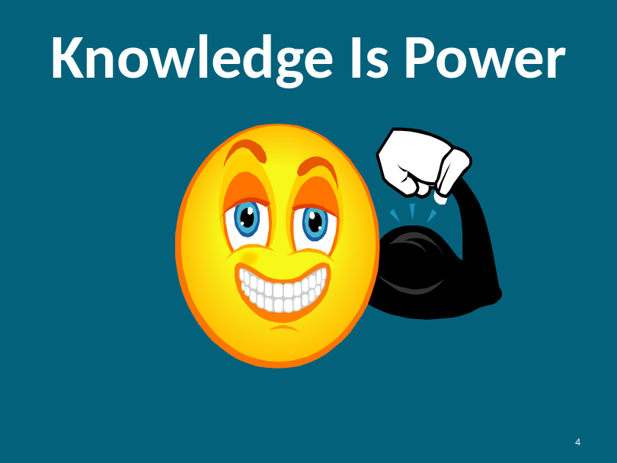  Knowledge is power. When you have knowledge, it helps you to:  - Make wise decisions  - Speak out  - Stay safe  - Know what is right  - Stick up for yourself  Instructor Note:  We have defined empowerment through the phrase “knowledge is power.” Please refer to the Introduction in the overview of the curriculum for more information.
Slide: 5  Defining Safety |  | 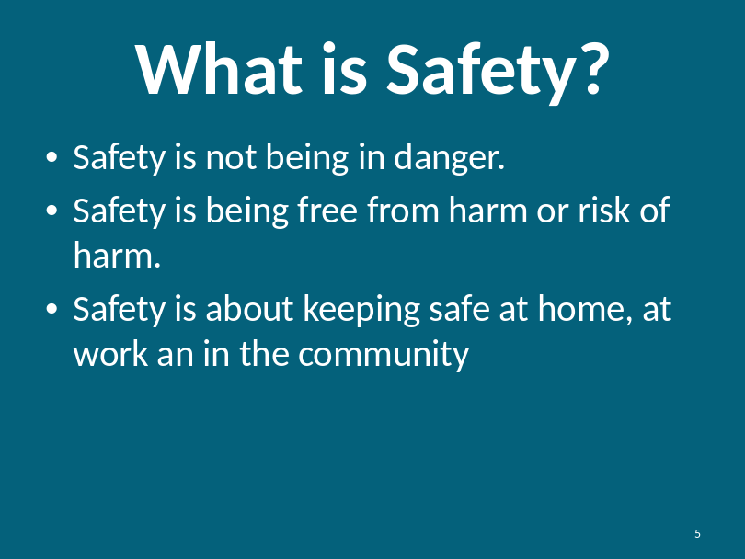  Safety is about not having someone hurt you, take your things or do things that scare you.  Instructor Note:  Remind participants of the Safety Exercise they did during Module #1 (Financial Safety) to help them define what safety means to them. If participants have not taken Module #1, you may optionally provide this exercise at this time.
Slide: 6  Defining Safety |  | 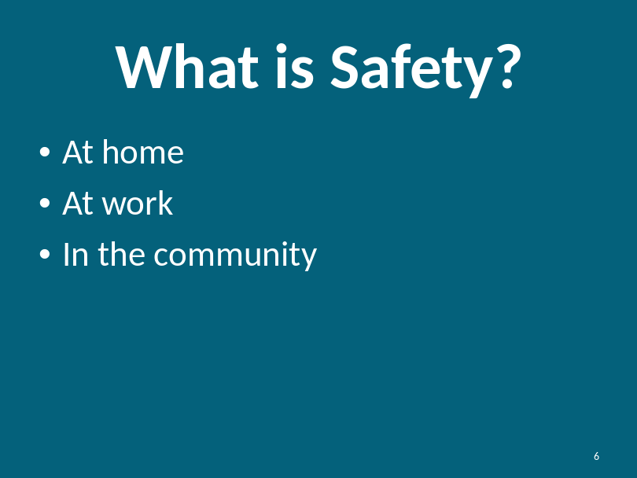  Can you name some ways to stay safe?  How do you keep safe at home?  Examples: locking your window and doors, being careful when you cook, being careful when you take a bath or shower,  Can you think of some other things?  What about safety at work?  Examples: protecting your purse, wallet, lunch, being careful with any tools you may use,  Can you think of other examples?  What about community safety?  Examples: not talking to strangers, using seatbelts, crossing the street at a traffic light.  Can you think of other examples?
Slide: 7  Overview of Safety |  | 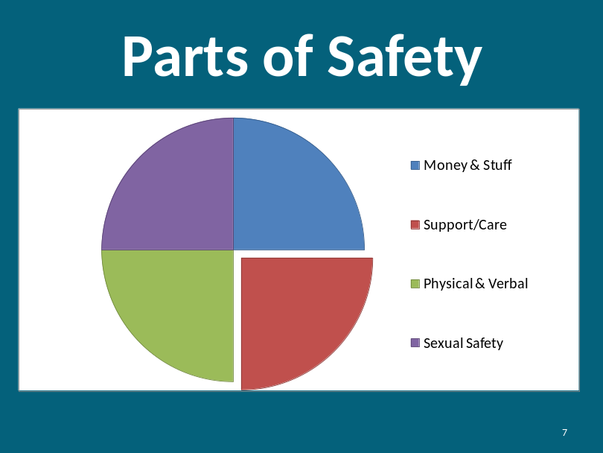  Part of safety is about keeping your money or stuff safe, being safe at home and being safe around others.  Safety is a part of being happy. Everyone has the right to be safe. All parts of your life should be safe.
Slide: 8  Overview of Safety |  | 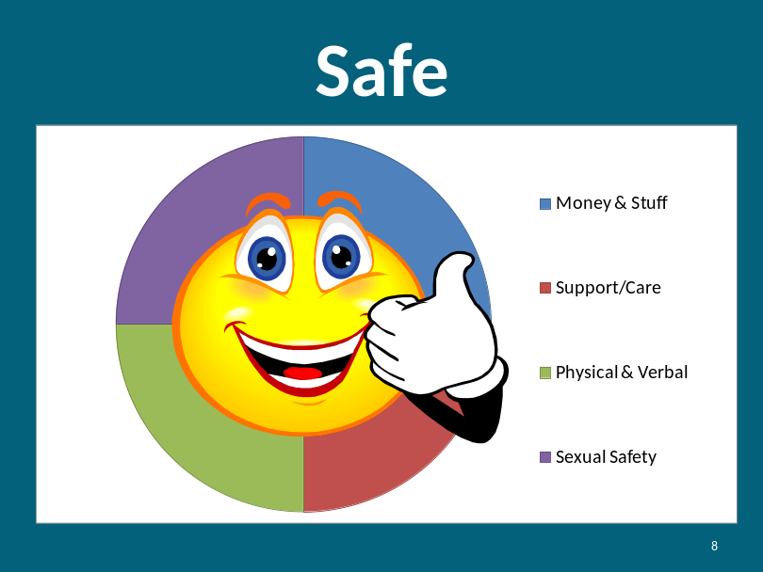
Slide: 9  Overview of Safety  Continued |  | 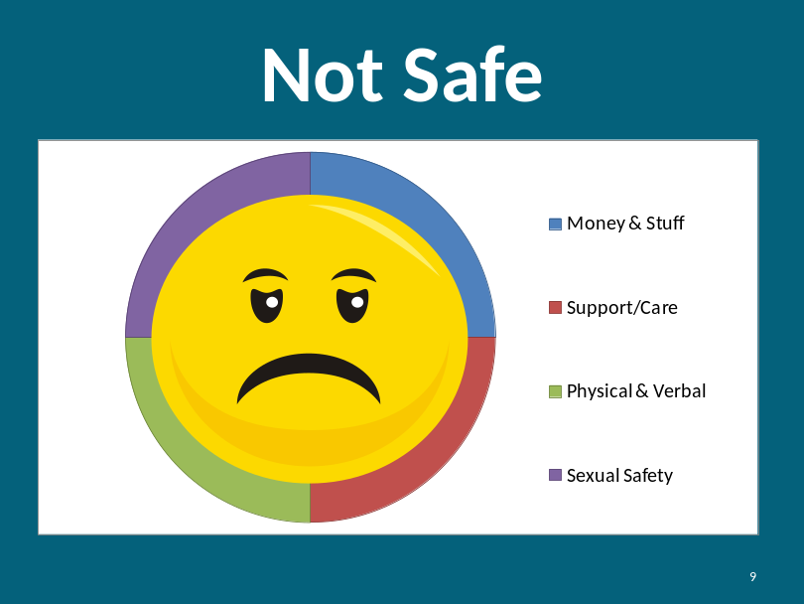  - Sometimes you may not feel safe.  - Sometimes when you are not safe, it makes you feel sad and unhappy.  - You have the right to be happy and safe.  Instructor Note:  In the following section, we discuss a consumer’s right to speak out. It is important to note that “speaking out” may be conducted differently with persons with non-verbal communication techniques. There are a variety of ways to speak out including, but not limited to, sign language, writing, and/or communication devices.
Slide: 10  Know Your Rights:  3 Themes |  | 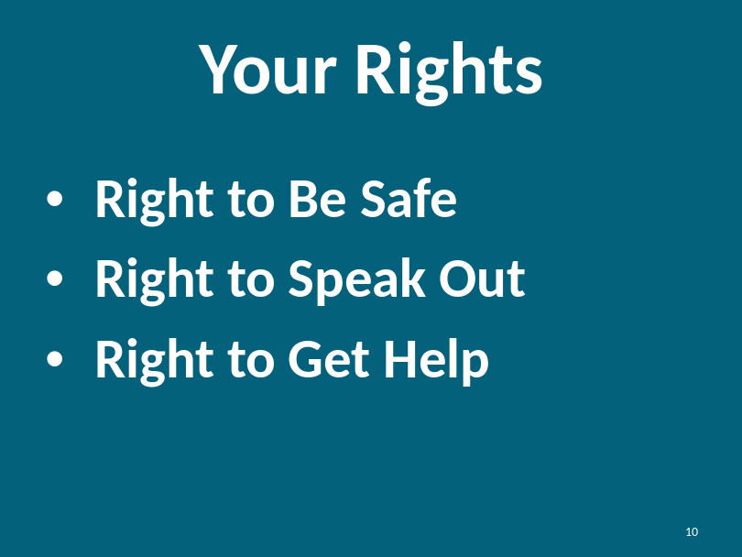  As a reminder, we are going to explore your rights to safety. Remember your drawings? Remember your feelings of safety?  - Right to Be Safe: at home, at work and in the community  What makes you feel not safe? How do you feel when you are not safe? Prompt: scared, worried, angry, sad, hurt or nervous to trust others.  - Right to Speak Out: You have the right to tell if you don’t feel safe.  What does speaking out mean to you? How would you tell a friend to speak out? Who would you speak out to if you didn’t feel safe?  - Right to Get Help: You have the right to have others help you when you are not safe.  We will talk more about how to get help later in the training.
Slide: 11 |  | For today, we are just going to talk about keeping yourself safe from neglect. You will learn some safety tips that you can share with your friends and family.  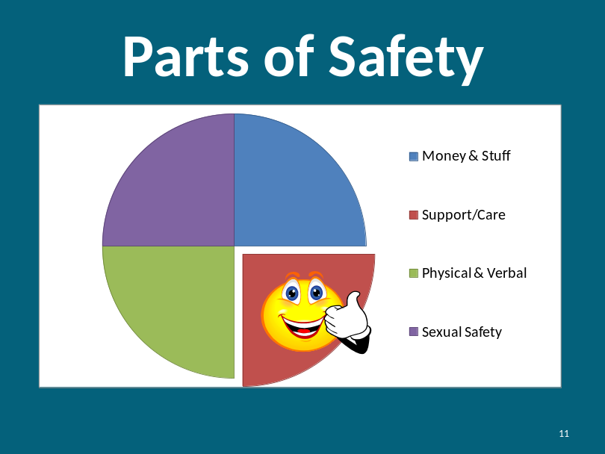
Slide: 12 |  | 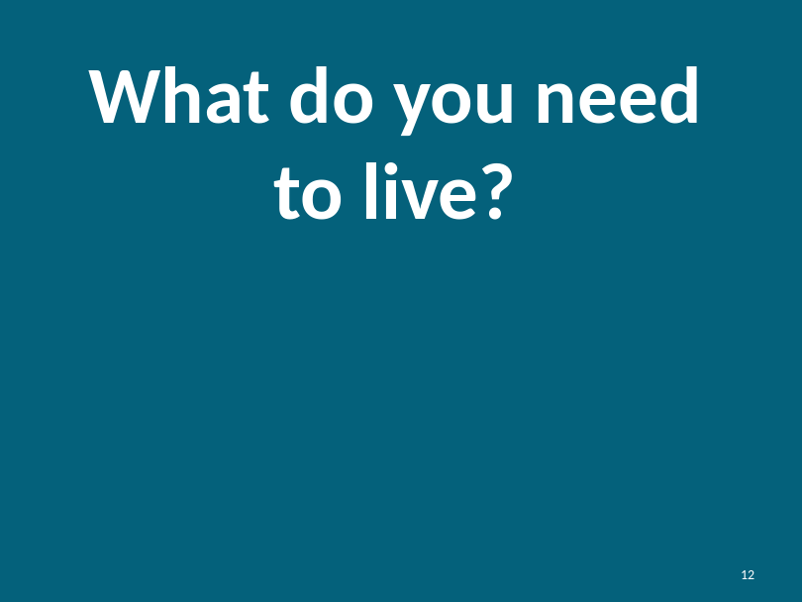
What is needed to live? |  | What Do You Need To Live?  Instructor should prompt the participants to provide the following types of answers:  - Bathroom/ hygiene  - Wheel chair or walker  - Computer and/or communication devices  - Dog  - Medication  - Food  - Place to live  - Belongings  - Transportation – car, bus, van  Trainer should provide personal examples of things they need to live.
What is needed to live?  Reasonble Accomodations |  | For people with disabilities, care and service providers (as well as hospitals, the police, schools, etc.) must accommodate basic needs according to the Americans with Disabilities Act (ADA). Such accommodations may include but are not limited to:  - Interpreters (American Sign Language)  - Captioning  - Reasonable access to bathrooms, bedrooms or other areas  - Alternative formats (Braille, electronic, large print)  For more information on the ADA, check the resources section of the curriculum, or go to www.ada.gov
Slide: 13  What do you need to live? |  | 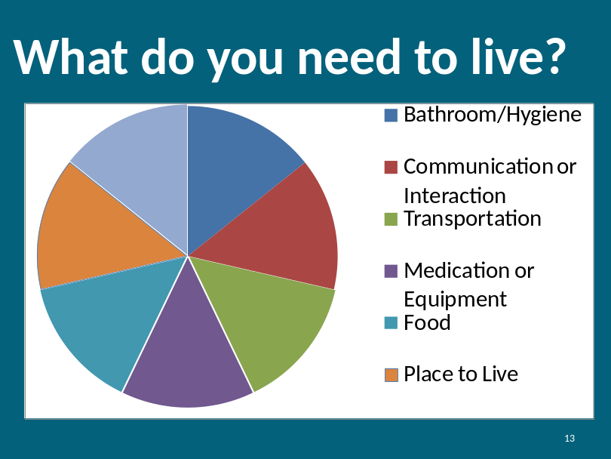
What do you need to live?  Continued |  | Instructor should define and show examples of different things you need to live:  - Bathroom/Hygiene  - Using the toilet  - Taking a bath or shower  - Having supplies like soap and toothpaste  - Communication and Interaction  - Friends and people to talk to  - Communication devices like computers  - Sign language  - Cell phone  - Transportation  - Rides to places you want to or need to go  - Ride to doctor or dentist  - Can be bus, van, taxi or car
What do you need to live?  Continued |  | - Medication or Equipment  - Pills  - Wheelchair or walker  - Breathing machines or oxygen  - Food  - Breakfast  - Lunch  - Dinner  - Place to live  - Belongings  - Books  - iPod/CDs/Music/DVDs  - Special pillow or blanket  - Animal / dog  - TV
Slide: 14  What do you need to live?  Continued |  | 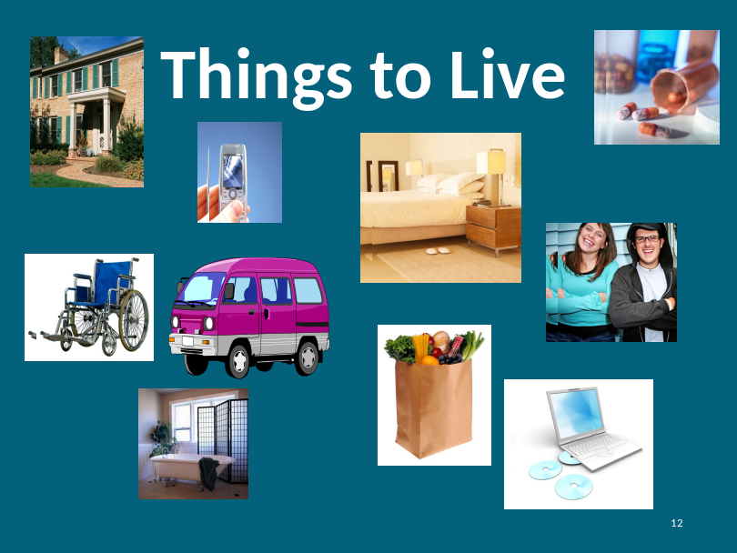  What are things you need to have a happy life?  Instructor: provide some personal examples of things that are productive and that make you happy. Examples: music, your car, a good book
Slide: 15  Needs of people with disabilities |  | 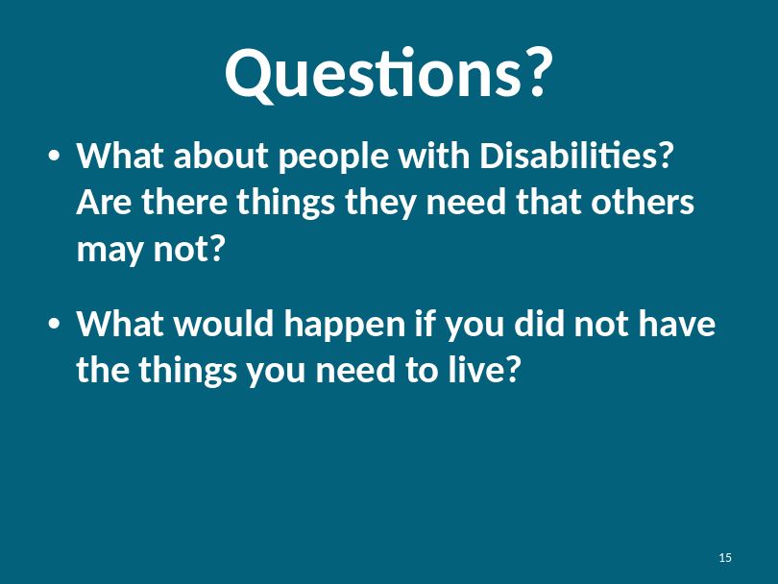
What about people with disabilities? Are there things they need that others may not?

Instructor should prompt responses like wheelchair, medication, walker, cane, translator, computer, communicator or assistant.

What would happen if you did not have the things you need to live?

Instructor will prompt for examples from participants then bring up slide after ideas are given by participants. Prompt for responses like:
- Wouldn’t be able to get to the doctor or the store
- Wouldn’t have the medicine I need. I would get sick.
Slide: 16  Defining Support People or Caregivers |  | 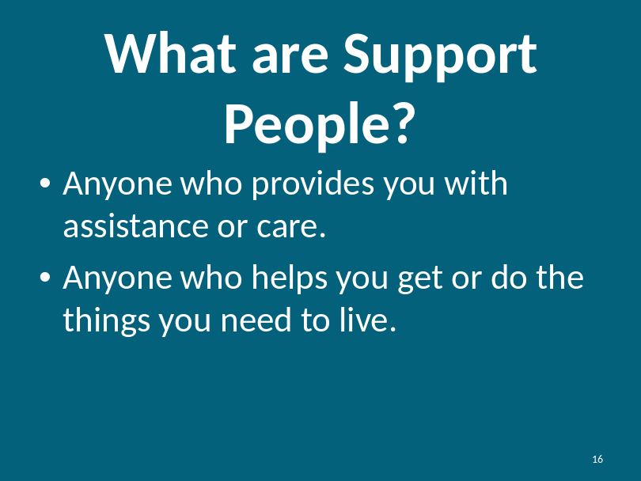
Slide: 17  Defining Support People |  | 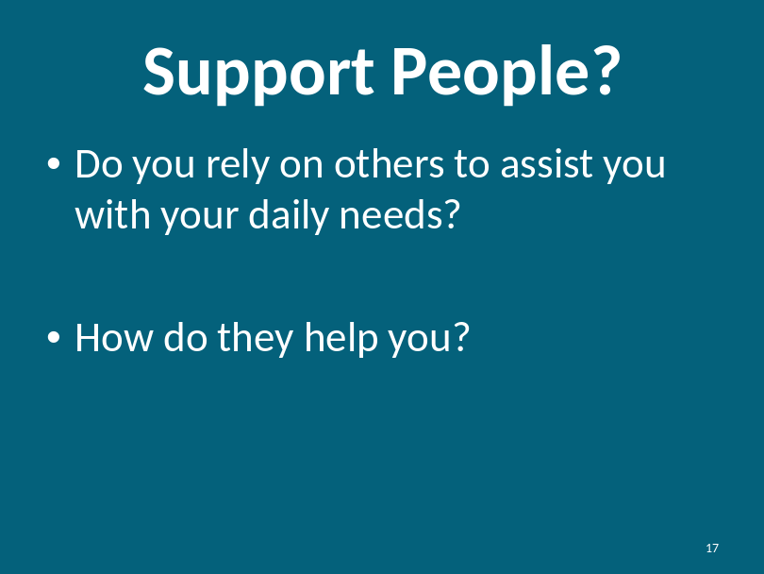
How many of you rely on others for helping you with what you need to live?

Instructor prompts participants to raise their hands.

Tell me how others help you.

Instructor prompts participants to share personal examples. Instructor may want to share ways others help them.
Who provides this help?

Instructor prompts for types of support people or caregivers that might help:
- Parent
- Nurse
- Van or car driver
- Personal assistant
Slide: 18  Defining Support Persons and Caregivers |  | 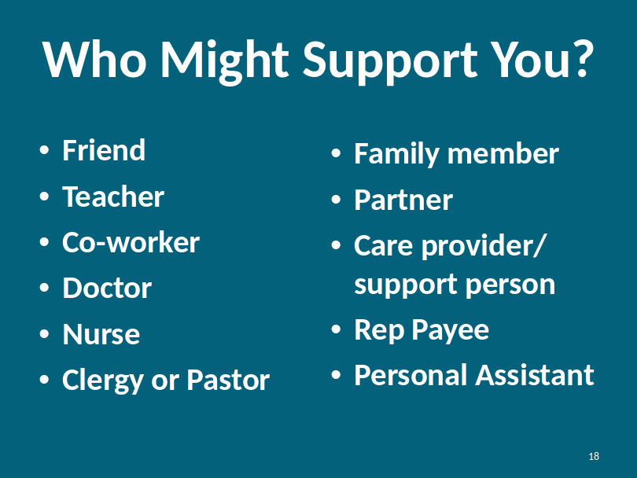
Paid versus Unpaid support persons |  | You may pay people to help you like, a personal assistant or a nurse. However, not all people who help you or support you are paid.
Slide: 19  What is Neglect? |  | 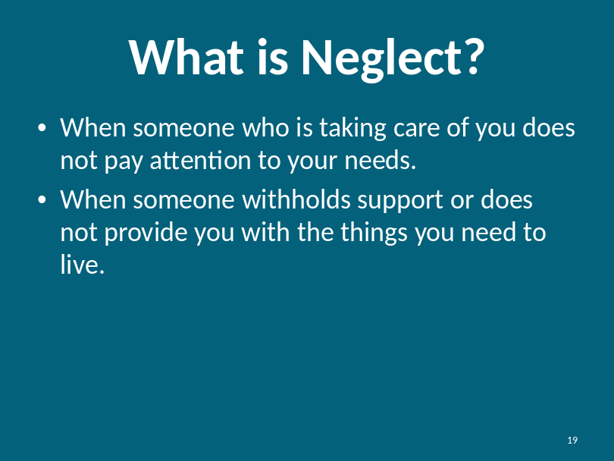  Instructor Note: This subject matter may be sensitive to participants. Be sure to express that not everyone is going to neglect them.
Defining Neglect and Withholding Support |  | Using your Yes and No Cards in front of you… Raise your RED card for Yes if you think the example represents neglect of care or support. Raise your GREEN card for No if you think there is no neglect.  Discuss each example and explore the participants’ answers if they differ. Have them explain their thoughts on the example and suggest ideas for handling the examples of neglect.  - Bill lives in a group home. He has to go to the bathroom. He calls staff, but she doesn’t take him to the bathroom for an hour.  Yes, because everyone has the right to go to the bathroom in a timely fashion. First, Bill should tell the staff person that he needs to go to the bathroom when he calls and that he can’t wait for an hour. Then, Bill should consider notifying a supervisor if this continues to happen.  - Leon needs his diabetes medicine before each meal. Leon’s mom forgets to give it to him today. After reminding his mom, she gives Leon his medicine.  No, Leon’s mom simply forgets to give Leon his medicine. She did not intend to withhold the medication. She gives it to him after being reminded.
Defining Neglect and Withholding Support |  | - Juanita needs her communicator to express herself, Juanita’s assistant moves her communicator away from her when Juanita asks too many questions. Juanita tells her assistant she doesn’t like that, but the assistant does it anyway.  Yes, Juanita has the right to communicate. If she has expressed her needs and they are not being met, she has a right to get help and tell someone else about it.  - Susan needs her walker to go to the bathroom. When the support person changes her sheets, she moves the walker away from the bed. Sometimes the support person forgets to move the walker next to the bed after she finishes changing the sheets.  Yes, Susan needs her walker. Susan should try to talk to the support person first. But if things don’t change, she should tell someone else until she gets help.  One thing to keep in mind when thinking about these examples is that people like Susan’s care provider may not mean to be neglectful, but the result is still neglect. In other modules, we will talk more about intent.
Who Might Neglect You?  Slide: 20  Who might neglect you? |  | 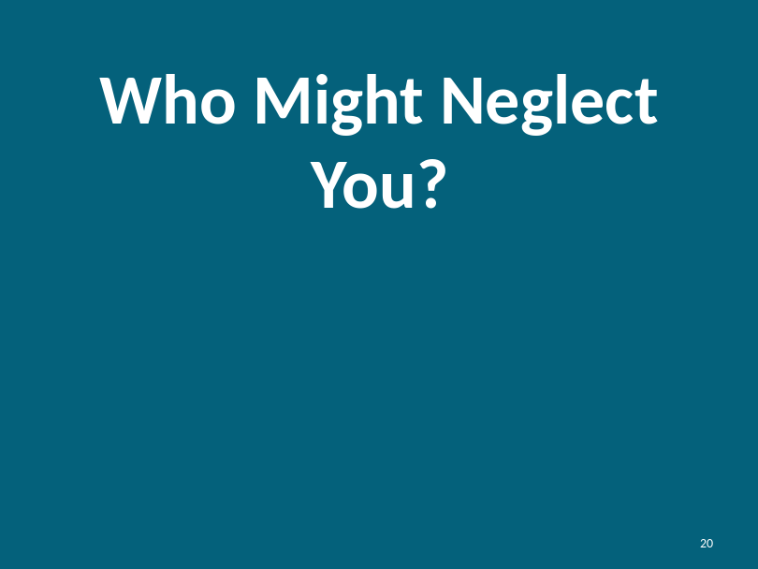  Unfortunately, sometimes people that are supposed to protect you might neglect or hurt you.  Who might neglect you?  Instructor should share a personal example of a situation they are aware of that will help prompt responses.
Slide: 21  Who Might Neglect You? |  | Instructor should use this slide to illustrate the point of who might not care for them the way they should be taken care of.  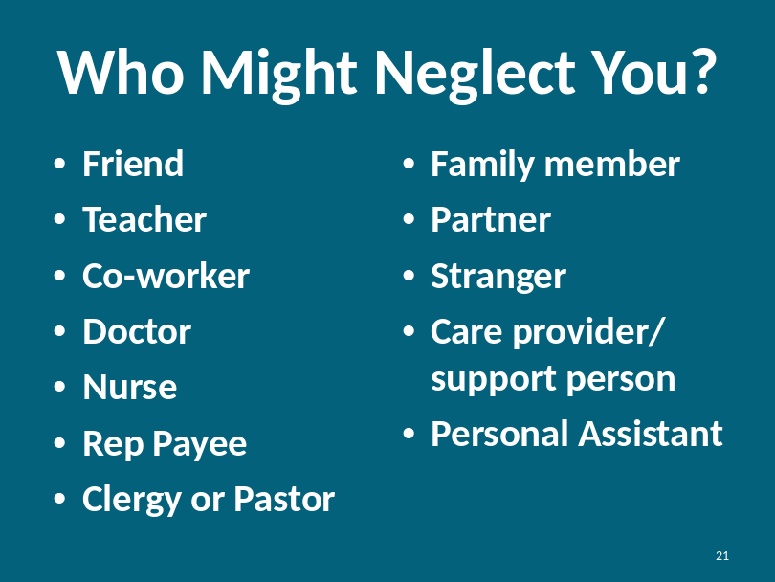  These are just examples of who might neglect you. As we discussed, there might be others.
Slide: 22  Paid vs. Unpaid Staff |  | 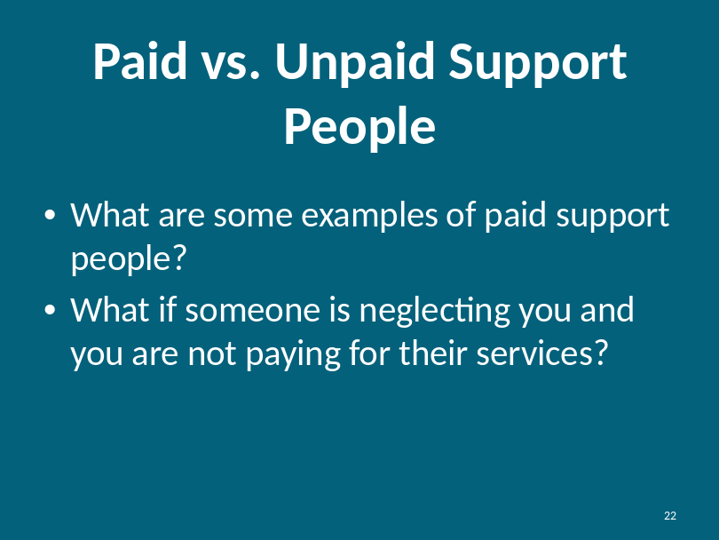
Paid versus Unpaid Support |  | What are some examples of paid support people?  Instructor prompts for examples like: nurse, personal assistant, staff member in a home, family member that you might employ.  When someone is paid to support you, it is their job to take care of you. If they do not do their job, you have some options in how you take care of the situation. You can:  - If they work for you, you can fire them.  - Report them to another staff person or someone who can help.  - Call their agency and report the neglect.  Instructor Note: Be cautious to remind participants to ensure they are safe from physical harm before they confront anyone about neglect.
Paid versus Unpaid Support |  | What if someone is neglecting you and you are not paying for their services?  - Let them know what you need  - If they don’t change, look for someone else to support you.  - Tell others around you what you need.  Instructor asks participants to add additional ideas.
Summarizing your rights regarding neglect |  | You have the right to be provided care. Your care should be kept safe. Sometimes, the people who should take care of you don’t do as good of a job as they can. These can be the same people you trust.  Sometimes these people might not know they are not taking good care of you the way they should.  Anyone could be someone who neglects you—even if they are your friend, co-worker, or care provider, but that doesn’t mean all of these people will neglect you. If someone doesn’t take care of you the way they should, it is your right to speak out and get help!
Slide: 23 |  | 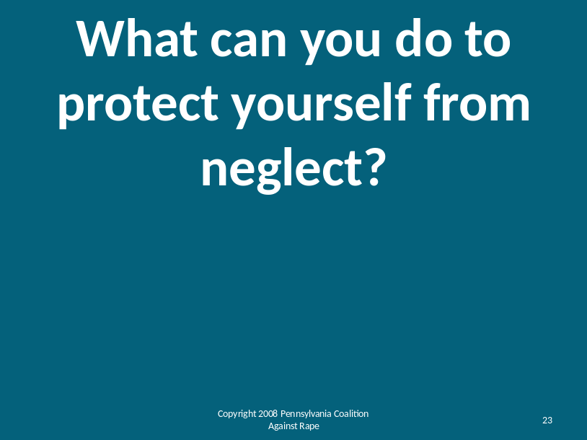
How to Protect Yourself from Neglect? |  | What can you do to protect yourself from neglect?  Instructors prompts responses then gives examples:  There are things you can do to protect yourself from being neglected. These things will help you keep safe:  - If you can hire staff:  - Interview more than one person for the job  - Pick or hire the person you like and who can do the job the best.  - Ask someone to help you interview.  - Create a job description and ask your employee to sign it.  - Periodically, discuss with them your expectations and their performance.  - You are an employer first and a friend second. While it is okay to be friendly, don’t let friendship get in the way of the things you really need.  - Trust your instincts or you gut feelings.  - Clearly communicate your needs. Tell them what you want. Keep telling them to ensure they do as you request.  - Tell them when they aren’t doing what you need. Tell them how to change.  - Seek help from others and tell someone else that might be able to help.  - Surround yourself with a circle of support. These are people you can trust. People who can help you if you are not getting the care you need.  Instructor asks for other ideas that may not have been covered. | Cr
Optional Exercise: Mock Interview |  | OPTIONAL EXERCISE  Depending upon the needs of the participants, instructor may have participants practice an interview with a potential employee.  Participant briefly describes the job duties.  Participant briefly outlines job expectations i.e. be on time, be respectful, be flexible with changing needs.  Participants define two of three important questions they wish to ask prospect i.e. Why did you leave your last employer? Why do you want this job?
Can you tell the person who is neglecting you to stop? (Is that safe?)

Instructor Note: Stress to participants that they must assess the situation to ensure they are not in any physical danger with the person they are telling before they tell.
Exercise: Practice Saying “No” |  | If you don’t want someone to neglect you or hurt you, can say “NO.”  Let’s practice saying “NO.”  Instructor demonstrates the appropriate way to say “No” by using a loud, stern voice, not smiling and looking at the audience in a confident stance.

Exercise: Practice Saying “NO” |  | Why don’t you try…using a loud voice, everyone in the class say “NO.” Repeat a few times.  Instructor observes participants and makes recommendations on things they may need to do when saying “NO.” Some examples:  - Use a loud voice to be sure they know you are serious and they can hear you.  - Try not to smile or giggle when you say “NO.” If you smile or giggle, people may not take you seriously.  - Be confident, sit or stand tall, try to look at the person you are saying “NO” to in the eye.  Now, turn to the person next to you and take turns saying “NO.” I would like you to try this at least 3 times.  Instructor walks around and observes each participant’s efforts to say “NO.” Instructor provides positive reinforcement and concrete tips for each participant on how to improve.  Now, we are going to go around the room. Each of you will show us you’re loudest and most meaningful “NO.”  Instructor encourages the class to clap after each participant says “NO.”

Module 2: Part 2: Exploring Experiences and Knowing Your Rights |  |  | Estimated Time:  55 minutes
Cues |  | Content |  | Notes
Explore three Examples |  | Instructor reads each Example. After each Example is read, the instructor will ask each of the outlined questions in order. The objective is for the instructor to garner participant’s specific answers.  At the appropriate time, the instructor should reinforce the key concepts of each of the Examples about participant rights and safety rules.  Instructor Note: The questions listed after each Example are a starting point for a group discussion. The instructor can tailor questions to the audience and the discussion.
Slide: 24  Example #1 |  | 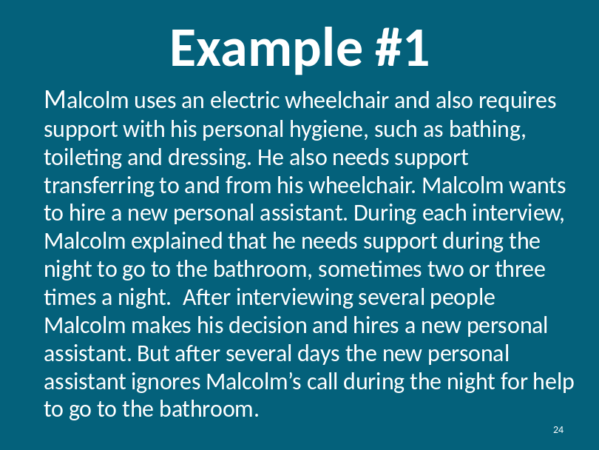
Explore one Example |  | Example #1  Malcolm uses an electric wheelchair and also requires support with his personal hygiene, such as bathing, toileting, and dressing. He also needs support transferring to and from his wheelchair. Malcolm wants to hire a new personal assistant. During each interview Malcolm explained that he needs support during the night to go to the bathroom, sometimes two or three times a night. After interviewing several people Malcolm makes his decision and hires a new personal assistant. But after several days the new personal assistant ignores Malcolm’s call during the night for help to go to the bathroom.  Refer to the Your Rights poster in the room and prompt:  Let’s remember the rights we discussed in the beginning.  Questions to ask:  What should he do?  For each response, ask “Why?”  - Malcolm should provide the assistant with a three month probation period upon hiring  - Explain to the employee that if they do not comply with your expectations you will have no choice but to find someone who will  - Even after the probation period, if the employee is not performing his duties, Malcolm can fire him
Slide: 25  Example #2 |  | 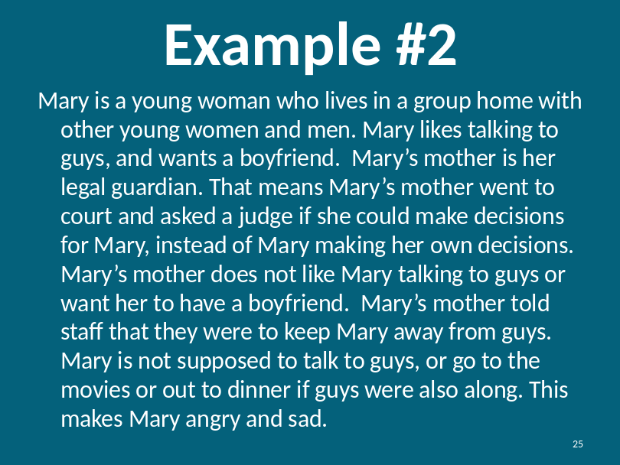
Explore one Example |  | Example #2  Mary is a young woman who lives in a group home with other young women and men. Mary likes talking to guys, and wants a boyfriend. Mary’s mother is her legal guardian. That means Mary’s mother went to court and asked a judge if she could make decisions for Mary, instead of Mary making her own decisions. Mary’s mother does not like Mary talking to guys or want her to have a boyfriend. Mary’s mother told staff that they were to keep Mary away from guys. Mary is not supposed to talk to guys, or go to the movies or out to dinner if guys were also along. This makes Mary angry and sad.  Refer to the Your Rights poster in the room and prompt:  Let’s remember the rights we discussed in the beginning.  Questions to ask:  What should Mary do?  For each response, ask “Why?”  - Mary should talk to her mother about her rights. She is an adult and has the right to make friends and talk to men  - Mary could go back to the judge and ask for the ability to make her own decisions  - Mary and her mother could get counseling to help both of them  - Mary can get training on how to manage appropriate relationships
Slide: 26  Example #3 |  | 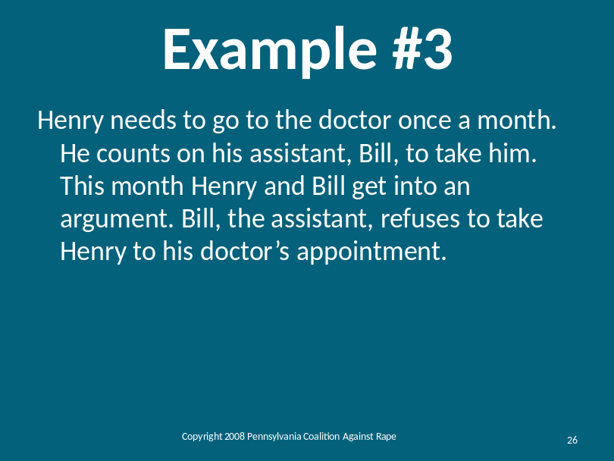
Explore one Example |  | Example #3  Henry needs to go to the doctor once a month. He counts on his assistant, Bill, to take him. This month Henry and Bill get into an argument. Bill, the assistant, refuses to take Henry to his doctor’s appointment.  Refer to the Your Rights poster in the room and prompt:  Let’s remember the rights we discussed in the beginning.  Questions to ask:  What should Henry do?  For each response, ask “Why?”  - Calmly discuss the issue with Bill  - Find someone else to take you to the doctor  - Tell Bill you will fire him if he doesn’t do what you need  - Have a back-up plan of another person who can help Harry if something like this happens  - Harry can get help from the agency that helped him hire Bill
Slide: 27  Why is it hard to tell? |  | 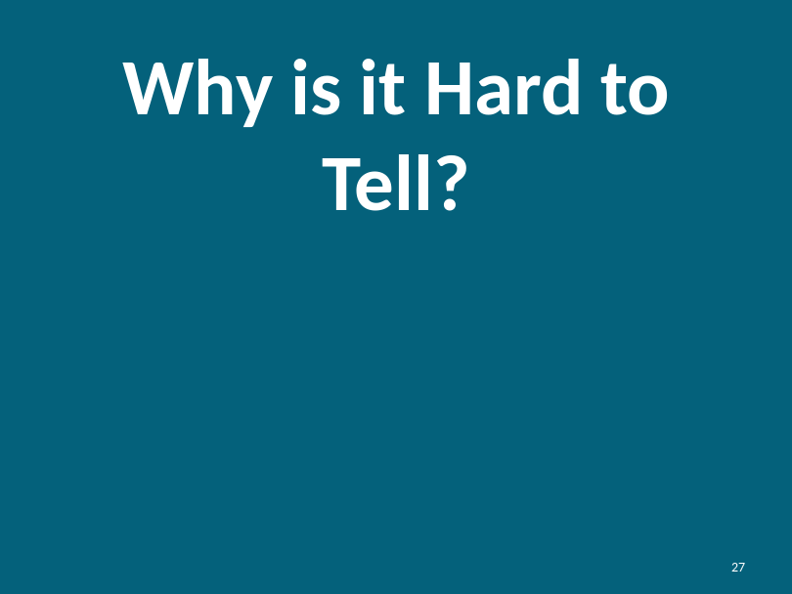  Instructor prompts:  - Scared of getting hurt or of getting in trouble  - Guilty for letting this happen to me  - I think it may be my fault somehow  - Embarrassed by what happened  - Don’t want to get someone in trouble  - Uncomfortable sharing the information  - Don’t like talking to people I don’t know
Optional |  | OPTIONAL EXERCISE  Has there been a time when it was difficult for you to tell? What happened?  Be aware that this question can lead to disclosure. It is important for the instructor to judge his/her participants and determine if this would be an effective exercise to use.  Instructor should provide one example from their own personal history.
Do you remember when we practiced saying “NO?” We talked about how important it is to be serious and say “NO” in a powerful way. When we tell someone that something wrong has happened or that someone has taken something from us, we need to use these same tips.

These are tools on how to tell if you think someone is abusing you or taking your things without your permission.

Slide: 28  How to Tell |  | 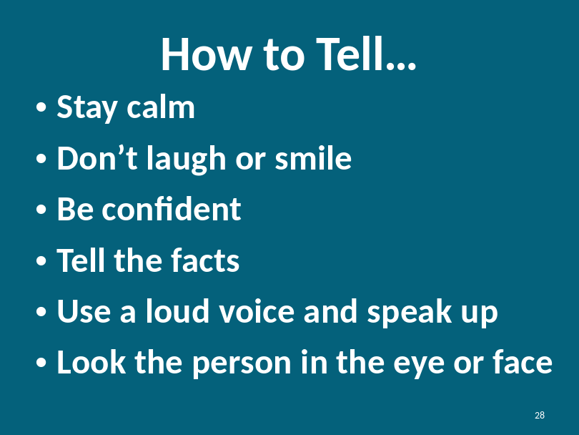
How to Tell |  | We discussed how hard it is to tell. Sometimes we feel uncomfortable or embarrassed to tell others when bad things happens.  When we are scared sometimes we raise our voice, cry or yell. It is important that we stay calm when telling so that they can understand what we are saying and help us to tell the whole story.  Sometimes when we are embarrassed we may smile, laugh or giggle. When we smile or laugh, it is hard for the person who we are telling to understand that we are not safe.
How to Tell |  | Even though you may think some of the story is not relevant, don’t hold back anything when telling what happened. The more information you provide, the more people can help you.  No matter what happens be confident in what you have to say. Even though it may be very difficult, try to look the person you are telling in the eye. This shows your confidence in yourself and the truth.  It is disappointing and frustrating when we tell someone something and we are not believed or helped. This is not your fault. If this happens to you, tell someone else until someone helps you. Keep telling until you are safe.  It can be hard to tell but it is important to tell. Sometimes how we tell can affect how people believe us.
Slide: 29  How to Tell Continued |  | 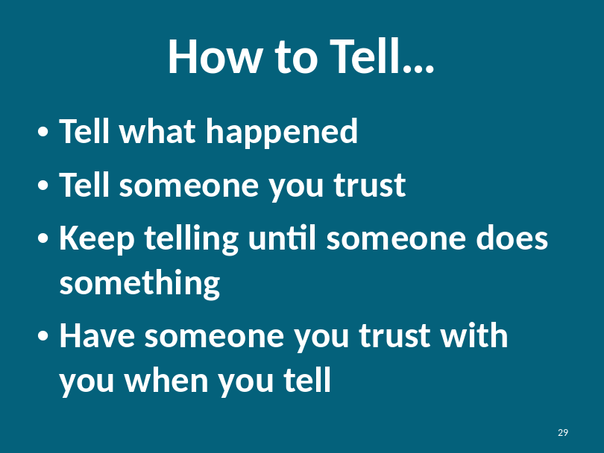  It is never too late to tell.
Slide: 30  Trust |  | We talked about how to tell. Now we are going to talk about who to tell. Of course, we want to tell people we trust.  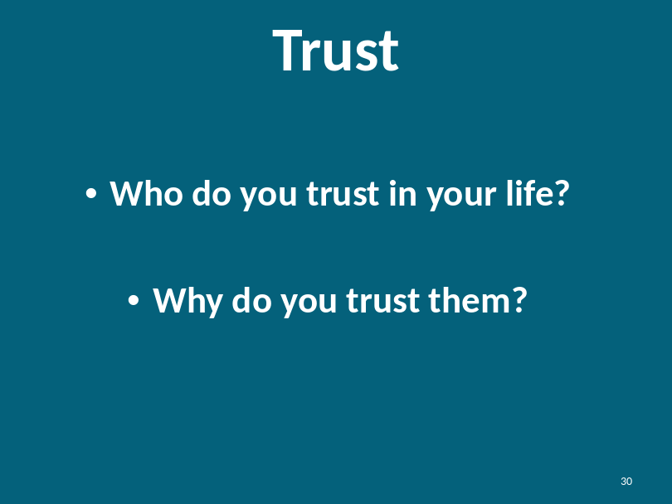
Defining Trust |  | Who do you trust in your life?  Instructor has each participant share with the class one person they trust. Instructor can be the first to share his/her person of trust.  Who is worthy of your trust?  Instructor prompt:  - Someone that makes you feel safe and comfortable  - You can rely on them  - They are honest with you  - They help you when you need help  - You can depend upon them  - Someone you go to when you need help  - Someone you know will help you when you need help  - Person that keeps their promises to you  - Someone you have gotten to know over time as being reliable  You have identified people you trust in your life. Do you see how this list matches up to why you trust them?
Slide: 31  Who Can You Tell? |  | 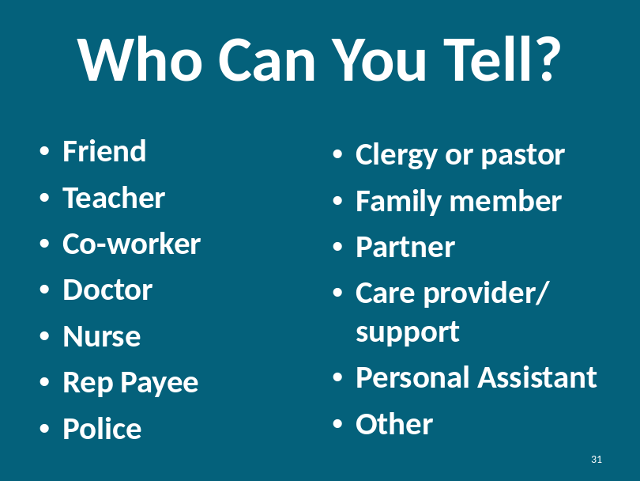  Instructor should explain that sometimes the same people we tell are the same people who may be people who can hurt us. Before you decide who to tell, you must decide who you can trust.  Who else can you tell?  Instructor encourages participants to share other ideas.
Who Can You Tell?  Continued |  | Would you ever tell a stranger? When?  Participants share situations when it may be appropriate to tell a stranger:  - When there is no one else to help  - When a stranger sees what is happening and no one else does  - When it becomes a legal issue  - Prompt for other responses from participants
Review what to do if you tell someone and they don’t believe you or do anything about what you tell them?

What do you do if you tell someone and they don’t help you or believe you?
Reiterate the importance of telling others until someone believes you and helps you. You might have to tell multiple people.

Module 2: Part 3: Wrap Up and Resources |  |  |  |  | Estimated Time:  15 minutes
Cues |  |  |  | Content |  | Notes
Slide: 32    Resources |  |  | 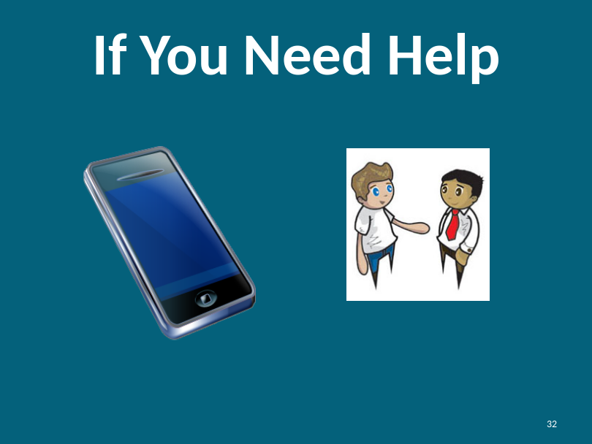  Remember, we talked about how to tell and keep telling until someone helps you. Everyone has the right to keep their body safe. If you need help you can:  - Speak out to staff members at your facility  - Speak out to family members, care providers or people you trust  - Talk to the police if you feel someone is neglecting or hurting you.  Instructor should refer to the resource list.

Module 2: Part 3: Wrap Up and Resources |  |  | Estimated Time:  10 minutes
Cues |  | Content |  | Notes
Slide: 33  Wrap Up |  | 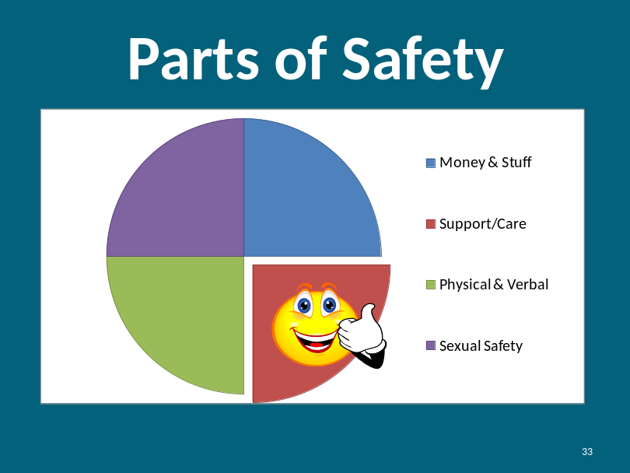  Now we understand how to keep you safe and how to protect yourself against neglect.  Do you have any questions?
Slide: 34  Rights  Reviewed |  | 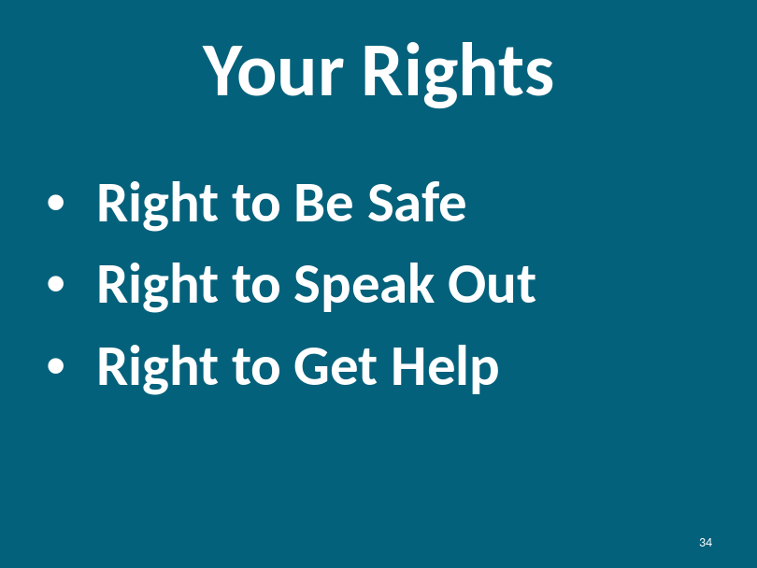  Instructor reviews the rights of every human being.  Next, review the concepts presented throughout the program.
Lesson Review |  | REVIEW EXERCISE  Instructor: You can review the concepts by either opening a discussion with the question or seeking answers from participants or you can recite the question and then you can provide a summary of the learning concept.  What is Safety?  Safety is a feeling. If you are safe you won’t get hurt and you are comfortable at home, at work and in your community
What do you need to live?
- Bathroom/ hygiene
- Wheelchair or walker
- Computer and/or communication devices
- Dog
- Medication
- Food
- Place to live
- Belongings
- Transportation – car, bus, van
What are support people or caregivers?
- Anyone who provides assistance or care to you.
- Anyone who helps you get or do the things you need to live
What is neglect?
- When someone who is taking care of you does not pay attention to your needs.
- When someone withholds support or does not provide you with the things you need to live.
How can you protect yourself against neglect?
Clearly define the job, your needs and expectations. Create a support system where you have back-up resources and people you can tell if something goes wrong.
Who do you trust?
We trust people we can count on. People who are always there for us. People who, over time have proven they are trustworthy.
If you told someone and they didn’t help you, what else would you do?
Continue to tell people until someone helps you and you feel safe.

What else could you do to get help?
Aside from finding someone to help you who is close to you, you can try to reach out to others like clergy or the police.
Refer to the resource list for other potential resources.
What are your rights?
- Right to Be Safe
- Right to Speak Out
- Right to Get Help
Slide: 35  Wrap Up |  |   You have increased your power by attending this class. You now have more skills to stay safe. Sometimes bad things can still happen. Remember, it is never your fault if you are abused. Tell someone you trust if this happens. Keep telling someone you trust until you get help.  You now have the power to keep yourself and your support and care safe.
Instructor asks each participant to openly share just one thing they learned today using either of the following two questions:

Share with the group one thing you learned today.
OR
What knowledge did you get here today?

Slide: 36  Thank You! |  |   Instructor thanks participants for coming and for sharing their ideas.

