Care Provider: Understanding Abuse and Your Responsibilities

Module Objectives:
- Participants will be able to identify different types of abuse.
- Participants will learn about the rights of the people they care for.
- Participants will learn about their responsibilities related to protecting the people they care for.

Care Provider | 1 | Getting Started, Power and Control, and Defining Abuse | - Overview  - Ground Rules  - Icebreaker  - Power and Control  - Defining Abuse | 90 Minutes
Care Provider | 2 | Examples of Abuse & Power and Control | - How to Tell  - Explore abuse examples  - Resources | 90 Minutes

Materials Needed:
Instructor Key:
- Italics – Prompts and instructions for trainers.
- Non-italics – suggested talking points for trainers.
- Bold Centered Text – Questions used for group exercises.

- Flip Chart
- Markers
- Masking Tape
- Participant Name Tents
- Computer with PowerPoint®
- CD Projector and Screen
- Pens for Pen Activity
- Power and Control Wheel

Part 1: Course Overview and Definitions |  |  |  | Estimated Time:  90 minutes
Cues |  |  | Content |  | Notes
  List the course’s ground rules. |  |  | Before your participants arrive, post the proposed ground rules on flip charts so everyone can see them. Keep both posted for the entire training.  Ground Rules:  - What is said here stays here  - Only one person talks at a time  - Listen when others are talking  - Turn off/mute cell phones  Whatever is said here is confidential. Please do not share other’s personal stories outside of this room.  Please be aware that if I learn that someone is being hurt or is hurting someone else that I will need to find out more information and make sure the person is safe. It is important that everyone is safe.
  Welcome  Clarify the classroom ground rules and review housekeeping information. |  |  | Before we get started with the training, we need to create some training ground rules. I listed some on the flip chart.  Instructor reads:  - Only one person talks at a time  - Listen when others are talking  - What is said in here stays in here  - Turn off/mute your cell phone  When acceptable to you, you can ask participants to put their cell phones on vibrate mode. Don’t answer phones during this training.  Are there other ground rules you’d like to add?  Here are some ground rules that were suggested at other trainings:  - Everyone should participate. Please participate freely.  - Be on time. I will start and end on time, so please be here on time so you don’t miss any information.  - Respect the opinions of others. Be respectful of others and what they think.  Once each participant has had an opportunity to add a ground rule, ask if there are any other comments and then by a show of hands ask the participants to accept ground rules by saying something like: “Can we all agree on these ground rules?
Housekeeping:
- You will have:
  - Breaks. (Add the number and length of the breaks; e.g. there will be one 15- minute break.)
  - The restrooms, vending machines, coffee and water are… (provide directions)

 |  |  | Now that the break times and restroom information is out of the way, let’s begin the training.
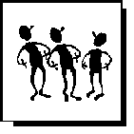  Conduct an icebreaker as an introductory exercise. |  |  | TIP: People are often hesitant to participate in training programs until they become comfortable with their fellow training participants and the instructor. To help initiate participant interaction, instructors often initiate exercises called “icebreakers” to get people talking and interacting. One of the most common methods to get participants talking is to have them talk about something they know- themselves or their own experiences.
  Icebreaker question |  |  | Why are you here?  What do you hope to learn today?
  Slides: 2  Objectives    Participant Handout |  |  | 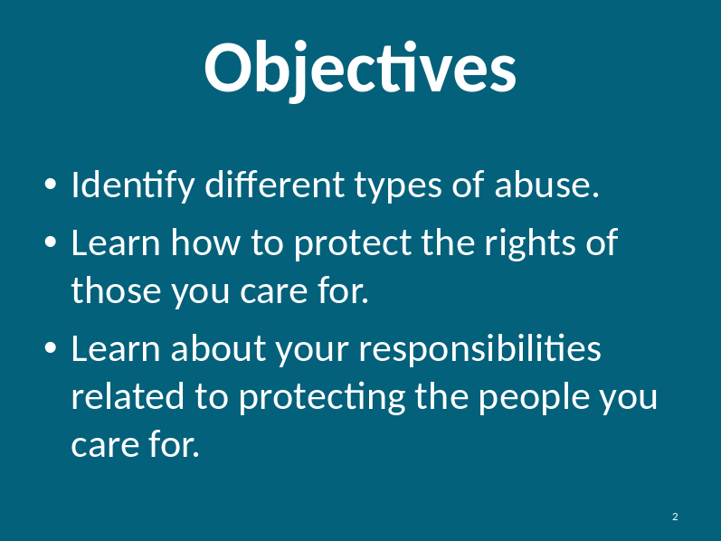  Page 2 in the Participant Handout
Slide: 3 |  |  | 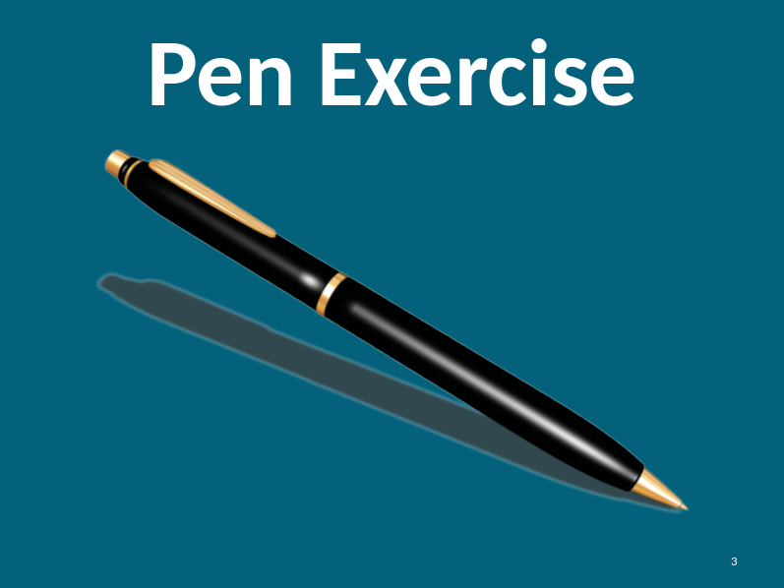
Pair participants with another classmate. Provide each pair with a pen to use for the exercise.

If there are participants who physically cannot participate or are not willing to participate, have them observe another pair.

Pen Exercise |  |  | - First participant holds pen.  - Second participant closes his/her eyes and asks for the pen.  - The controller of the pen does not comply.  Provide a series of instructions that restricts control. For example, use only one arm, you cannot move from your position, use you’re least dominant hand only.  - Participants switch.
Discuss Power and Control |  |  | How did that make you feel?  Prompts:  - Helpless  - Loss of control  - Dependent  - Frustrated  - Angry  Did this provide any insights on how people with disabilities might feel on a daily basis?  Have participants explain the insights. Look for more complete answers than a simple yes.  This exercise should have given you some sense of power and control. All care providers have some power over the people they care for. This exercise should have given you a sense of the frustration people with disabilities might feel when they do not have control.
Participant Handout  Introducing Power and Control |  |  | Instructor Note: On a flip chart record participants answers to each of the below questions. Post their answers to each question on the wall around the classroom before beginning the next exercise.  Page 3 in the Participant Handout  What is Power?  - Power is a noun.  - Ability to make decision for yourself or someone else  - Ability to influence others  - Ability to do what you want  - Ability to act  - Possession of authority. Not necessarily using the authority.  The person aims to acquire and employ power in the relationship. For example, the person may use force or threats of physical harm to intimidate another person, thereby gaining physical and emotional power over that person. Or, the person may force the person with a disability to relinquish control over the person they care for and thereby gain financial power.  Every care provider has power. Not all power is negative. When a care provider crosses the line and takes advantage of his/her power, it becomes abuse.
Introducing Power and Control |  |  | What is Control?  - Control is a verb.  - To exercise restraining or directing influence  - Control situation  - Control others behaviors  With sufficient power, a person can control others – forcing or coercing him/her to do as the person wishes. For example, with power, an abuser may control decision-making, restrict access to another’s needs and may control social contact.
How are Power and Control interrelated, how are they different?
- Power is a noun describing ability and Control is a verb describing an action.
- Control is doing or committing an act while Power is the ability to have influence over someone or something with no action involved.
- Abuse begins when one takes advantage of their Power and crosses the line to Control another person
Slide: 4  Power & Control  Violence  :  Power and Control  Participant Handout  Group Exercise |  |  | Instructor Note: Have participants refer to a larger version in the Participant Handout on page 4.  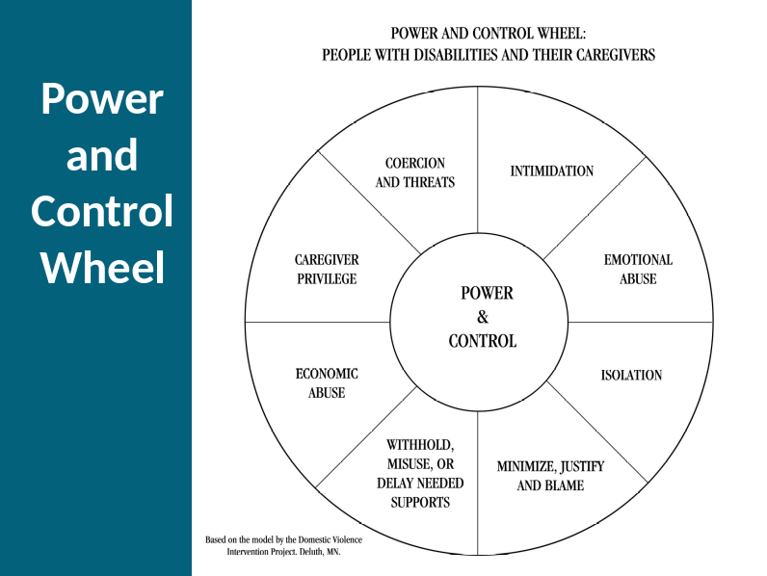  Group exercise:  - Split participants in small groups of 2-4 participants.  - Assign each group the task of reviewing one or two of the violence types on the chart. For example, have one group review Coercion and Threats and Intimidation while another group reviews Caregiver Privilege and Economic Abuse.  - Within each subgroup, participants should share examples of such abuse.  - After each subgroup discusses examples, they will then share general impressions with the class.
Slide: 5  Equality Wheel  Power and Control  Participant Handout  Optional Group Exercise |  |  | As we could see from some of the examples you shared, abuse may not always be intentional on the part of the abuser. Nonetheless, it is still abuse.  The first step in stopping abuse is to understand it. Our understanding will help us to not only identify abuse but to role model appropriate behaviors.  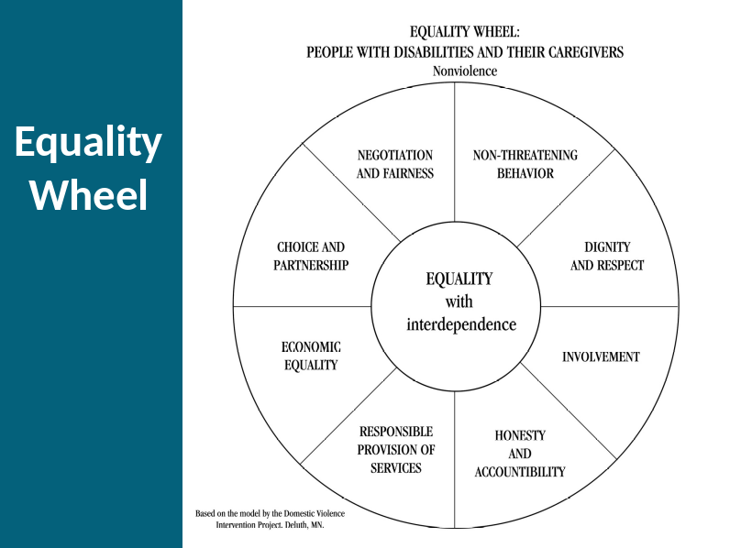  Optional Group exercise:  - Subgroups from the last exercise regroup.  - Using the Nonviolence wheel on page 6 in the Participant Handout, assign each group the corresponding nonviolent behaviors.  - Each subgroup compares these behaviors to the corresponding violent behaviors discussed in the last exercise.  - After each subgroup discusses examples, they will then share general impressions with the class.
Slide: 6  Power and Responsibility |  |  | 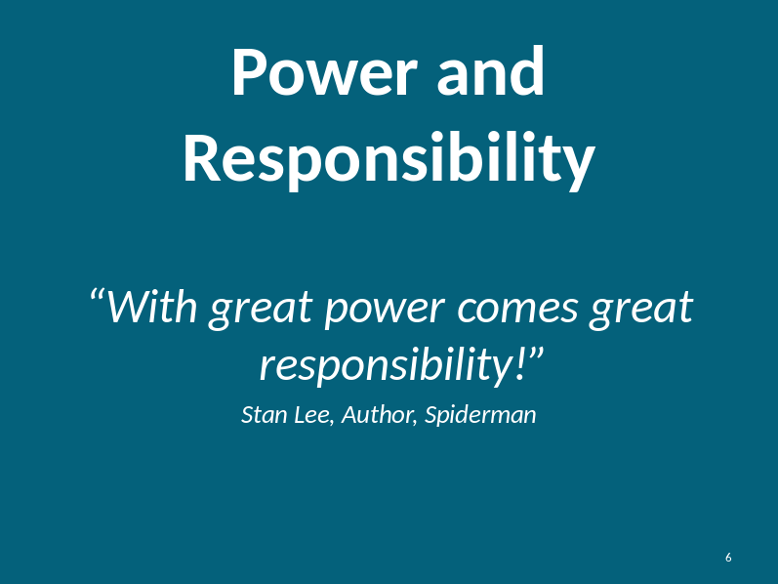  Remember the pen exercise?  We got to feel what it is like to feel powerless. We may forget or not realize the great power we have over the people we care for.  It is our responsibility to use that power fairly and wisely. Putting ourselves in the place of people with disabilities and their needs will help us to be more empathetic to their situation.  Always remember, this is someone’s life. We could be abusive to someone without even knowing it.  Everyone has the right to be safe, to speak out and to get help.
Participant Handout  Group exercise and worksheet |  |  | Instructor Note:  - Utilizing the worksheet on page 8 in the Participant Handout, first have participants answer the three questions by themselves.  - Then have them discuss their answers with a partner or small group.  - Lastly, have the participants discuss their findings with the class.
  Question | Your Response
  What does safety mean to you? List at least 3 words that describe safety. | Examples: comfort, confidence, no fear, non threatening, happiness, no worries
  What are things you do to stay safe? | Examples: mindful of my surroundings, avoid certain people, wear a seat belt, lock my doors and windows, travel in pairs
  If you weren’t safe, what would you do? | Examples: Seek help, call 911, tell someone, look at options and formulate a plan
Slide: 7 |  |  | 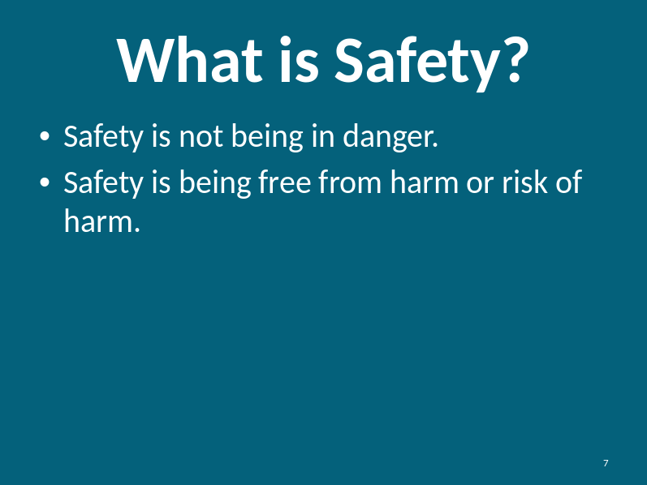  This is the definition we give to people with disabilities to define safety.  You might find this definition helpful to use when talking to people with disabilities about safety and abuse.
Small group discussion |  |  | Instructor: have participants discuss the below question with a partner or within a small group. Have participants share the results with the class.  How is safety different for people with disabilities?  Instructor Note: Below outlines some examples that exhibit what people without disabilities can do that might be different from people with disabilities:  - Can choose who comes to their house and who is around them  - Control over transportation  - Control over finances  - Control over body and needs  - Can choose who they live with
Participant Handout  Slide: 8  Care Provider Responsibility |  |  | As a care provider, you have the responsibility to help the people you support when you suspect abuse. Let’s review the responsibilities you have as a care provider. On page 10 in the Participant Handout.  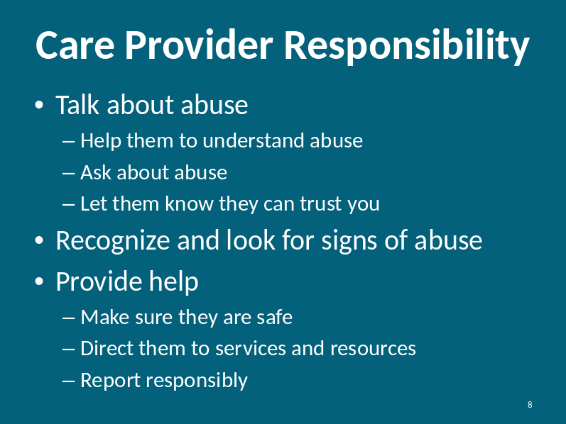  Throughout this curriculum, we will give you tools to do all of these.  First, let’s put this topic in the proper context.
Participant  Handout  Slide: 9  Statistics Quiz |  |  | For the next couple of minutes, we are going to take a brief quiz on abuse statistics for people with disabilities. On page 11 in the Participant Handout.  The purpose of this quiz is to provide the startling truth about the frequency of abuse of people with disabilities.  For each question, please choose the answer you think best fits. After we poll the class, I will tell you the right answer.  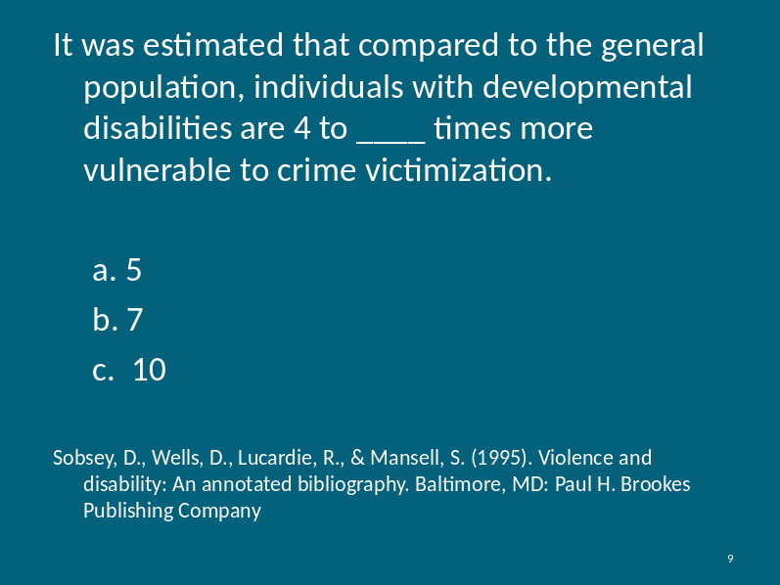  Answer: c. 10  It is widely known that people with disabilities are frequent victims of abuse due to their vulnerability and reduced ability to control their environment.
Slide: 10  Statistics Quiz |  |  | 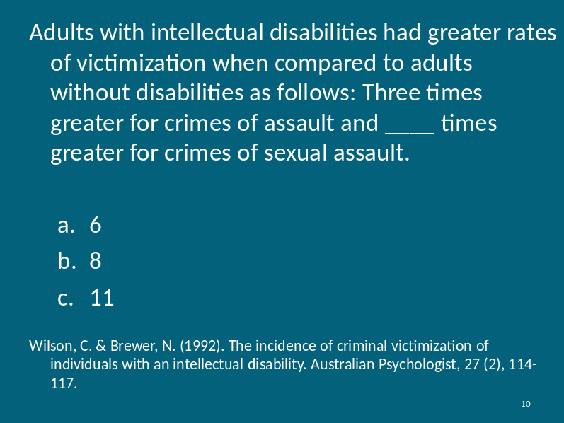  Answer: c. 11  Adults with intellectual disabilities often don’t have the tools to protect themselves and prevent abuse. They may not know how to tell, they might not understand what is happening to them. They might not know they have the right to be safe.
Slide: 11  Statistics Quiz |  |  | 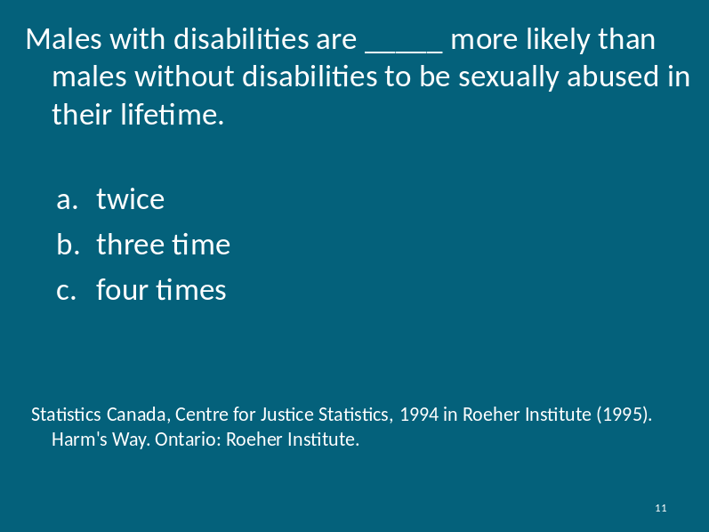  Answer: a. twice  Predators and perpetrators take advantage of people with disabilities. They look for people who are at risk and less likely to tell. They look for people they can scare, overpower and intimidate. Hence male victimization is much higher for people with disabilities than the general population.
Slide: 12  Statistics Quiz |  |  | 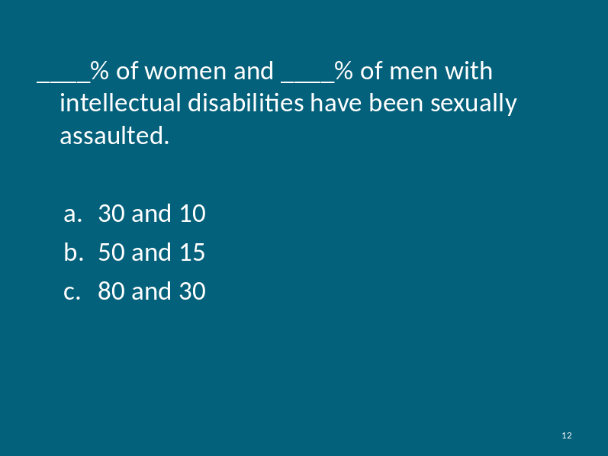  Answer: c. 80 and 30  People with disabilities may be coerced, threatened or intimidated to perform sexual acts with people they know. Care providers may convince them that somehow the person with a disability owes them something.
Slide: 13  Statistics Quiz |  |  | 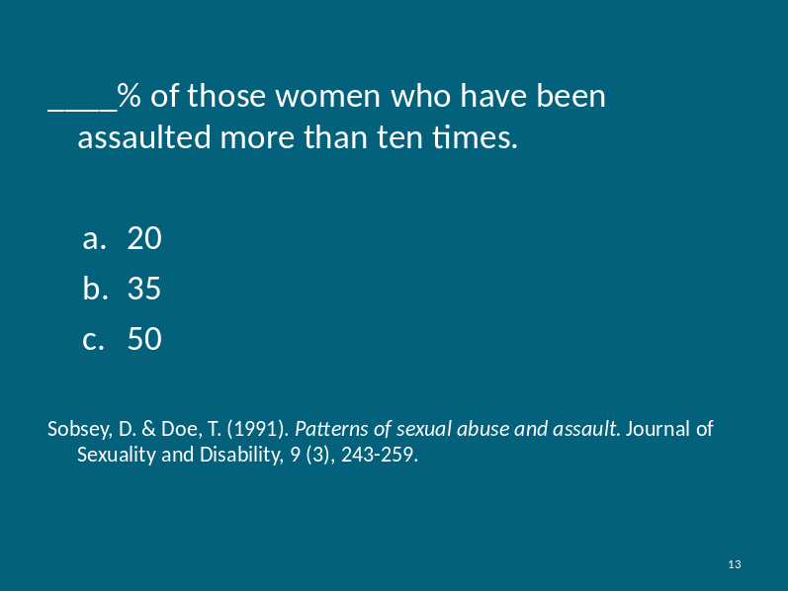  Answer: c. 50  Victimization of people with disabilities often happens more than one time. Sexual abuse may happen repeatedly for a number of years by the same abuser. A person may be victimized by multiple perpetrators throughout their life.
Slide: 14  Statistics Quiz |  |  | 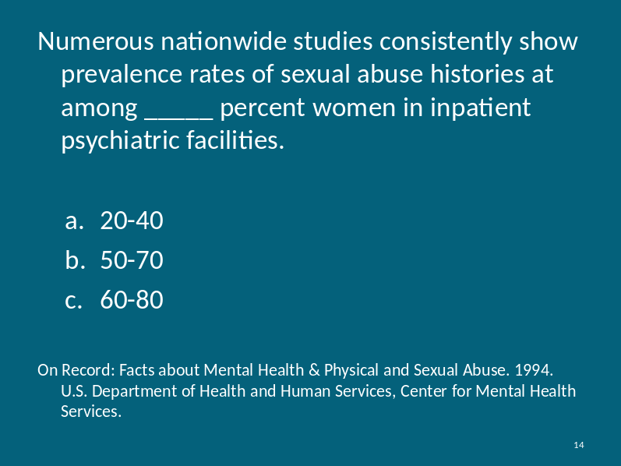  Answer: b. 50-70  Even in facilities where people with disabilities are supposed to be protected by care providers, we see high rates of abuse. Women are more likely to be abused than men.
Slide: 15  Statistics Quiz |  |  | 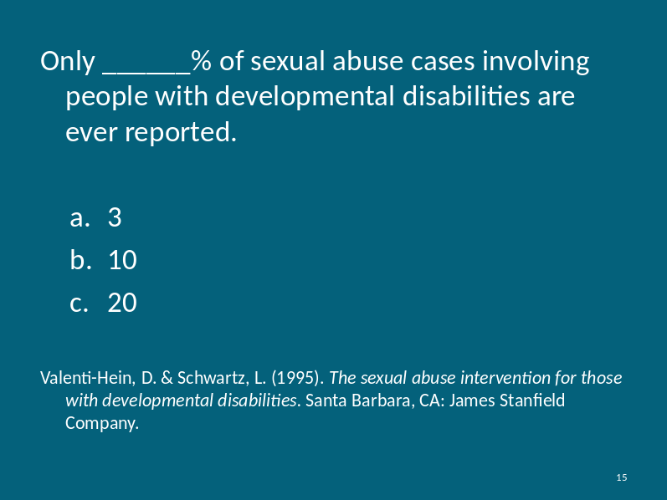  Answer: a. 3  Sadly, very few sexual abuse cases are reported. Victims may not know they can tell or they may not know how to tell. Sometimes when they do tell, they are not believed.  Note that within the general population, 22% of sexual abuse cases are reported. Still a low number, but significantly higher than the 3% of cases reported involving people with disabilities.  More statistics available through the FBI Uniform Crime Report:  http://www.fbi.gov/ucr/cius2008/data/table_01.html
Slide: 16  Statistics Quiz |  |  | 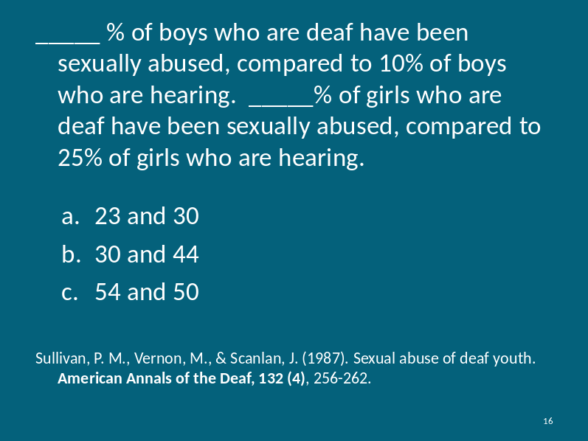  Answer: c. 54 and 50  Deaf individuals experience even higher levels of victimization. Because the deaf frequently can’t speak with their voice, they may not be heard completely when they use sign language.
Why is this important? |  |  | Do these statistics surprise you?  Why does this happen?  Instructor prompt:  - Access to help and resources may be limited or restricted by the abuser  - People with disabilities are easy to manipulate  - Sometimes people with disabilities won’t tell because they are afraid they will get in trouble  - Often when a person with disability tells, they are not believed because of how they tell and who they tell.  Why is this important to you us as Care Providers?  Instructor prompt participants to share the following reasons:  - You can identify abuse  - You can keep people safe  - You can help stop abuse  - You can get them the help they need  - You can save someone’s life
Slide: 17  Caregiver Responsibility |  |  | 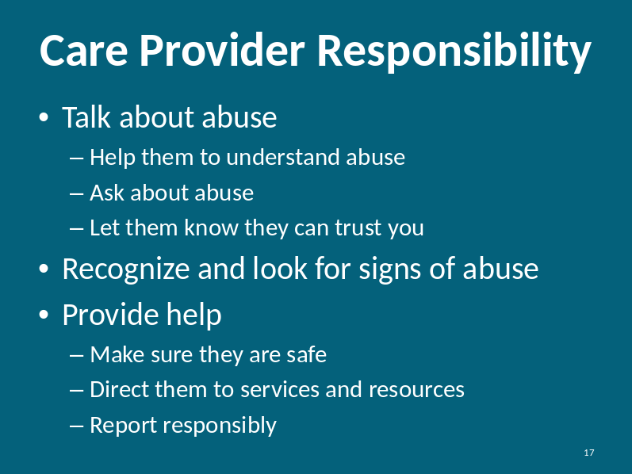  Care providers have a unique responsibility to help those they care for. People with disabilities may not have the physical or mental capacity to seek the help they need. They might not know who to ask for help. They may not be believed when they ask for help. It is your job to help them get help.  You also have the unique ability to spot abuse after it has occurred. With this knowledge you can help protect them from future abuse.  Throughout this curriculum, we will give you tools to help you fulfill your responsibility as care providers.
Slide: 18  What is Abuse?  Participant Handout |  |  | 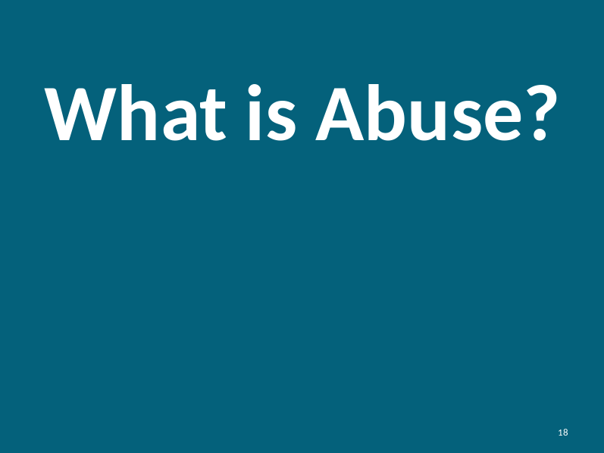  What is abuse?  - When someone is harmed or at risk of being harmed, they are often victims of abuse.  - There are many different forms of abuse.  - As we discussed previously, people with disabilities are at higher risk of being victims of abuse than people without disabilities.  On page 9 in the Participant Handout.
Slide: 19  Defining Abuse |  |  | In this module we will explore the six different types of abuse.  - First, we will define each type of abuse.  - Second, we will provide examples of each type of abuse.  - Third, we will explore how to identify this abuse.  - Last, we will provide tips and suggestions on what you as a caregiver can do to help the people you care for.  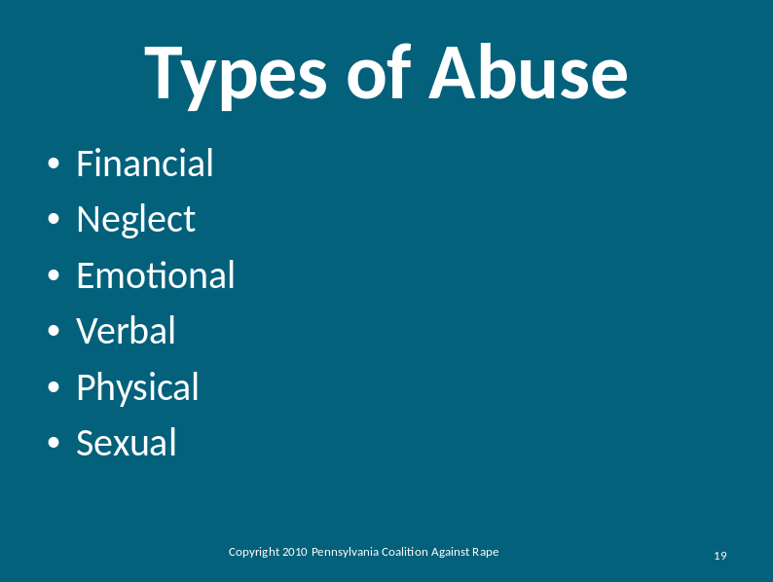
Participant Handout  Defining Each Type of Abuse |  |  | Instructor: Using lecture style, define each type of abuse using the below definitions. On page 12 in the Participant Handout.  Financial: The intentional misuse of another person’s money or assets for personal gain.  Neglect: The failure of a caregiver to provide for a person’s basic needs.  Emotional: The use of manipulation, deception or deprivation intended to violate the emotional or psychological integrity of a person.  Verbal: The use of specific language that humiliates or insults another person. This can include profanity, name calling and yelling.  Physical: The infliction of injury or unreasonable confinement resulting in bodily harm or injury.  Sexual: Occurs any time a person is forced, coerced, and/or manipulated into any unwanted sexual activity. This can include anything from sexual harassment, to groping and rape.
How does intent play a role in abuse?

What is the purpose of the action? Even if the abuser does not intend to abuse the victim, the action can still be abuse if it is a misuse of power and control.
Slide: 20  Defining Financial Abuse |  |  | As we discussed, financial abuse is the intentional misuse of a person’s money or assets for personal gain.  Here are some examples:  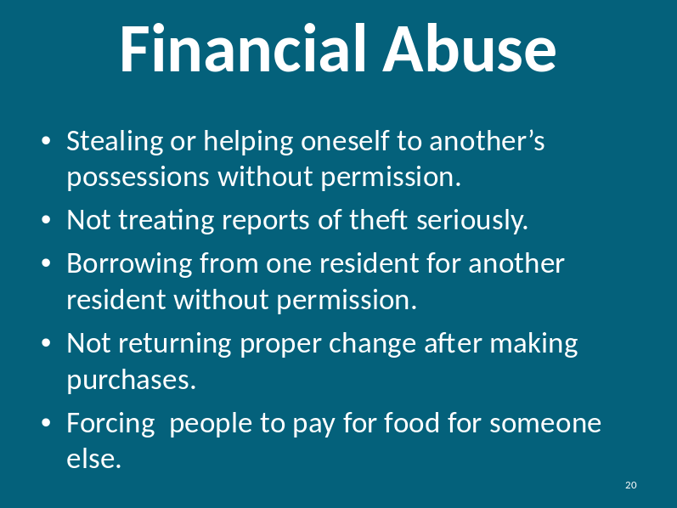  Instructor Note: Many people with disabilities utilize a “Rep Payee” to manage their money. A rep payee has legal authority to manage the finances on behalf of a person with disabilities. Financial abuse by a rep payee should be reported to the Social Security Administration.
Slide: 21 |  |  | You can see signs of financial abuse by looking for these indicators.  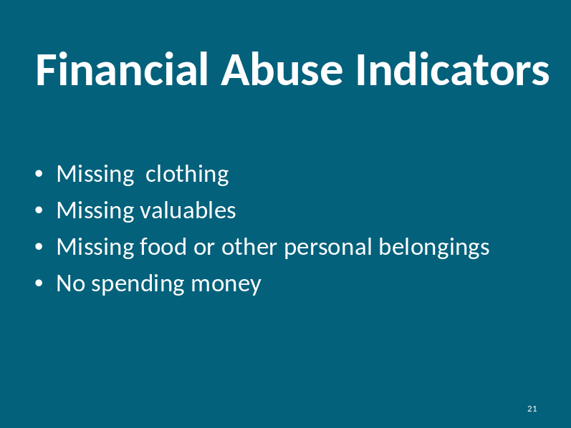
Slide: 22  Defining Neglect |  |  | Neglect is the failure of a caregiver to provide for a person’s basic needs.  Neglect can take the form of active or passive neglect. Active neglect is the willful deprivation of goods or services while passive neglect is the inadvertent deprivation of goods or services. Passive neglect happens every day to people with disabilities. With passive neglect, caregivers may not be aware that neglect is happening.  Here are some examples of neglect:  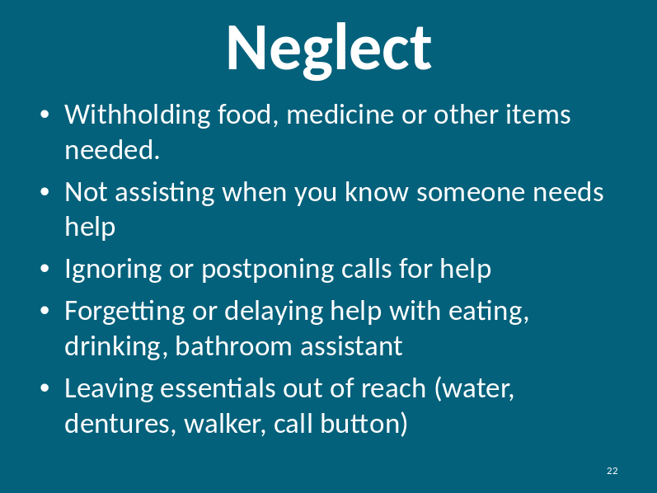
Slide: 23  Defining Neglect |  |  | You can see signs when someone is neglected. Here are some indicators:  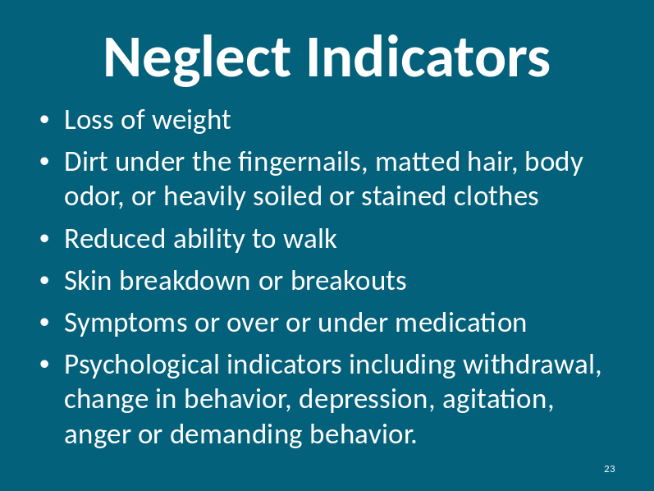
Slide: 24  Defining Emotional Abuse |  |  | Emotional abuse is the use of manipulation, deception or deprivation intended to violate the emotional or psychological integrity of a person.  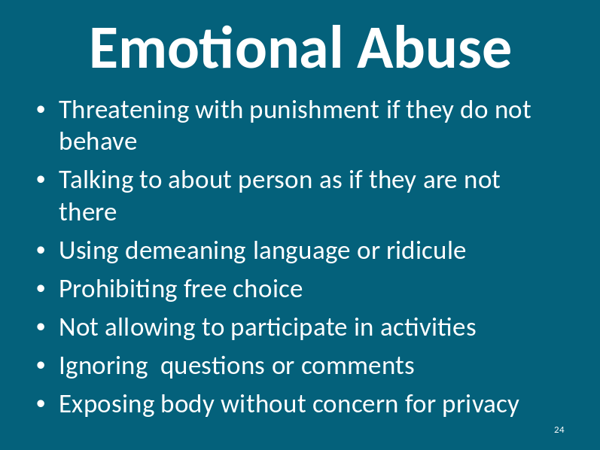
Slide: 25  Defining Emotional Abuse |  |  | You can see signs when someone is emotionally abused. Here are some indicators:  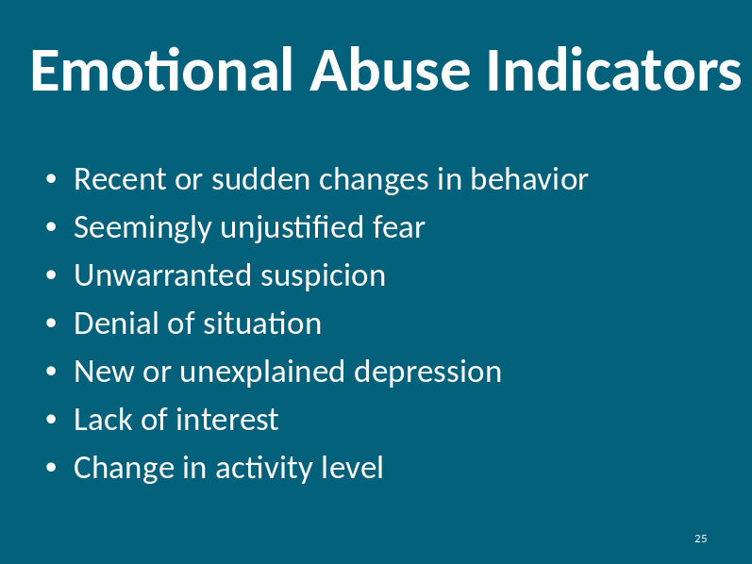
Slide: 26  Defining Verbal Abuse |  |  | Verbal abusive behavior is the use of specific language that humiliates or insults another person. This can include profanity, name calling and yelling.  Below is a list of examples of verbal abuse:  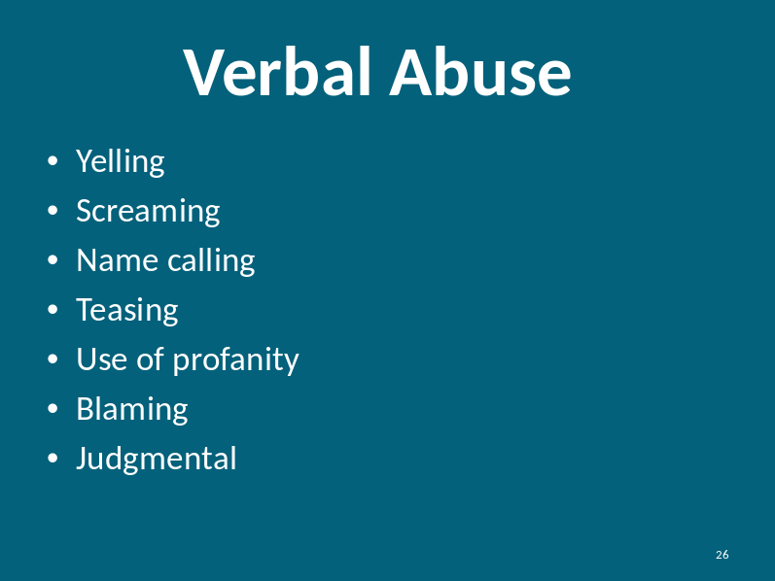  Verbal abuse is often coupled with emotional abuse. Verbal abusive behavior is often a way to hurt or control others.
Slide: 27  Defining Verbal Abuse |  |  | 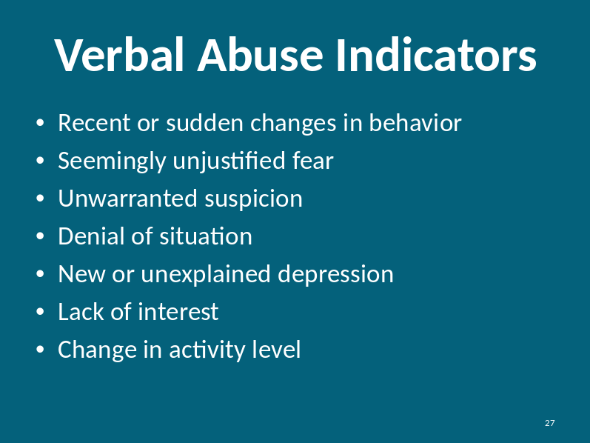
Slide: 28  Defining Physical Abuse |  |  | Physical abuse is the infliction of injury or unreasonable confinement resulting in bodily harm or injury.  Below is a list of examples of physical abuse:  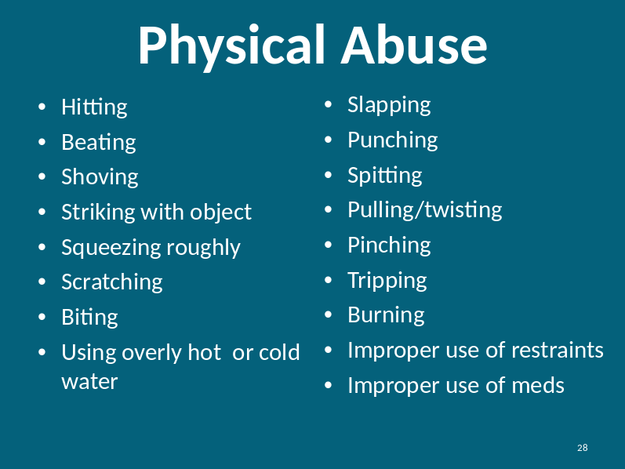
Slide: 29  Defining Physical Abuse |  |  | 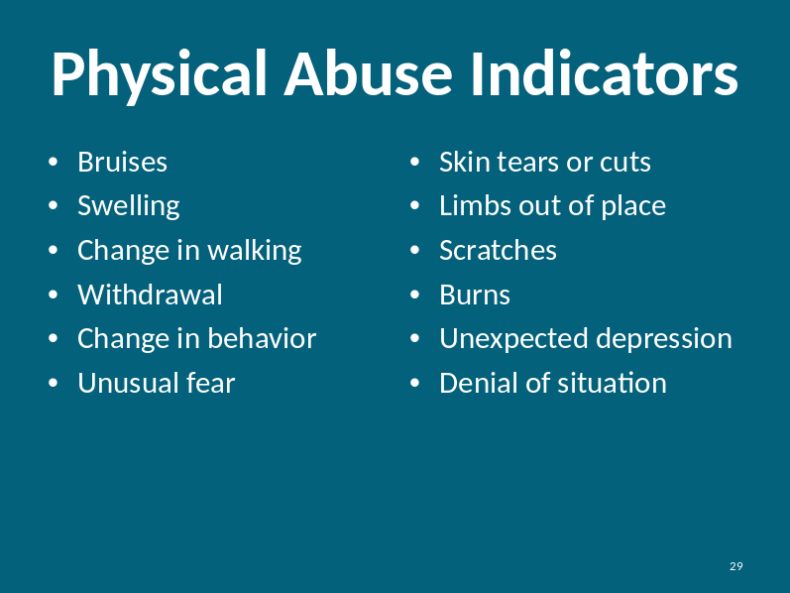
Slide: 30  Defining Sexual Abuse |  |  | Let’s talk about sexual abuse.  Sexual abuse occurs any time a person is forced, coerced, and/or manipulated into any unwanted sexual activity. This can include anything from sexual harassment, to groping and rape.  This could include but not be limited to unwanted or non-consensual:  - Intercourse  - Masturbation  - Anal sex  - Oral sex  - Touching  - Kissing  - Groping  Below are some examples of sexual abuse:  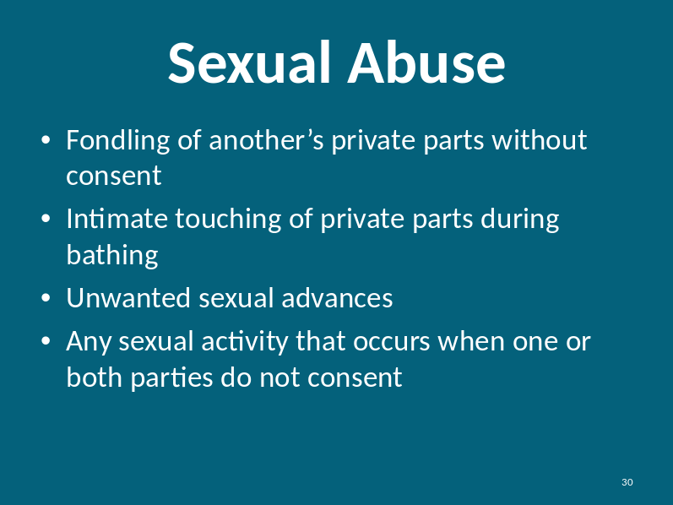
Sexual abuse is when someone does something sexual to you that you don’t want to do. Although it may feel good, it can still be abuse because the person didn’t want to or agree for it to happen.

Sexual acts between a care provider and the person he/she cares for is sexual abuse, even if both people consent.

This is an issue of power differentials, and may bring up discussion. Care providers have power over the people they care for, and thus beginning a sexual relationship that cannot be between equals is thus abusive.

Sometimes, sexual abuse takes the form exposure to material or language instead of touch.
Slide: 31  Defining Sexual Abuse |  |  | 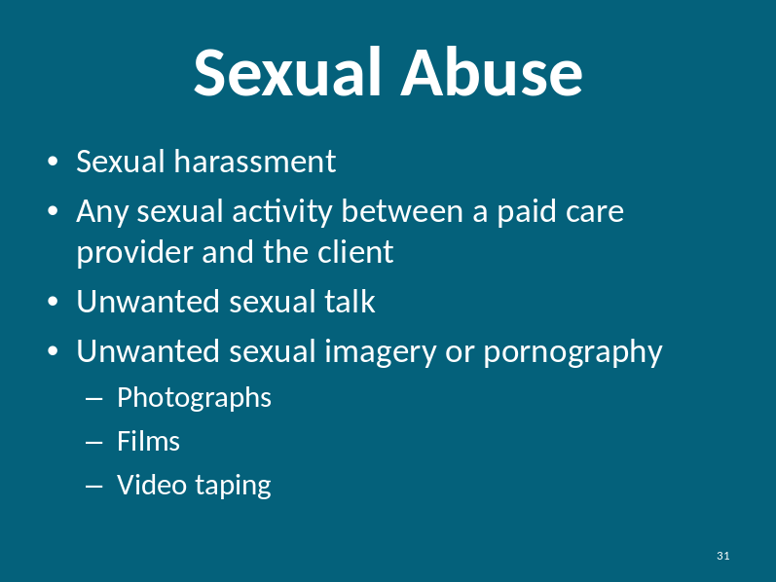
Slide: 32  Consent |  |  | In talking about sexual abuse, we need to discuss the concept of consent.  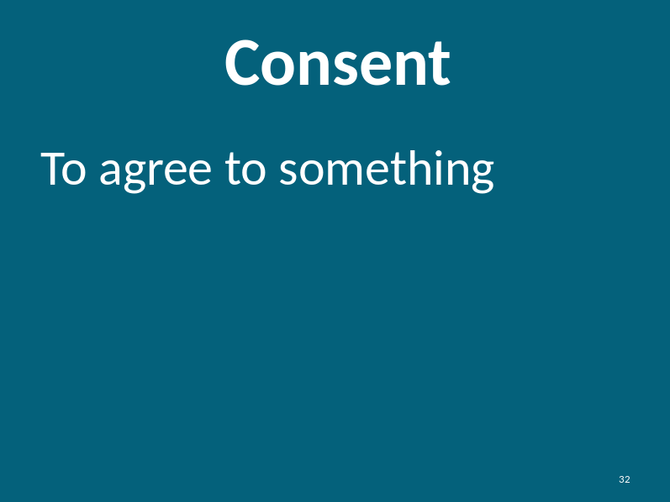  Instructor Note:  Give some non-sexual examples where people may or may not consent to something like:  - Pizza for dinner  - Going to the store  - Use of your cell phone  When someone consents they choose to do something. They agree to move forward with an action or activity. For most day-to-day activities, people have choices. When it comes to health, hygiene and nutrition (taking medicine, bathing and eating), we may not have complete choice.
Slide: 33  Consent  Connecting Consent to Sexual Abuse |  |  | We can agree to something in many ways. We can say, “Yes.” We can nod our heads up and down to show Yes. We can say things like “I want to do that.” We can also show an “okay” sign by using thumbs up or saying Yes using American Sign Language.  In addition to saying “No”, we can put our hand up to exhibit “Stop.” Saying “Stop” can be very effective way to communicate “No.”  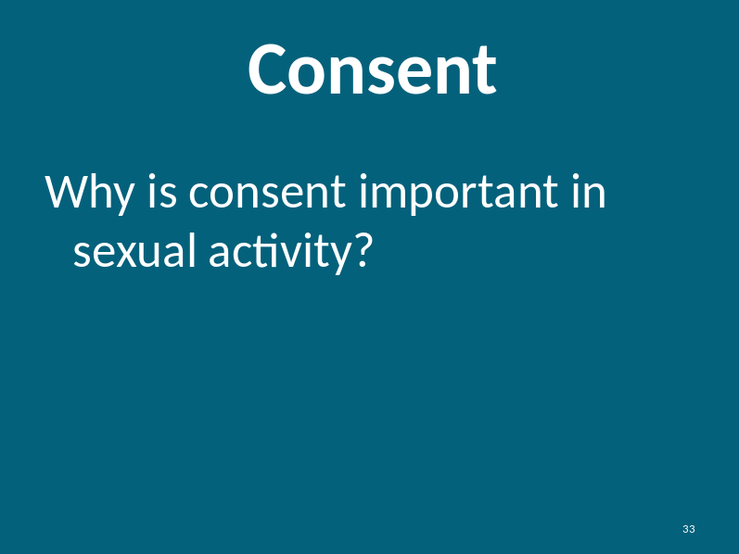  Instructor asks the participants and then discusses each one that is shared.  Why is consent important in sexual activity?
Connecting Consent to Sexual Abuse  Continued |  |  | Instructor should discuss the following talking points if not shared by participants:  - It is important that each person feels comfortable with the sexual activity and understands what they are agreeing to.  - It is important you know the other person is agreeing to the sexual activity.  - Sexual activity is always a choice.  - Agreeing to kiss is not agreeing to touching, and touching is not agreeing to oral sex or intercourse. Each act requires consent.  - Both people need to consent to all acts.  - Consenting once does not mean you consent forever.  - You can take away consent by saying things like “No” or “Stop” or “I don’t want to”.  - You can take away consent at any time by showing you don’t want to do something.  Bottom Line—In the case of sexuality there is ALWAYS a choice.
Slide: 34  Defining Sexual Abuse |  |  | There are both visible and psychological signs of sexual abuse.  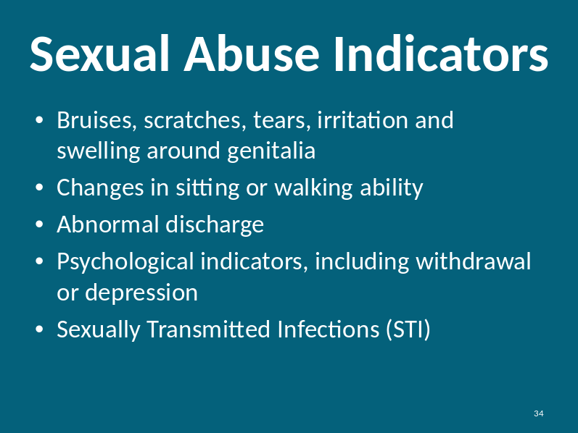  Sexual abuse is often coupled with physical abuse. The effects of sexual abuse have both physical and psychological implications. Victims of sexual abuse often suffer emotional abuse symptoms as well.
Slide: 35 |  |  | 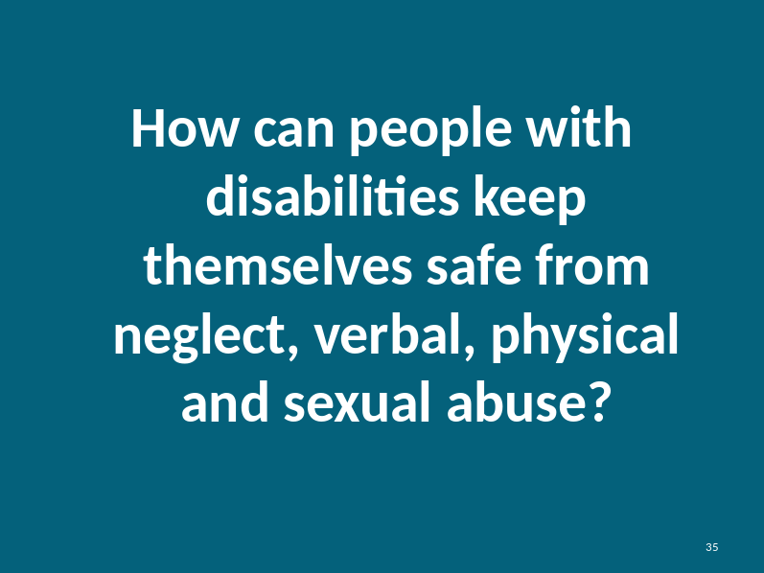  Instructor asks participants to share ideas on how people with disabilities can protect themselves from abuse.  How can people with disabilities keep themselves safe from neglect, verbal, physical and sexual abuse?  Instructor Prompts:  - Say “No” to the abuser  - Tell someone that they are being abused  - Tell again if they don’t do anything  - Tell someone else  - Tell until someone does something to help
What can people with disabilities do to keep their money and belongings safe?

Instructor prompts:
- Keep belongings and valuables in a safe place
- Use the bank to keep additional money
- Don’t lend money or things to people they don’t trust
- Create a spending plan and review their finances frequently.
- Speak out to someone they trust about what is happening
- Keep telling until someone does something
Participant Handout  Slide: 36  Identify Signs of Abuse |  |  | As we saw there are similar signs or indicators of abuse. If you see these physical signs, you will need to inquire further to identify the nature of the abuse.  On page 15 in the Participant Handout.  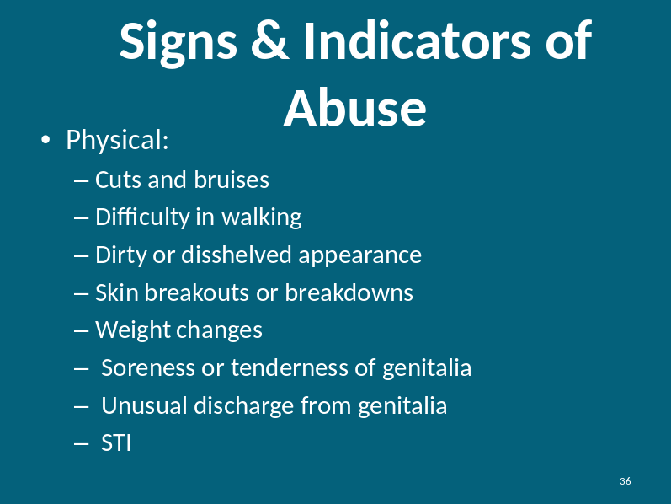  There are both physical and psychological signs of abuse. Physical signs are a lot easier to detect.
Participant Handout  Slide: 37  Identify Signs of Abuse |  |  | As we saw there are similar signs or indicators of abuse. If you see these psychological signs, you will need to inquire further to identify the nature of the abuse.  On page 16 in the Participant Handout.  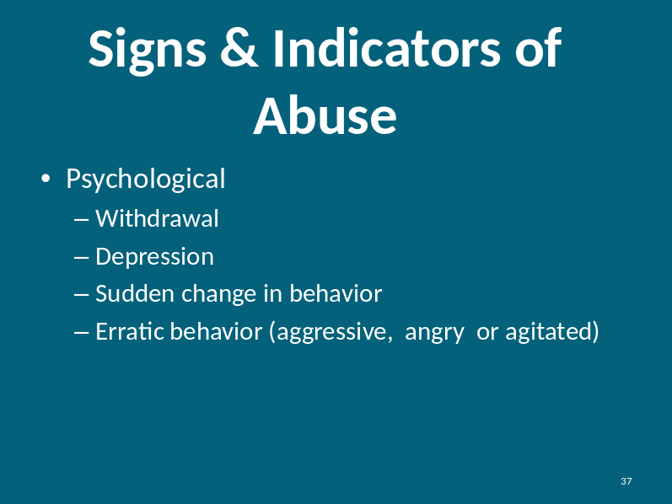  Psychological signs of abuse are harder to detect. As care providers, you know the people you care for better than most people. Watch for changes in behavior like sudden anger, crying, yelling, and withdrawing from interaction.

Part 2: How to Tell and Examples of Abuse |  |  | Estimated Time:  90 minutes
Cues |  | Content |  | Notes
Slide: 38  Caregiver Responsibility |  | 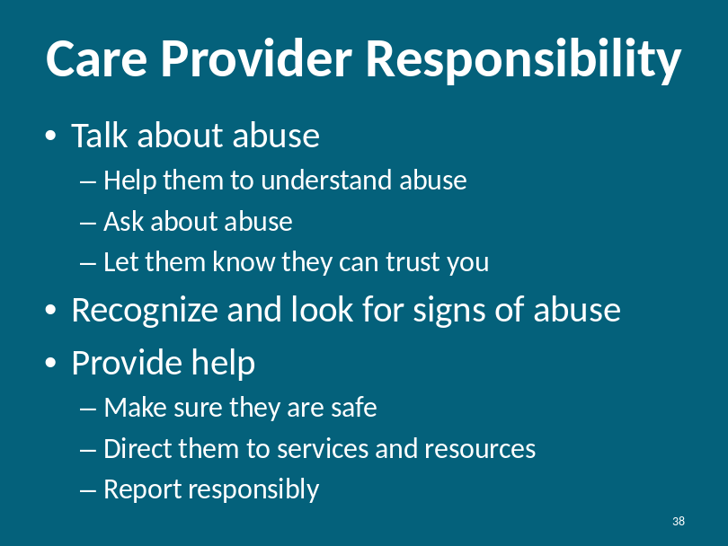  Care providers have a unique responsibility to help those they support. People with disabilities may not have the physical or mental capacity to seek the help they need. They might not know who to ask for help. They may not be believed when they ask for help. It is your job to help them get help.  You also have the unique ability to spot abuse after it has occurred. With this knowledge you can help protect them from future abuse.
Slide: 39  Asking and Talking about Abuse |  | 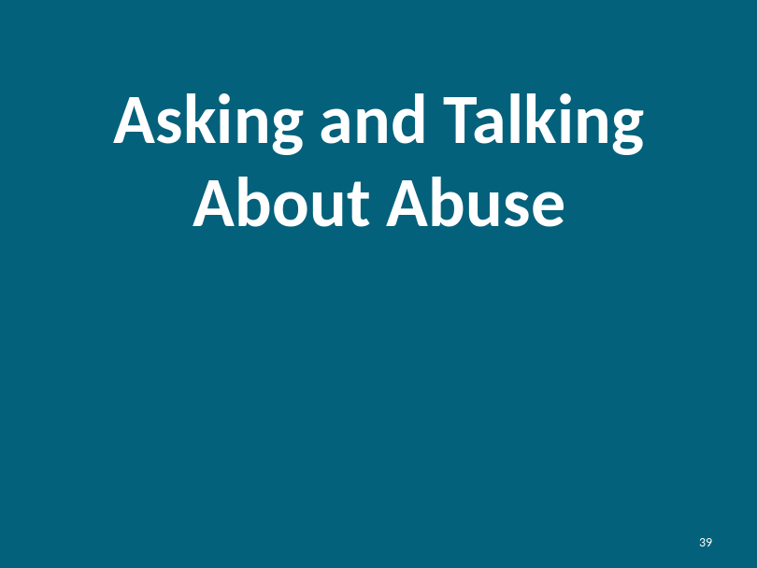  Here are some ways you can begin a conversation regarding abuse:  - Has anyone made you feel uncomfortable?  - Has anyone made you do things you did not want to do? Or has done things to you that you didn’t want?  - Is there anyone in your life you are afraid of?  - Has this person ever hurt you?  - If you talk to other people or go out with friends are you afraid of what this person might say or do to you?  - Has this person made you do things you did not want to do? Or done things to you that you didn’t want?
Participant Handout  Slide: 40  How to Tell |  | We have explored the need to tell and get help. We know that people with disabilities have a difficult time telling because they don’t always have the tools to do so. For the next few minutes, we will provide you with some tips and tools to help the people you care for tell if they are being abused.  On page 17 in the Participant Handout.  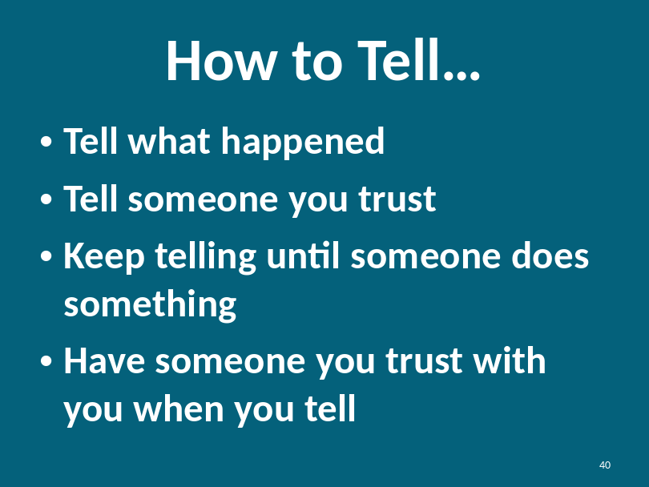
Participant Handout  Slide: 41  How to Tell |  | Another challenge that people with disabilities have when telling their story, is that their expressions and behaviors may not reflect what happened to them.  It is disappointing and frustrating when we tell someone something and they don’t hear us or they don’t believe us.  Therefore, it is important for us as caregivers to help them learn how to tell what happened to them in a serious manner. This will help them be believed.  On page 18 in the Participant Handout.  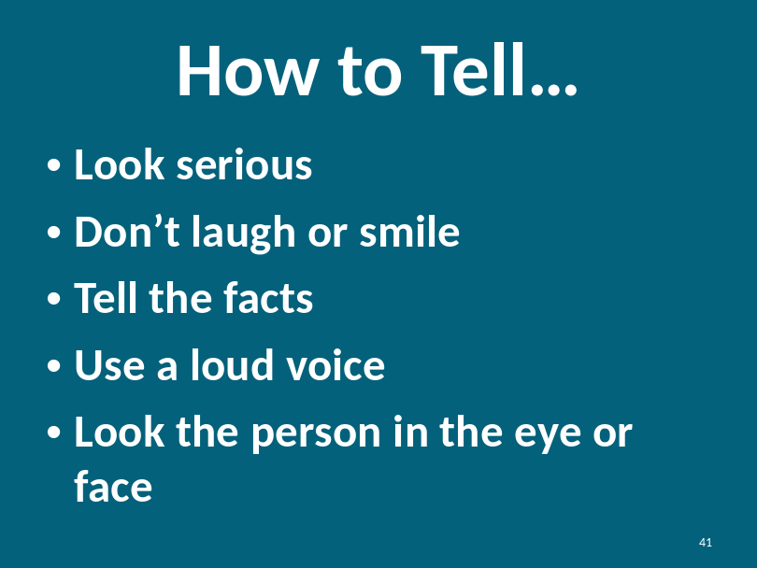
Slide: 42  Report Responsibly  Participant Handout |  | 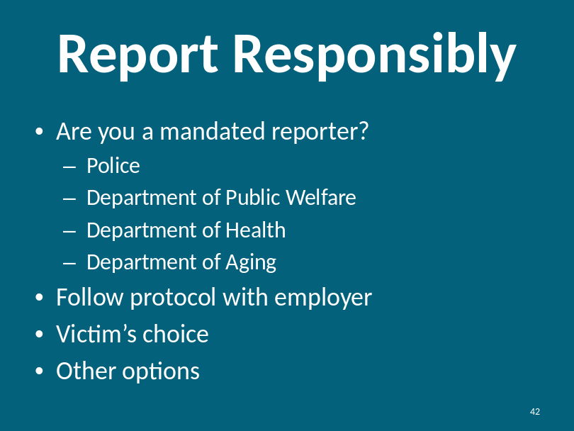  On page 19 in the Participant Handout.  Please be aware of your audiences mandated requirements, if any. You may want to initiate a conversation regarding mandated reporting. This slide is intended to be a starting point for a conversation about reporting. Who your audience is will influence the context of your conversation.  As we cited in the previous slide, one of the care provider’s responsibilities is to report responsibly. As such, we must first consider the type of abuse, whether a crime has been perpetrated and to whom you could report the crime.
The following are examples of reportable crimes:
- Any physical form of sexual abuse should be reported to a rape crisis center and the police.
- Any serious form of physical abuse should be reported to the police.
- Financial abuse or stealing may be a crime. You can consult with the police for verification of criminal activity.
Forms of neglect or withholding support may not be a crime but should be reported to either senior staff members or family members to ensure the situation stops.

Slide: 43  Resources  Participant Handout |  | While it is important to provide emotional support to the victims, please keep in mind that you are not a counselor and should refer the victim to professional services.  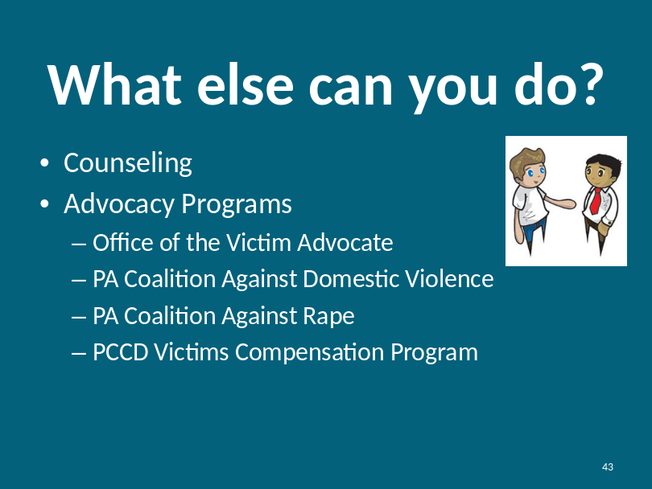  Instructor Note:  On page 20 in the Participant Handout.  Define the different types of professionals available to victims. For example, explain the difference between crisis center counseling and help and the use of a clinical psychologist or psychiatrist.  Many on-site facilities provide access to psychological and counseling services.  Some of the services available may not be credentialed but are experienced with providing advocacy and victim services.  Refer to the resource guide for other available resources.
Participant  Handout  Explore examples for  each type of abuse and discuss |  | Now that you have the tools to help victims of abuse, we will explore some examples of abuse and together we’ll brainstorm on ways to support the victim.  Begins on page 22 in the Participant Handout.  Instructor read each example. After each example is read, the instructor will ask each of the outlined questions in order. The objective is for the instructor to garner participant’s specific answers.  At the appropriate time, the instructor should reinforce the key concepts of each of the Examples about participant rights and safety rules.  Note: The questions listed after each example are a starting point for a group discussion. The instructor can tailor questions to the audience and the discussion.
Slide: 44 |  | 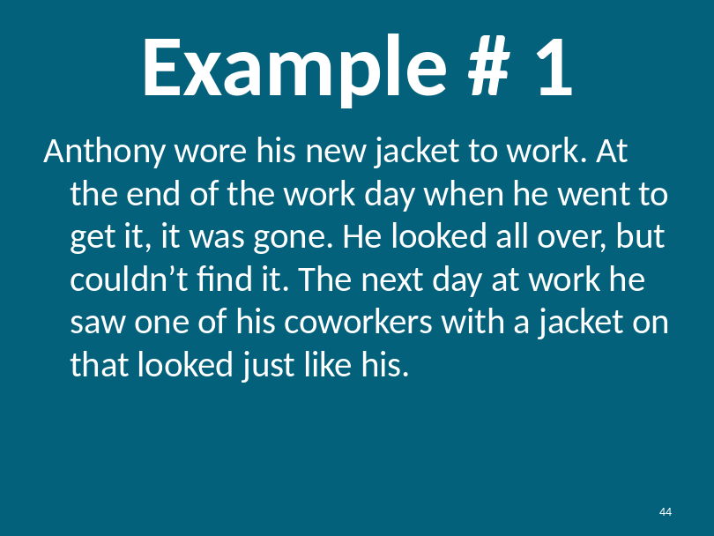
  Explore  Example |  | Example #1  Read example out loud. Ask the following questions. For each response, ask why?  What type of abuse is this?  Financial or economic abuse if the jacket was stolen. The jacket may have been accidently taken by coworker because he mistook Anthony’s jacket for his.  What should he do?  - Anthony should try to talk to his coworker.  - Anthony can discuss his concerns with his boss.  - In the future, Anthony should label his clothing.  - If theft is suspected, Anthony should explore reporting the theft to the police.  What could you do?  - Provide support to Anthony, talk to him, listen to him and help suggest solutions.  - Try to talk to coworker to confirm the jacket was taken.  - Go to the supervisor of both coworkers to report the theft.  - Ask Anthony if he would like to report the theft to the police.
Slide: 45 |  | 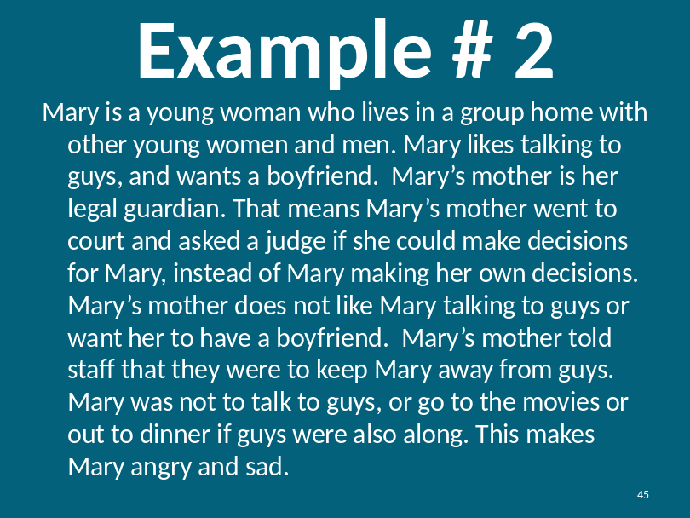
Explore Example |  | Example #2  Read example out loud. Ask the following questions. For each response, ask why?  What type of abuse is this?  Emotional abuse because Mary’s mother is trying to isolate Mary from having relationships that are natural and necessary.  What should Mary do?  - Mary should seek guidance about how to approach her mother with her problem.  - Mary can seek help to garner legal independence.  What could you do?  - Counsel Mary on her rights. While her mother is her legal guardian she legally cannot control who sees and doesn’t see Mary.  - Offer to talk to Mary about sexuality and relationships.  - Offer to talk to Mary’s mother regarding normal relationships.  - Provide a safe place for Mary and her mother to talk together.  - Provide Mary and her mother with a copy of “Guardianship in PA” from the DRN website. It explains that Guardians are to give people in their charge an opportunity to make decisions as much as possible about their health, safety and quality of life. The Guardian should only make choices when the individual is no longer able to do so.
Slide: 46 |  | 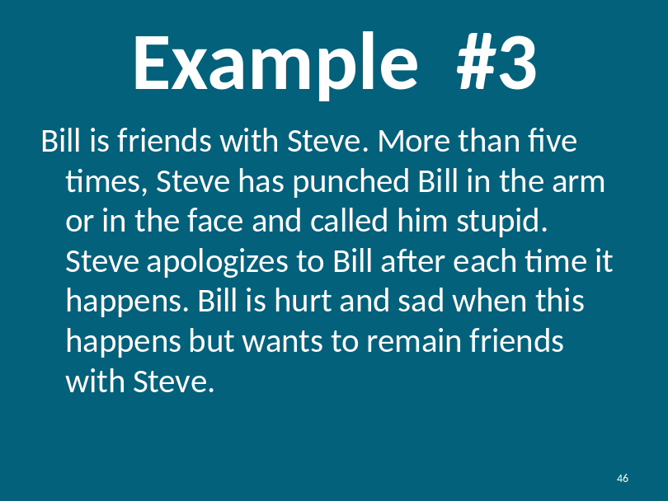
Explore  Example |  | Example #3  Read example out loud. Ask the following questions. For each response, ask why?  What type of abuse is this?  Verbal, emotional and physical  What should Bill do?  - Bill should tell someone that Steve is abusing him.  - If the abuse does not stop, Bill should report Steve to the police.  - Bill should not be friends with people who want to hurt him.  What could you do?  - Must address the situation immediately.  - Talk to Steve and request he stops hitting, punching and name calling.  - Provide moral support to Bill.  - If abuse continues and Bill would like help, assist Bill with reporting the abuse to the police.  - Separate Bill and Steve and be sure other individuals in the area are free from Steve’s abuse.  - Get Steve into counseling so he understands the seriousness of his actions.  - Offer counseling to Bill.
Slide: 47 |  | 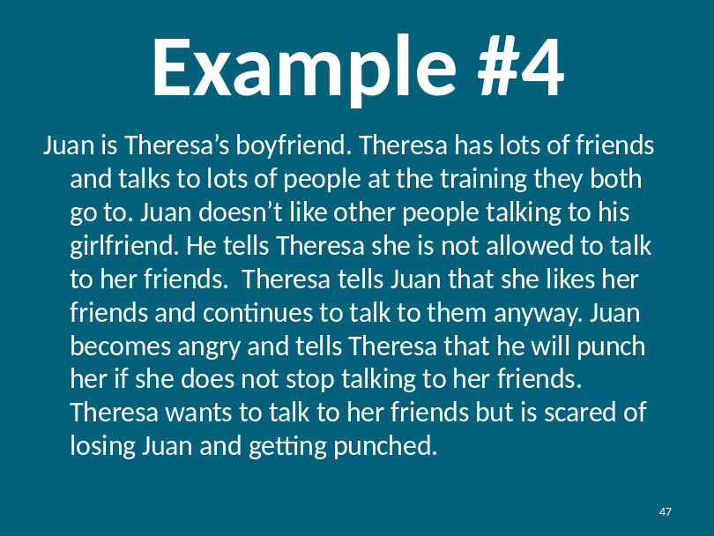
Explore Example |  | Example #4  Read example out loud. Ask the following questions. For each response, ask why?  What type of abuse is this?  Verbal and Emotional Abuse. Juan is coercing and threatening Theresa.  What should Theresa do?  - Theresa should ask for help and protection from Juan.  - Theresa should consider breaking up with Juan.  What could you do?  - Make sure Theresa is in a safe environment.  - Talk to Juan about the repercussions of his actions.  - Offer counseling for both Juan and Theresa.  - If Theresa is in immediate danger, get a protection from abuse order and/or get her services through a victim’s service organization, if she agrees to the help.
Slide: 48 |  | 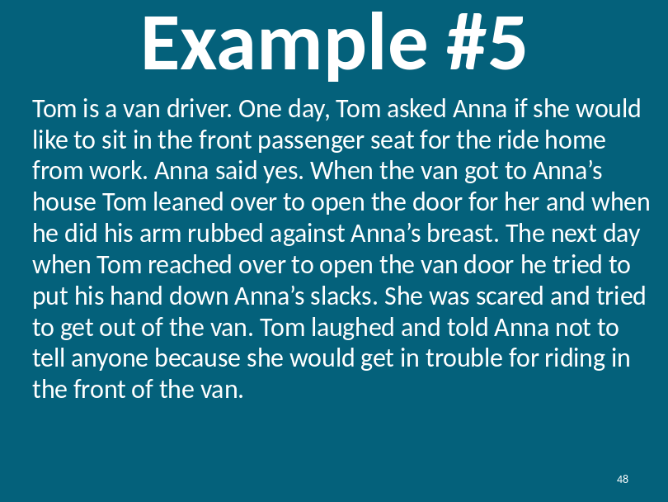
Explore Examples |  | Example #5  Read example out loud. Ask the following questions. For each response, ask why?  What type of abuse is this?  Emotional and Sexual Abuse  What should Anna do?  - Anna should tell someone she trusts about Tom’s actions.  - Anna could report Tom’s actions to the van company.  - Anna could tell her employer what happened to her.  What could you do?  - Encourage Anna to tell and go to authorities.  - Get counseling for Anna if she agrees to it.  - Report Tom to his supervisor(s) if Anna wants you to.
Instructor Note: Have participants refer to a larger version of the chart in their workbooks.
Review with participants the varieties of abuse:
- Coercion and threats
- Intimidation
- Emotional Abuse
- Isolation
- Minimize, Justify and Blame
- Withhold, Misuse or Delay needed support
- Financial or Economic Abuse
- Caregiver Privilege

Instructor Note:

The following examples of abuse feature caregivers as the abuser. This may be a sensitive topic for participants as they are caregivers. If disclosure of abuse occurs and/or a participant expresses severe discomfort, offer to take a break or discuss their specific concerns offline.

Slide: 49 |  | 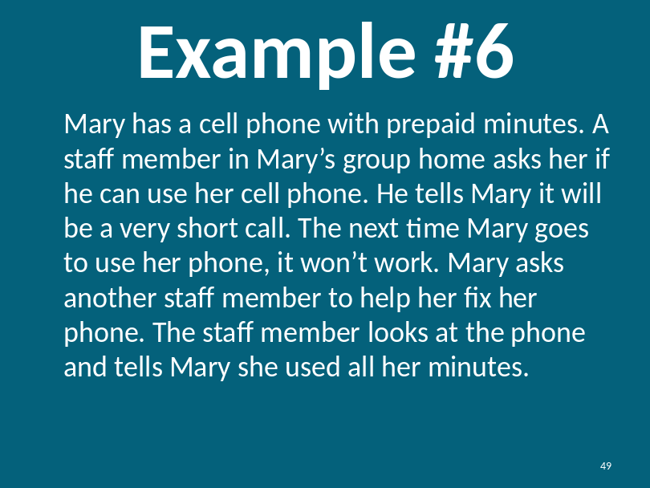
Example #2  Financial Safety |  | Example #6  Read example out loud. Ask the following questions. For each response, ask why?  What type of abuse is this?  Financial or economic abuse  What should Mary do?  - Mary should report the employee to his supervisor.  - Mary should not lend her phone to him again.  - Mary should tell someone she trusts.  What could you do?  - Report the employee to his supervisor.  - If the employee works for you, fire or formally reprimand him.  - Counsel Mary on taking charge of her possessions and how to say “NO.”
Slide: 50 |  | 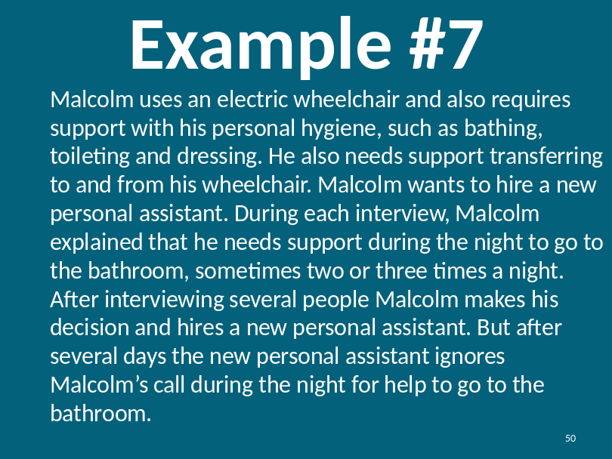
Explore  Examples |  | Example #7  Read example out loud. Ask the following questions. For each response, ask why?  What type of abuse is this?  Neglect  What should he do?  - Malcolm should develop a short-term plan to cover the new assistant’s shift.  - Malcolm should fire the assistant.  - Malcolm should ask the agency that the attendant works for if they have an on-call number to report situations, with employees.  What could you do?  - Support Malcolm’s decision to dismiss the assistant.  - Give Malcolm guidance on how to handle the conversation.  - Offer to be there with Malcolm if he needs it  - Help Malcolm create a good job description in the future.  - Offer to sit in on interviews.
Slide: 51 |  | 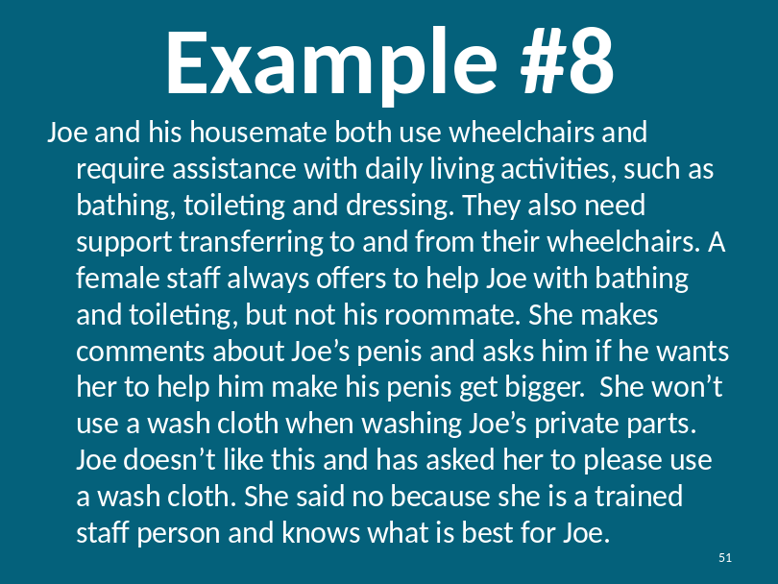
Explore Example |  | Example #8  Read example out loud. Ask the following questions. For each response, ask why?  What kind of abuse is this?  Sexual Abuse  What should Joe do?  - Tell someone he trusts.  - Tell the female nurse’s supervisor.  - Report to the police.  What could you do?  - Provide emotional support to Joe.  - Report the female nurse’s behavior to her supervisor, if Joe would like you to.  - Offer to get Joe counseling.  - Offer to help Joe contact the police.
Lesson Review  Safety |  | REVIEW EXERCISE  Instructor: You can review the concepts by either opening a discussion with the question or seeking answers from participants or you can recite the question and then you can provide a summary of the learning concept.  What is Safety?  Safety is a feeling. If you are safe you won’t get hurt and you are comfortable at home, at work and in your community.
Power & Control |  | What is Power?  - Power is a noun.  - Ability to make decisions for yourself or someone else  - Ability to influence others  - Ability to do what you want  - Ability to act  - Possession of authority. Not necessarily using the authority.
Power & Control |  | What is Control?  - Control is a verb.  - To exercise restraining or directing influence  - Control situation  - Control other’s behaviors
Types of Abuse |  | What are the Six Types of Abuse?  - Financial: The intentional misuse of a person’s money or assets for personal gain.  - Neglect: The failure of a caregiver to provide for a person’s basic needs.  - Emotional: The use of manipulation, deception or deprivation intended to violate the emotional or psychological integrity of a person.  - Verbal: The use of specific language that humiliates or insults another person. This can include profanity, name calling and yelling.  - Physical: The infliction of injury or unreasonable confinement resulting in bodily harm or injury.  - Sexual: Occurs any time a person is forced, coerced, and/or manipulated into any unwanted sexual activity. This can include anything from sexual harassment, to groping and rape.
Consent |  | What is consent?  Agreeing to something. Saying yes. Showing signs of saying yes; i.e., nodding your head.
Consent |  | Why is consent important in sexual activity?  - It is important that each person feels comfortable with the sexual activity  - It is important you know the other person is agreeing to the sexual activity  - Sexual activity is always a choice  - Agreeing to something (kissing) is not agreeing to touching, and touching is not agreeing to oral sex or intercourse  - Consenting once does not mean you consent forever  - You can take away consent by saying things like “No” or “Stop” or “I don’t want to”  - You can take away consent at any time by showing you don’t want to do something
Physical Signs of Abuse |  | What are Physical Signs of Abuse?  - Cuts and bruises  - Difficulty in walking  - Dirty or disheveled appearance  - Skin breakouts or breakdowns  - Weight changes  - Soreness or tenderness of genitalia  - Unusual discharge from genitalia  - STI
Psychological Signs of Abuse |  | What are Psychological Signs of Abuse?  - Withdrawal  - Depression  - Sudden change in behavior  - Erratic behavior (aggressive, angry or agitated)
Caregiver Responsibility |  | What is Care Provider Responsibility?  - Talk about abuse  - Help them to understand abuse  - Ask about abuse  - Let them know they can trust you  - Recognize and look for signs of abuse  - Provide help  - Make sure they are safe  - Direct them to services and resources  - Report responsibly
Responsible Reporting |  | What are some steps to ensure you report responsibly?  - Are you a mandated reporter?  - Police  - Department of Public Welfare  - Department of Health  - Department of Aging  - Follow protocol with employer  - Victim’s choice  - Other options
Share with the group one thing you learned today.

What knowledge did you get here today?

Do you have any questions for me or the class?

Slide: 52 |  | 

